RBMS
MILWAUKEE

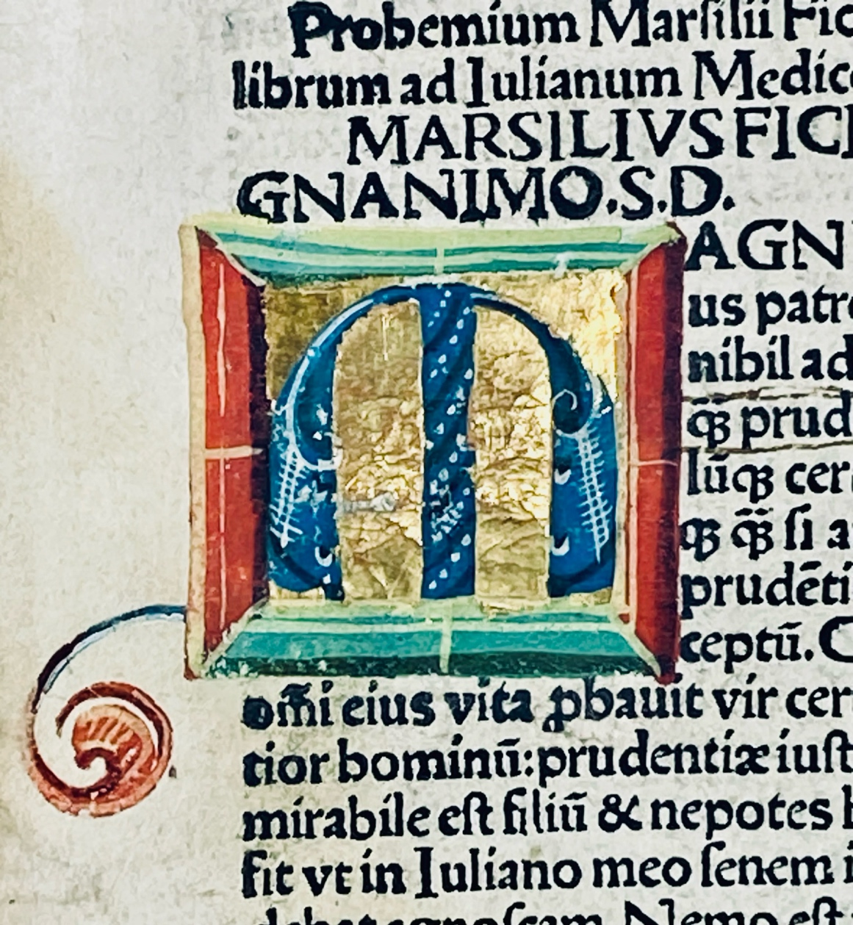

JUNE
MMXXVI
CC PART THREE 1470-1501
James Gray Booksellers

 |  |  |  | CC-3 | 15th Century Selection
Cat # | Page Nº | Book Nº | Author | Date | Blog Address
1 | 5 | 601J | Augustine | 1498 | https://wp.me/p3kzOR-7Fu
2 | 9 | 466J | Balthasar de Porta | 1495 | https://wp.me/p3kzOR-7rN
3 | 11 | 939J | Basilius Magnus | 1478 | https://wp.me/p3kzOR-922
4 | 17 | 284J | Burley /Aristotle | 1500 | https://wp.me/p3kzOR-7rN
5 | 25 | 453J | Diogenes Lærtius | 1500+ | https://wp.me/p3kzOR-7HC
6 | 31 | 753J | Dunns Scotus. | 1476 | https://wp.me/p3kzOR-7HF
7 | 37 | 658J | Eusebius | 1487 | https://wp.me/p3kzOR-7Ha
8 | 41 | 525J | Ficino | 1497 | https://wp.me/p3kzOR-8lb
9 | 51 | 448J | Gruytrode | 1495 | https://wp.me/p3kzOR-8RR
10 | 59 | 882J | Gruytrode | 1495 | https://wp.me/p3kzOR-8rj
11 | 61 | 444Ji | Guillermus Paris | 1480 | https://wp.me/p3kzOR-6Yw
12 | 71 | 670J | Juvenalis | 1497 | https://wp.me/p3kzOR-67c
13 | 87 | 671J | Livius | 1491 | https://wp.me/p3kzOR-8ta
14 | 97 | 976J | Melber | 1476 | https://wp.me/p3kzOR-9F2
15 | 103 | 794J | Prosper of Aqutain | 1487 | https://wp.me/p3kzOR-7Du
16 | 105 | 935J | Reginaldetus | 1489 | https://wp.me/p3kzOR-8RX
17 | 61 | 444Jii | Turrecremata | 1481 | https://wp.me/p3kzOR-6Yw
18 | 115 | 537J | Beil/Sammelband | 1499 | https://wp.me/p3kzOR-99o

Terms of Business

Prices are net.

We accept payment in American currency in American Diollars and British Pounds and Euros by Check or Wire/ACH.

All items are subject to prior sae

Postage and Insurance is Extra

Ant item may be returned within ten days if found wanting.

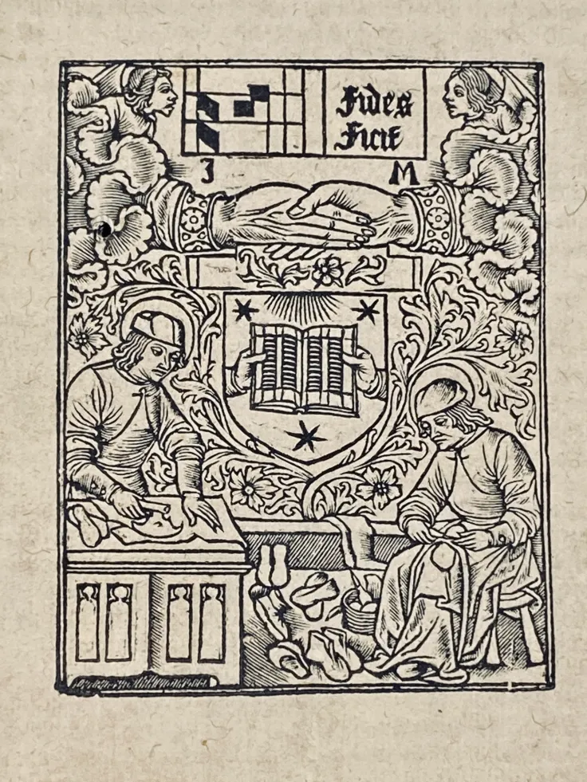

1

601J Augustine (Jean de Fécamp (early 11th century –1079) Libellus Meditationum

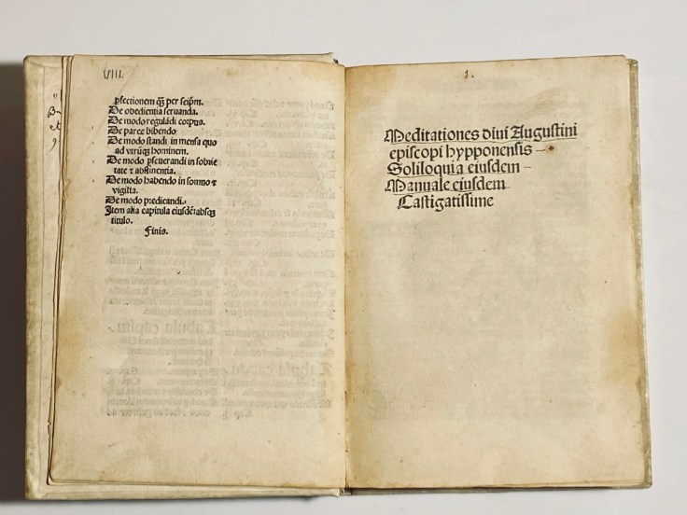

601J Pseudo-Augustine; Saint Augustine 354-430; Bernard of Claravallensis 1090-1153; Peter Damian 1007-1072; Saint Anselm of Canterbury, 1033-1109; Vincent Ferrer 1350-1419; Maﬀeo Vegio 1407-1458; Pope Pius II,(Enea Silvio Bartolomeo Piccolomini) 1405-1464,
Medtationes divi Augustini episcopi Hyppoensis Soliloquia eivsden Manuale eidsdem Castigaissime. [a¹]
Brescia: Angelus Britannicus de Pallazolo Biblioteca Virtual del Patrimonio Bibliograìfico. 8 Oct. 1498 $5 500
Title and list of contents π1r; Title page,a1r 1)[Pseudo-] Augustinus [Pseudo- Anselmus; Jean de Fécamp]. Meditationes, caption “Invocatio dei omnipotentis ad morum et vite reparationem”, The invocation of the Almighty God for the reparation of character and life.
2) a2r-e5r; [Pseudo-] Augustinus. Meditationes,

3) e5r-i3r; [Pseudo-] Augustinus. Soliloquia,

4) i3r-kkv [i.e. l1v], Manuale including preface, i3r-v; [Pseudo-Bernardus Claravallensis . [i.e. Hugo de Sancto Victore]. Meditationes de cognitione humanae conditionis,
5) l2r-m8v; [Pseudo-] Bernardus Claravallensis. Epistola de perfectione vitae,

6) n1r-n2r; Petrus Damiani. Sermo unicus [i.e Institutio monialis, chapt. 6],( De Institutione monialis, which had the aim of safeguarding Western Christians from the decadent uses of the East. Notable in this work, among other things, Damiani, then Bishop of Ostia, condemned Maria Argyre’s use of a golden fork to eat. ‘Forks were a new invention at the time.)

7) n2v-n3r; Anselmus Cantuariensis. Meditatio de redemptione generis humani,

8) n3v-n7r; Anselmus Cantuariensis. Orationes ad sanctam Mariam virginem,

9) n7r-o7v; Father N. Laudensis [Maphae9us Vegius? Jacobus Arrigoni Laudensis?]. [Verse], incipit “Mens mea q[ui]d cogitas? Quid tantis / ceca procellis / Sponte tuam credis mox peritura ratem?”, “My mind, what are you thinking? Why are you so blind / blind to the storm / Do you automatically believe that your rate will soon perish?”

10-18) o8r :8, elegiac distichs,; Pius II, Pont. Max. In laudem divi Augustini, o8r-v; Maphaeus Vegius. Epigramma in laudem Monicae, o8v-o9v; colophon, ov; printer’s device, o9v; Vincentius Ferrerius. De vita spirituali [also known as De interiori homine formativus],
19) ²l1r-²m11v;

20) p1r-p7v. [Pseudo-] Bernardus Claravallensis. Sermo de passione domini .
18 semi mystical texts in this beautiful and excellent little book, maybe eleven Authors, So from the top I will try to discuss the authorship and the texts!
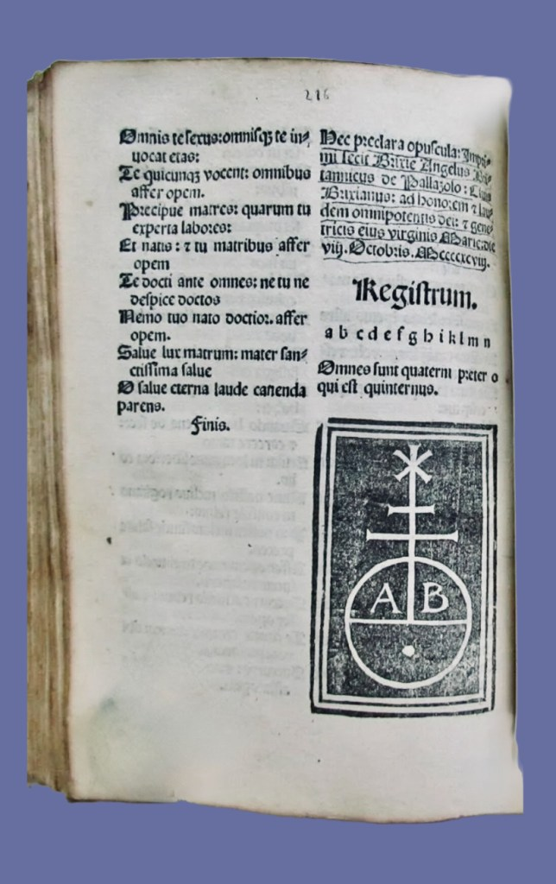
United States of America
Baltimore MD, The Walters Art Museum Library
Chicago IL, The Newberry Library
Collection of the late Phyllis and John Gordan, New York NY
New Haven CT, Yale University, Beinecke Library
Philadelphia PA, Free Library of Philadelphia, Copinger-Widener Collection
San Marino CA, Huntington Library
Stanford CA, Stanford University, Green Library
University Park PA, Pennsylvania State University, Eberly Family Special Collections Library
Goﬀ A1294; HC(Add) 1951; IGI 1013;Sajó-Soltész 406; IBE 126; IBPort 35; Madsen442; SchmittII2828,15; Hubay(Eichstätt)110; Oates2628; Pr6998; BMC VII 980; BSB- Ink L-136; GW 2972 (Pseudo-Augustinus)
https://data.cerl.org/istc/ia01294000

2
466J Balthasar de Porta (fl. 1487- 1499)
Expositio Canonis Missae. (Canon sacratissime misse: unacum expositione eiusdem: ubi in primis premittit pulchra contemplatio ante missam habenda de christi pulcritudine. Et quo mo[d]o ipsa in sua passione: ab eo o[mn]ino fuerat ablata. Qualiterque quilibet celebrans debeat esse dispositius incipit foeliciter.)
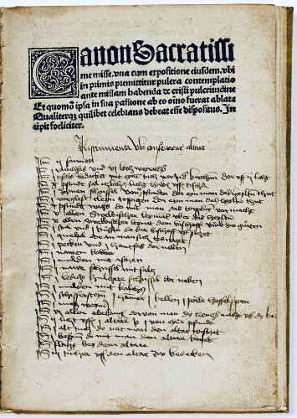
[Leipzig : Gregorius Böttiger (aka Werman), about 1495. Price: $11,000

Chancery half-sheet Quarto: 18.5 x12.5 cm. Signatures: aa-dd⁶, 24 of 24 leaves. Editio princeps, text in gothic letter, including a set of large caps, large woodcut initial and display face on title page, On the lower half of the title page there is a contemporary sacristy inventory has been added in a neat late-15th-century German hand, headed Instrumenta bei unserm altar (“Items kept at our altar”). The list, written in 25 lines with “Item” marks in the margin, reads in cleaned diplomatic form:

Instrumenta bei unserm altar
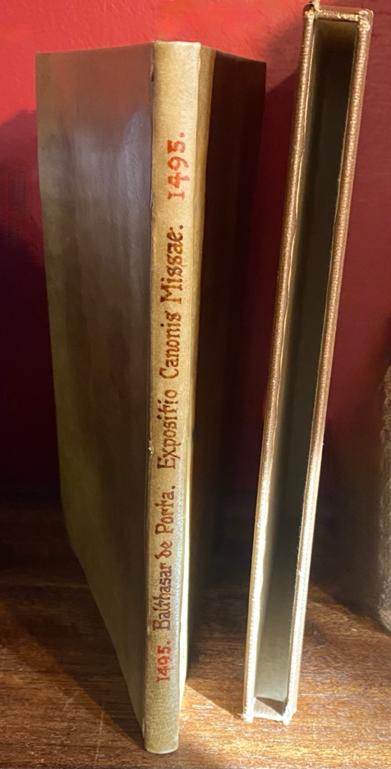
Item Salz
Item das heilige Wasser
Item ein Kessel
Item Wachs do mit man das Taufwasser macht
Item allen Ornatstücken Hemd oder die Gürtel
Item die Ampullen zum Wein und zum Wasser
Item ein Tüchlein bei der Opferpforte
Item Hostien und Becken dazu
Item Wasser und Wachs
Item neue Pfännlein mit Salz
Item Liechtlin bei dem Altar
Item Öltöpflein, Ampullen, Kellen und Pötte
Item Wein und alte Tücher für den Altar
Item Becken und Fläschlein zum Altar gebrauch
Item Tücher und Decken zum Altar bedecken.
This inventory of liturgical implements—wax, salt, holy water, ampullae for wine and water, vestments, altar cloths, and basins—documents the practical contents of a parish sacristy at the time of printing and gives this copy exceptional research value for the study of late-medieval material religion and Mass practice. This copy is bound in antique parchment .
Balthasar de Porta’s Canon Missae, also contains the the proposal of the Exposition of the Eucharist before the celebration of mass . This commentary on the Mass, has verses taken from the Jesuida of Hieronymus de Vallibus, which are used in the appropriate context to illustrate or emphasize the author’s meaning. We know very few facts about the life of Balthasar de Porta , a Cistercian monk who served as Provisor at the order’s College (Saint Bernard) at Leipzig until about 1499. In the same years, he also published another work about Mass, the Expositio mysteriorum missae (Leipzig: Kacheloven, 1494) and a work on the heretical Bohemian Brethren, Conclusiones contra quorundam Bohemorum errores (Lepzig: Böttiger, about 1494), in which Balthasar refutes specific “errors” of the Hussite beliefs. Balthasar de Porta was Provisor of the Cistercian College of St. Bernhard in Leipzig (fl. 1487-1499).
Goff B39; H 2345*; GfT GfT: Gesellschaft für Typenkunde des XV. Jahrhunderts. Veröffentlichungen. 33 parts. Leipzig [etc], 1907-39. 521, 522; Pell 1753; BSB-Ink B-25; GW 3216; ISTC ib00039000. US copies: Huntington Library (2), Southern Methodist Univ, Yale University https://data.cerl.org/istc/ib00039000

3

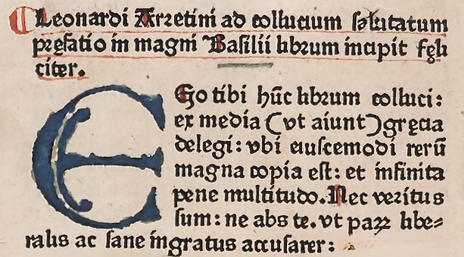

939J Basilius Magnus (c. 330-379)
De legendis antiquorum libris, sive De liberalibus studiis (Tr: Leonardus Brunus Aretinus). Ed: Martinus Brenningarius
Ulm: [Johann Zainer the Elder, 1478]. Price $9,600
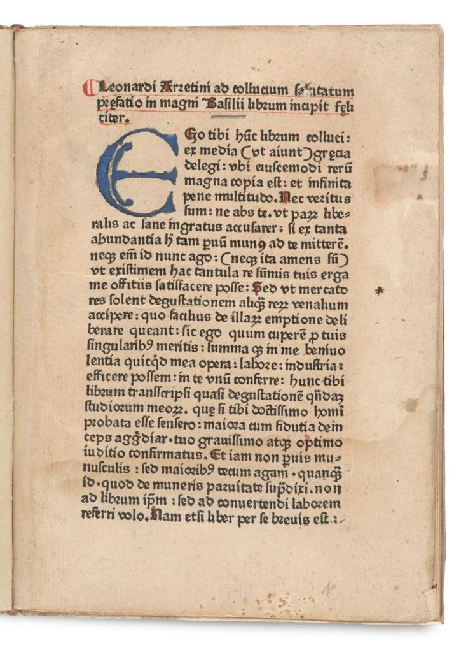

Quarto Signatures a-b⁸ First Latin edition translated by Leonardo Bruni. Rubricated, with one 6-line and twenty 5-line wood-cut initials coloured in blue, pink and yellow incorporating figurative ornaments (plants, animals), as well as numerous pilcrows, majuscules, initial-strokes and marginals in red. Blank leaf a1 is missing. The spine with fault at top edge, faint water staining throughout, occasional foxing, leaf a²enforced at side edge, the same leaf with a small marginal tear, leaves a² and a³ with traces of removed manicule.Bound in later vellum.

Basil the Great wrote what we call De legendis libris gentilium (Greek: Πρὸς τοὺς νέους, ὅπως ἂν ἐξ Ἑλληνικῶν ὠφελοῖντο λόγων) in the later fourth century, probably in the 360s–370s, when he was already an established bishop and ascetic leader. De legendis libris gentilium addresses a pressing problem faced by Christian families: how to educate youth within a Greco-Roman school system dominated by pagan poetry, rhetoric, and philosophy. Basil himself had received the highest classical training in Athens, and the treatise reflects his effort to reconcile that formation with Christian ascetic and theological commitments. Rather than rejecting classical literature outright, he argues that pagan authors may be read selectively for their moral exempla and rhetorical discipline, provided that their theological errors are avoided. Secular learning, in Basil’s formulation, prepares the soul for virtue but does not supplant divine revelation. The work thus offered an early and authoritative blueprint for integrating classical education into Christian life—precisely the principle that would make it foundational for Renaissance humanists such as Leonardo Bruni.

Bruni’s translation of Basil’s De legendis libris gentilium must be understood as a deliberate intervention in the educational and theological culture of the early fifteenth century. Bruni was not merely recovering Greek texts for stylistic pleasure; he was constructing a defensible intellectual program in which the study of classical literature—the poets, historians, and orators of antiquity—could be presented as morally formative and fully compatible with Christian life. At a moment when the revival of pagan authors still provoked suspicion within ecclesiastical and scholastic circles, Bruni sought authoritative precedents from the Church itself. By translating Basil into a polished, Ciceronian Latin and circulating the text among humanist readers, Bruni effectively embedded the studia humanitatis within an orthodox Christian framework, presenting humanist education not as a rival to theology but as its necessary preparation. As James Hankins has noted, Bruni consistently framed classical learning “not as an end in itself, but as a moral and civic preparation for the highest forms of life,” a principle that finds its most authoritative patristic support in Basil’s De legendis libris gentilium.


Basil the Great was uniquely suited to this role. As a Greek Father of the Church and a foundational theological authority, Basil offered an unimpeachable patristic endorsement of selective engagement with pagan literature. In De legendis, Basil argues that classical texts should be read discerningly, not for their false theology but for their ethical exempla and rhetorical discipline, which train the soul for higher truth. Bruni’s choice of this text allowed humanists to claim that the careful reading of pagan authors was not a Renaissance novelty but a practice sanctioned by early Christianity itself—one exemplified by figures such as Moses and Daniel, who first mastered secular wisdom before attaining divine knowledge. In Bruni’s hands, Basil becomes the bridge between classical culture and Christian doctrine, transforming humanism into a project that could flourish within the Catholic Church rather than in tension with it.

Basil’s treatise addresses a recurring tension in the history of the humanities: how to preserve the study of classical literature while subjecting it to moral and intellectual scrutiny. Writing at a time when pagan texts dominated elite education yet conflicted with Christian doctrine, Basil neither rejected nor romanticized the classics, but subordinated them to higher truth. Classical learning, he argues, refines judgment and trains virtue, yet it remains preparatory rather than ultimate. This hierarchy allowed later readers to defend the humanities not as autonomous cultural capital but as formative discipline directed toward ethical ends. It is precisely this argument that would resonate in the Renaissance and continues to illuminate the enduring question of what the humanities are for.
This is early printing by the Ulm pioneer printer Johann Zainer the Elder, our copy with large, gorgeously ornamented initials rubricated in several colours.
Provenance: Enclosed a receipt of Antiquariat Ackermann, Munich, mentioning the sale of the present copy, dated 13 February 1968.( Ackermann celebrated their Jubiläumskatalog in 1965) and an export license Of great rarity, only 2 copies traceable for us at auctions in the last 50 years.
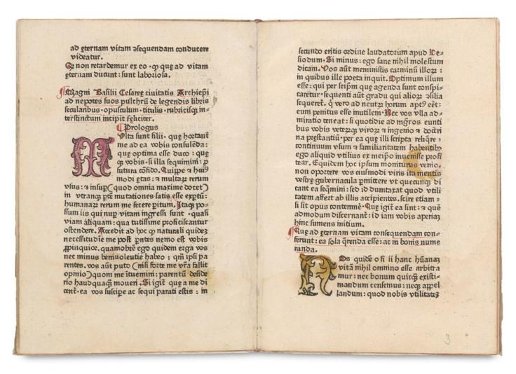

Goff B274; HC 2689*; Amelung, Frühdruck I 31; Pell 1997; CIBN B-179; Coq 69; Zehnacker 375; Voull(B) 2615,10; Bod-inc B-130; Sheppard 1813; Pr 2519; BMC II 525; BSB-Ink B-228; GW 3706. https://data.cerl.org/istc/ib00274000

ISTC records one US Copy: University of Michigan Ann Arbor .

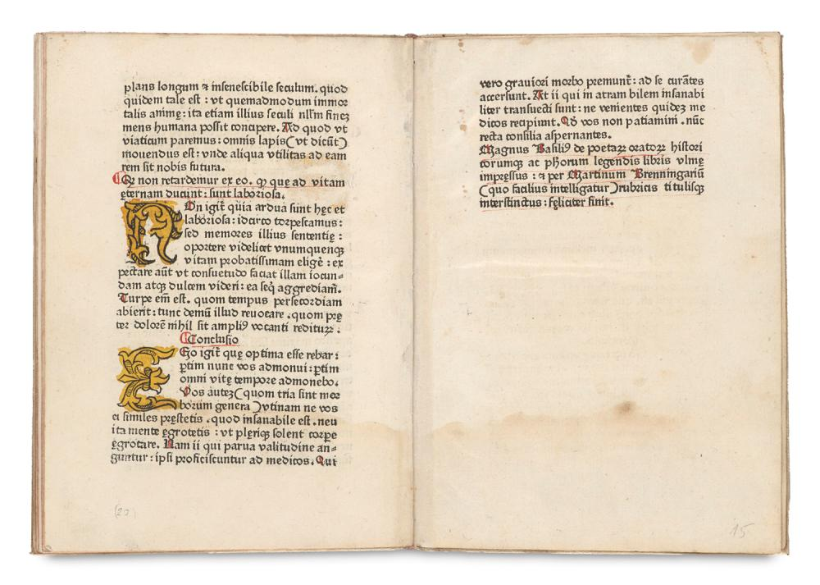
284J Aristotle , –Gualtherus Burlaeus. (Walter Burley (c. 1275–1344/5 ))

4

284J Aristotle , –Gualtherus Burlaeus. (Walter Burley (c. 1275–1344/5 ))

Expositio Gualteri Burlei super decem Libros Ethicorum Aristotelis (Contains the text of Robert Grosseteste’s translation of the Nicomachean Ethics)
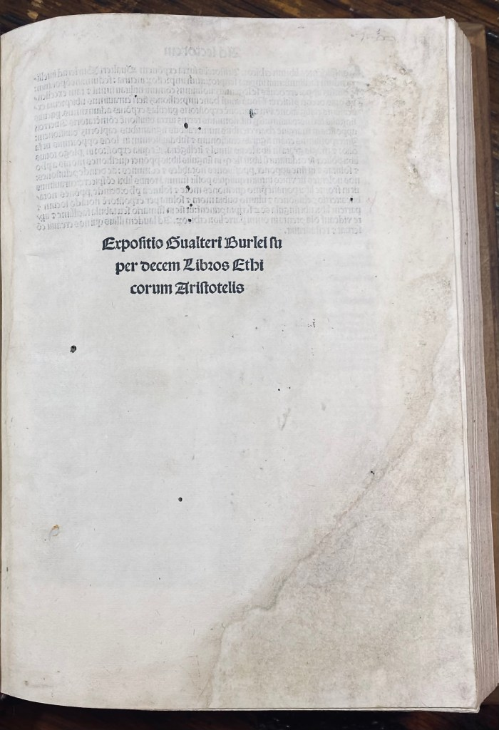
Venice: Simon de Luere for Andreas Torresanus, 4 September 1500 Price $11,500

Folio, 12 1/4 X 8 1/2 in. A⁸ a⁶b-x⁸ y¹⁰. Second edition after the first of 1481.
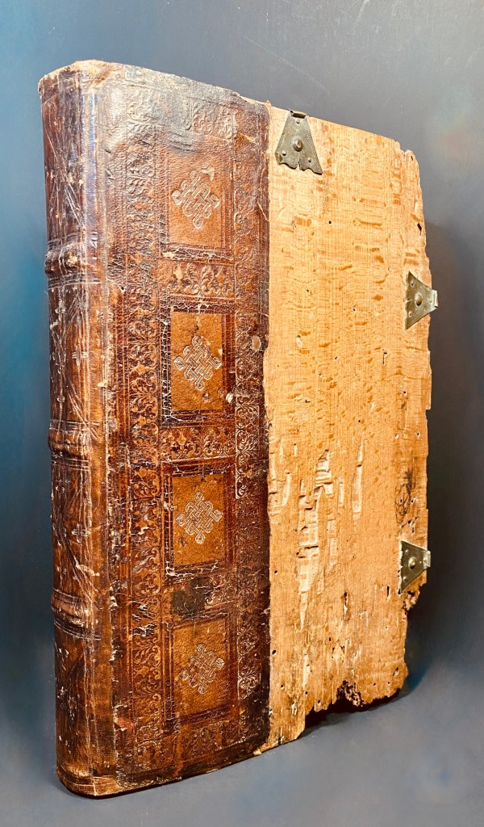

This copy is bound in contemporary 1/4 blind-tooled goatskin over wooden boards with 3 (of 4) metal catches on front cover, rebacked retaining most of original backstrip, conspicuous termite damage on front cover, rear cover replaced with modern board, endpapers renewed; contents washed with residual soiling on opening leaves, worming through much of volume generally not impairing legibility, crude restoration in blank margins at beginning and end .
Ethica Nicomachea, Books 1-10, in the Latin translation of Robertus Grosseteste( 1175-1253) , incipit “[O]Mnis ars et om[n]is doctrina similiter aut[em] [et] actus [et] electio bonum quodda[m] ap=pete[re] videt[ur]. J[de]o b[e]n[e] enunciaueru[n]t bonu[m] q[uo]d omnia appetu[n]t”, b1r-y9v; colophon (Venetijs impresse arte Simonis de Leure: impensis v[ir]o domini Andree Torresani de Asula. Anno M.D. die v[er]o, IIIJ. Septebris.,), y10r; printer’s register, y10r. Wood cut diagrams.
Walter Burley, was one of the most prominent logicians and metaphysicians of the Middle Ages “The first Latin translations of Aristotle’s Nicomachean Ethics, the Ethica vetus and the Ethica nova, are the object of six commentaries from the first half of the thirteenth century, presumably written by Parisian arts masters. Typical for these early commentaries is the interpretation of Aristotle’s doctrine in the light of Christian religion. In 1246/1248, Robert Grosseteste achieved a complete translation of the Nicomachean Ethics. The first to write commentaries on it were Albert the Great (twice) and Thomas Aquinas. Both attempted to interpret Aristotle philosophically; the extent to which Aquinas nevertheless admitted theological views is disputed in scholarship. The commentary of Aquinas was a major source for many other commentaries of the late thirteenth and early fourteenth centuries. Long before the Renaissance recovery of Greek learning, the foundations of Aristotelian philosophy in England were laid at Oxford by a remarkable generation of scholars. Among them, Robert Grosseteste, Bishop of Lincoln, produced the first complete Latin translation of Aristotle's Nicomachean Ethics, while Walter Burley, one of the most influential English philosophers of the fourteenth century, transformed that text into a practical instrument of university teaching. Together they helped establish Aristotle's moral philosophy at the center of English intellectual life.
This edition preserves that distinctly English tradition. Although printed in Venice in 1500 by the great publisher Andrea Torresani, the text itself represents the mature product of Oxford scholarship: Aristotle's Ethics in Grosseteste's translation accompanied by Burley's exposition. For generations of students, Burley's commentary served as a guide to the study of ethics, political life, virtue, and human happiness. Through works such as this, Aristotle ceased to be merely an ancient authority and became an integral part of the curriculum that shaped English clerics, scholars, administrators, and teachers.
The volume thus stands at a pivotal point in the history of ideas. It links classical Greece to medieval Oxford and carries that tradition forward into the age of print. Few books illustrate more clearly how Aristotle was absorbed into the intellectual culture of England and transmitted through the university system that would influence education throughout the English-speaking world.
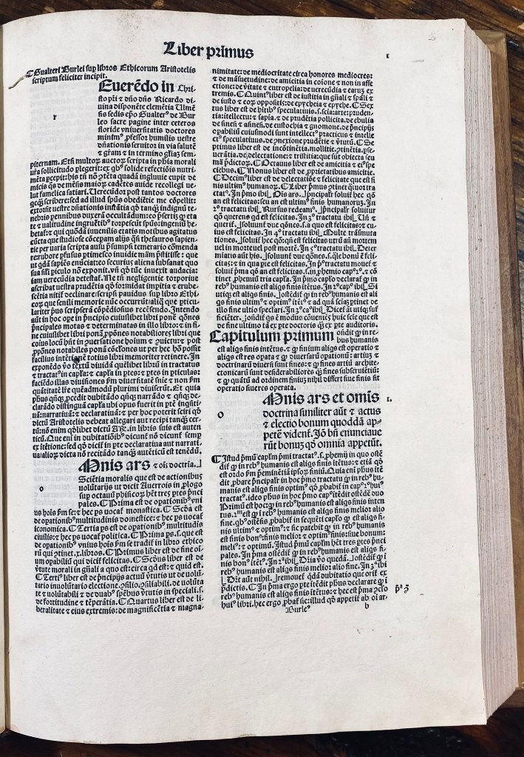
Goff; b-1301 ; BMC 15th cent.,; v, 576 (ib. 24667); GW; 5779; ; Hain-Copinger; *4144; Harman, m. incunabula in the University of illinois library at urbana-champaign (1979); 191; ISTC (online); ib01301000; Proctor; 5269; Pellechet; 3080 lines df (2002)
https://data.cerl.org/istc/ib01301000
Locations: Boston Public Library
The Newberry Library
Free Library of Philadelphia
University of Illinois

For the first edition 1481 (Goff 1300) 2 Locations: Harvard University, St. Bonaventure University, Franciscan Institute, Holy Name Library.
Aristotle’s ethics in the italian renaissance (ca. 1300–1650): the universities and the problem of moral education. Brill, Leiden
Iacopo Costa. The Ethics of Walter Burley. Alessandro D. Conti. A Companion to Walter Burley. Late Medieval Logician and Metaphysician, A Companion to Walter Burley : Late Medieval Logician and Metaphysician, pp.321-346, 2013, Brill’s Companions to the Christian Tradition, ISSN : 1871-6377 ; 41. ⟨halshs-00843864⟩
Conti, Alessandro, “Walter Burley”, The Stanford Encyclopedia of Philosophy (Summer 2016 Edition), Edward N. Zalta (ed.), URL = <https://plato.stanford.edu/archives/sum2016/entries/burley/&gt;.
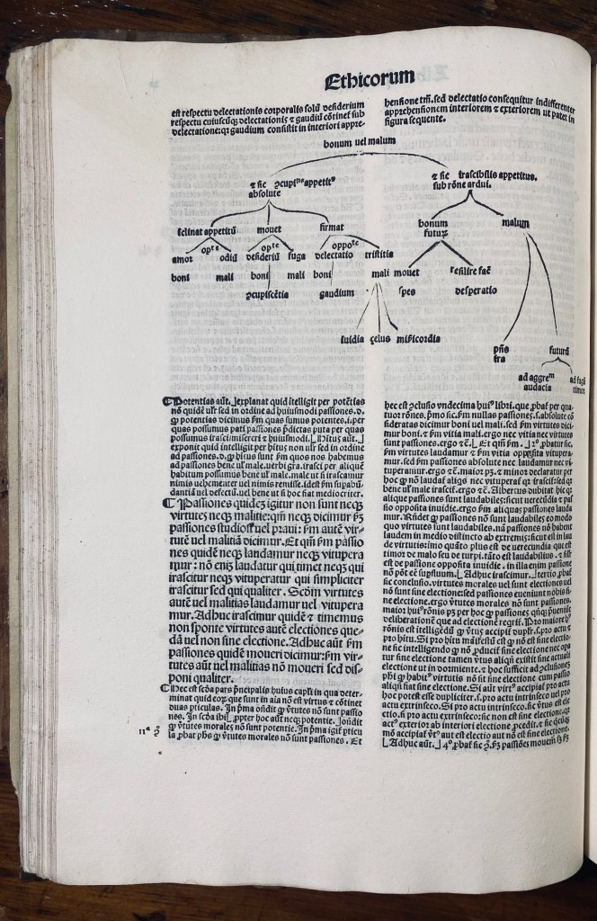
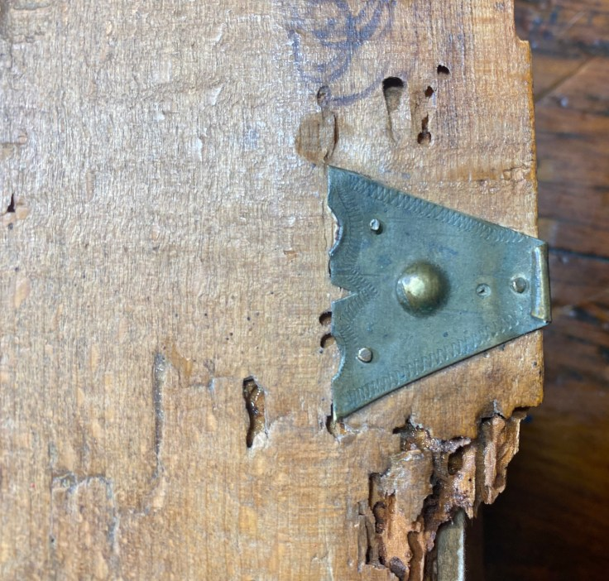

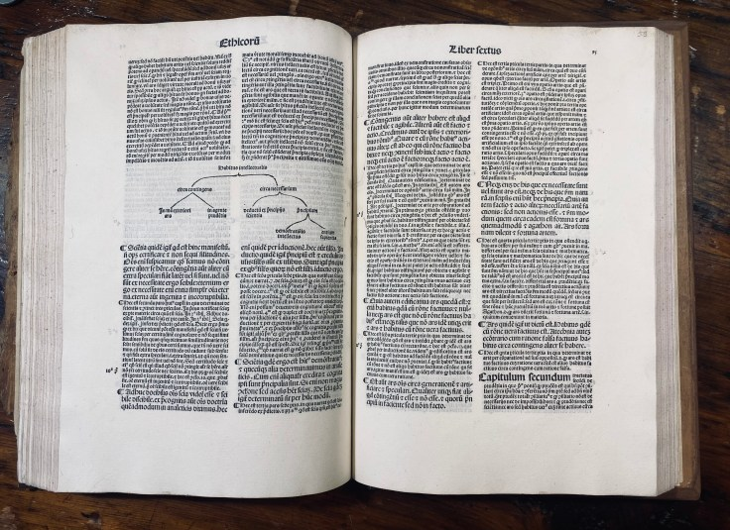

5) 453J Diogenes Lærtius , (Tr: Ambrosius Traversarius 1386-1439.)

Diogenis lærtii historiographi de philosophorum vita decem per q[uam] fecundi libri ad bene beateq[ue] viuendu[m] co[m]motiui.
Paris : Guy or Jean Marchant, for Jean Petit, [about 1509]. {Venundantur Parisius in vico Diui Iacobi apud Leonem Argenteum. : Price: $3,600
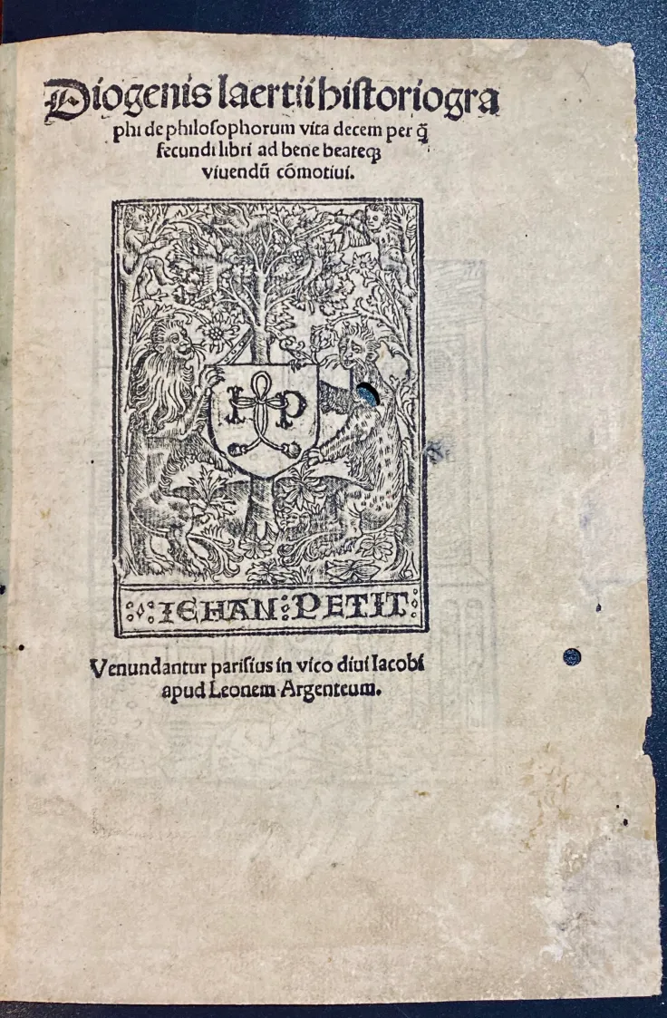
Quarto. 20 x 14.5 cm. Signatures: A⁸, a-y^{8/4}, z⁶ .Portrait of a weary philosopher at his writing table on verso of title page.(see back cover of this catalogue. Charming woodcut on last page (Marchant’s device). Some nice woodcut initials. Marginal annotations and underlinings. Wormholes. Modern binding in ¾ calf, marbled boards, marbles end leaves. With the Ex libris of Jos Nève. Lærtius divides all the Greek philosophers into two classes: those of the Ionic and those of the Italic school. He derives the first from Anaximander, the second from Pythagoras. After Socrates, he divides the Ionian philosophers into three branches: (a) Plato and the Academics, down to Clitomachus; (b) the Cynics, down to Chrysippus; (c) Aristotle and Theophrastus. The series of Italic philosophers consists, after Pythagoras, of the following: Telanges, Xenophanes, Parmenides, Zeno of Elea, Leucippus, Democritus, and others down to Epicurus. The first seven books are devoted to the Ionic philosophers; the last three treat the Italic school.
The work of Diogenes is a crude contribution towards the history of philosophy. It contains a brief account of the lives, doctrines, and sayings of most persons who have been called philosophers; and though the author is limited in his philosophical abilities and assessment of the various schools, the book is valuable as a collection of facts, which we could not have learned from any other source, and is entertaining as a sort of pot-pourri on the subject. Diogenes also includes samples of his own wretched poetry about the philosophers he discusses. Diogenes is generally as reliable as whatever source he happens to be copying from at that moment. Especially when Diogenes is setting down amusing or scandalous stories about the lives and deaths of various philosophers which are supposed to serve as fitting illustrations of their thought, the reader should be wary. The article on Epicurus, however, is quite valuable, since it contains some original letters of that philosopher, which comprise a summary of the Epicurean doctrines. IEP

https://data.cerl.org/istc/id00226000 GW VII Sp.436a
Goff D226; H 6197?; Moreau ICP vol I p.317 nº68; Günt(L) 2256; Walsh 3631b; BMC(Fr) p.135; BM STC (F) S. 135; Renouard (M) Iehan Petit 833; Renouard (M) Jean Marchant 708) § Jean Petit’s 4th device on t.p.; Guy Marchant’s device (Silvestre 39) IA,; 153.795;).


Holdings
AustriaKlagenfurt, Archiv der Diözese Gurk, Bischöfliche Gurker Mensalbibliothek
FranceMoulins, Médiathèque Samuel Paty,Orléans, La Médiathèque Poitiers, Médiathèque François Mitterrand,GermanyDarmstadt, Universitäts und Landesbibliothek (Inc-II-205)
Leipzig, Universitätsbibliothek,München, Universitätsbibliothek (4 Inc.lat. 983)
München, Bayerische Staatsbibliothek (2), HungaryPannonhalma, Főapátsági Könyvtár / Bibliotheca Archiabbatiae Ordinis S. Benedicti de Sacro Monte Pannoniae
United Kingdom of Great Britain and Northern IrelandLondon, British Library (9039.e.16(3))
United States of America
Cambridge, MA, Harvard University, Radcliffe Institute for Advanced Study, Schlesinger Library. Number of holding institutions. 11

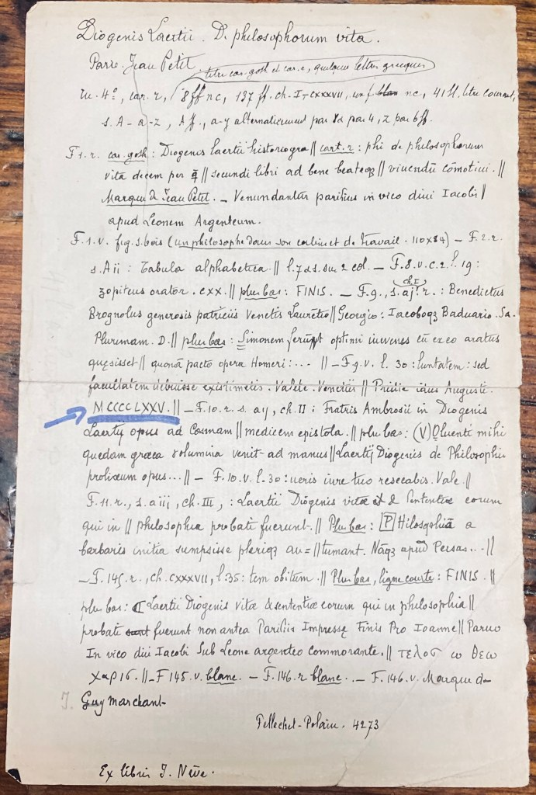
6

753J Duns Scotus, (c.1265-1308) An Annotated edition of commentary on book IV of Lombard 1476
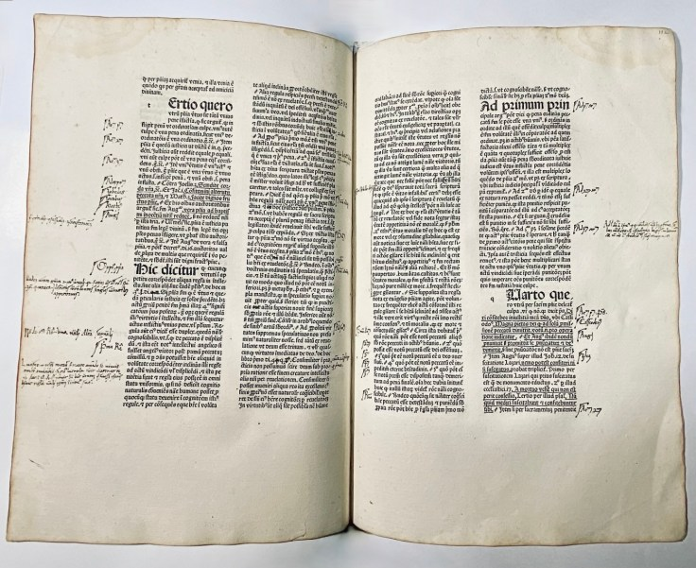
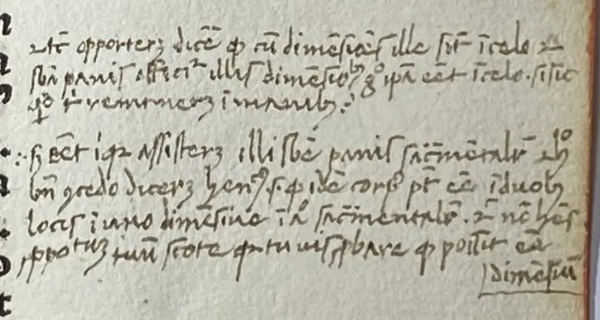

753J — John Duns Scotus (c.1265–1308)

Quaestiones in quattuor libros Sententiarum Petri Lombardi
Edited by Thomas Penketh and Bartholomaeus Bellatus. Part IV only.
Venice: Johannes de Colonia, 1476 (before 3 October 1477).
Price: $9,900

Folio (28 × 20 cm). Collation: a–g¹⁰ h–i⁸ k–o¹⁰ p–q⁸ r–z¹⁰. 240 leaves. Bound in later but early vellum, recently re-backed. The first few leaves (including the first leaf) lightly dusty and slightly stained; the remaining leaves exceptionally clean and fresh. A large-margined copy.
Extensively annotated throughout by a near-contemporary scholastic reader in a 15th-century Gothic cursive, with sustained academic marginalia reflecting active use in a Scotist curriculum. The annotations mark objections and responses, reject false inferences, and articulate doctrinal positions on free will, sin, grace, and Eucharistic presence. Several extended marginal arguments address the non-dimensional, non-local presence of Christ in the Eucharist and the formal rooting of sin in the will rather than in external act—features characteristic of advanced late-medieval Franciscan teaching within a university studium.
This volume contains Book IV of Peter Lombard’s Sententiarum libri quattuor, the portion devoted primarily to the sacraments and the “last things.” Of its fifty distinctions, Book IV treats baptism (2–6), confirmation (7), the Eucharist (8–13), penance (14–22), extreme unction (23), holy orders (24–25), and marriage (26–42), concluding with discussions of resurrection, judgment, and eternity. Penance and the Eucharist—both heavily annotated here—were among the most intensely debated topics in late-medieval theology.
John Duns Scotus, the Franciscan “Doctor Subtilis,” lectured extensively on Lombard’s Sentences at Oxford and Paris, and his commentary became one of the most influential theological works of the later Middle Ages. While the commentary survives in numerous medieval manuscripts, it was also widely printed in the final decades of the fifteenth century. The present volume—issued separately from the other three parts—preserves unusually clear evidence of university-level engagement with Scotist theology now of its early transmission into print.
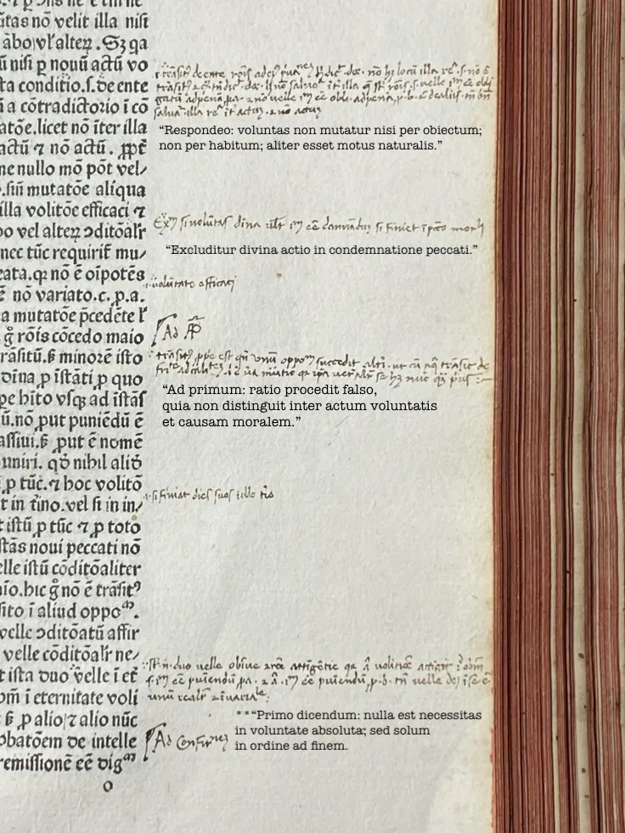

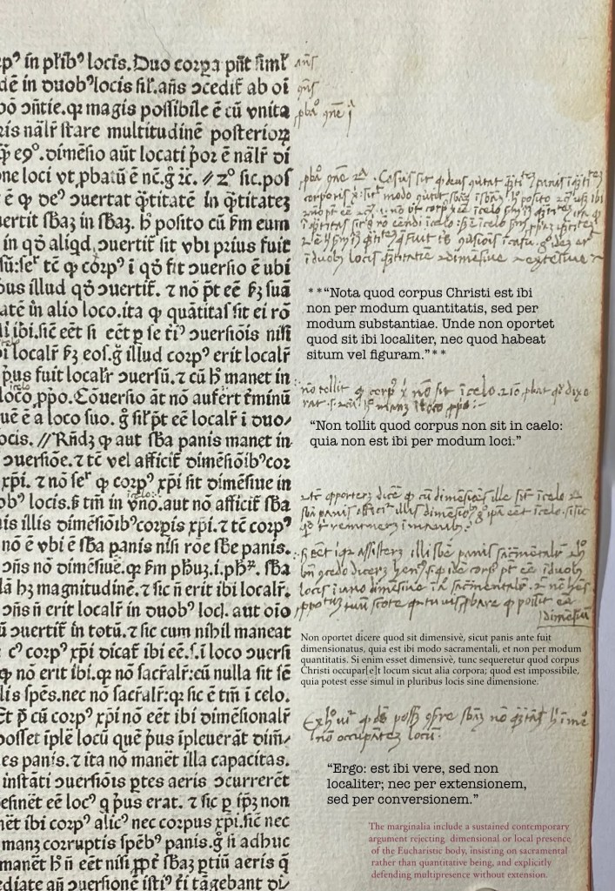
“The first question raised in the Prologue to John Duns Scotus’s Commentary on the Sentences of Peter Lombard is “Whether it is Necessary for Man in His Present State To Be Supernaturally inspired with some doctrine.” Scotus’s answer is “Yes,” but only after a discussion of several important epistemological issues connected to understanding and faith.” [Mann, William E.(1992) “Duns Scotus, Demonstration, and Doctrine,” Faith and Philosophy: Journal of the Society of Christian Philosophers: Vol. 9: Iss. 4 , Article 2.]
Duns Scotus’s commentary was based upon his University lectures; but there is controversity around this because no manuscripts exist at Oxford, which has manuscript evidence for lectures on the other three books.
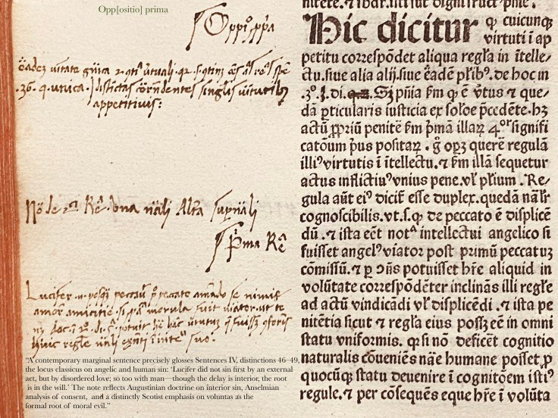
ISTC: https://data.cerl.org/istc/id00379000
Goff D379; HC 6416*; C 2124 (I); Pell 4451; CIBN D-256; Hillard 753; Girard 174; Lefèvre 163; Parguez 392; Péligry 314; Richard 199; Castan(Besançon) 401; Polain(B) 1353 (II,III); IDL 1638; IBE 2197; IGI 3598; IBP 1993; SI 1398; Sajó-Soltész 1211; IBPort 619; Martín Abad D-76; Mendes 442, 443, 444, 445, 446, 447; Madsen 1459 (IV); Lőkkös(Cat BPU) 175; Voull(Trier) 1862 (II); Voull(B) 3747 (III), 3751 (I), 3752 (II); Ohly-Sack 1052; Sack(Freiburg) 1300; Walsh 1693, 1694; Oates 1721 (IV)

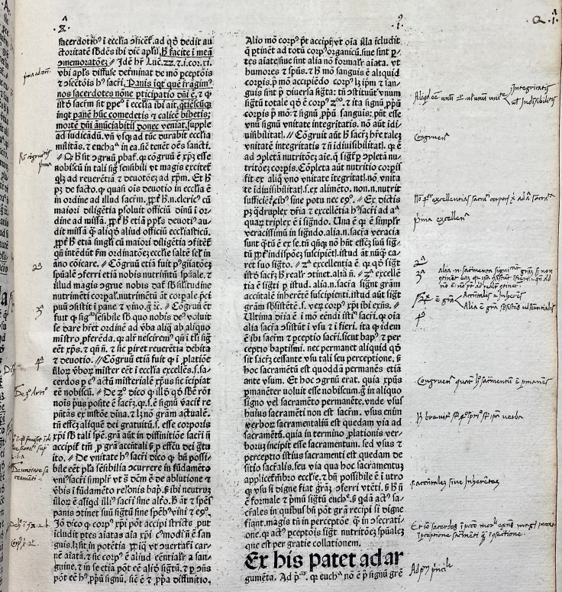
7

Eusebius: (La vita el transito) 1487

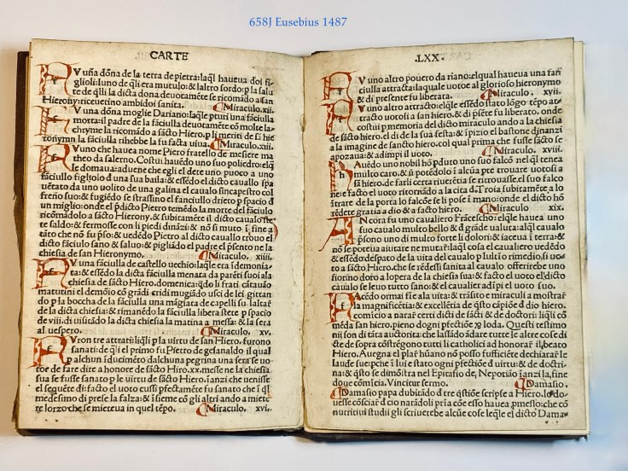
Two North American copies.

658J. Eusebius -(275-339)
(La vita el transito) Eusebius Cremonensis: Epistola de morte Hieronymi; Aurelius, Augustinus, S: Epistola de magnificentiis Hieronymi; Cyrillus: De Miraculis Hieronymi).
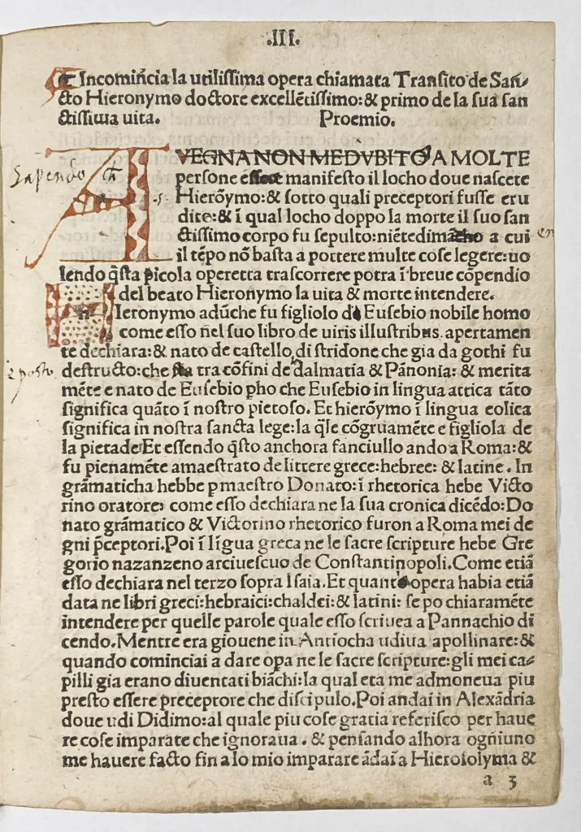
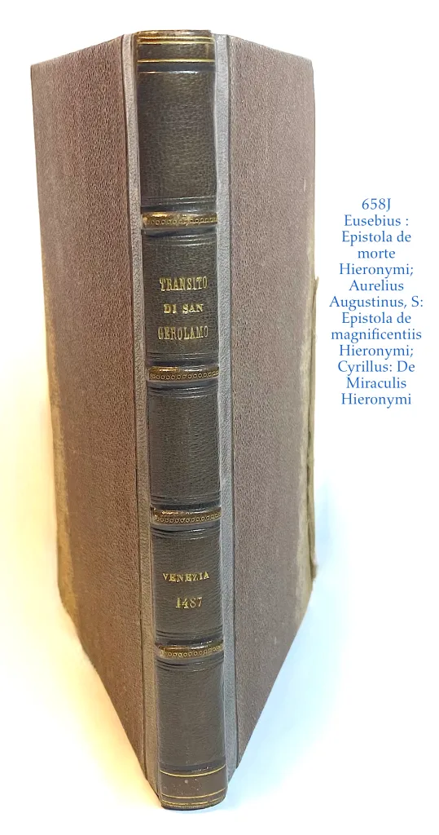
[Venice, Hannibal Foxius, 1 June 1487]. $7,000

Octavo 16.7x12cm. Signatures: a-i8. 72 leaves, 36 lines, Roman letter, rubricated with capital letters in red ink. Several annotations in ink and marginal notes, first leaf mounted, 5 leaves, small wormholes touching the letters on the front edge of 4 leaves, 2 intermediate margins reinforced with old paper strips, small worming marks on 4 leaves. – Bound in twentieth century quarter Morocco, with a spine label “Transito di San Gerolamo, Venetia, 1487”
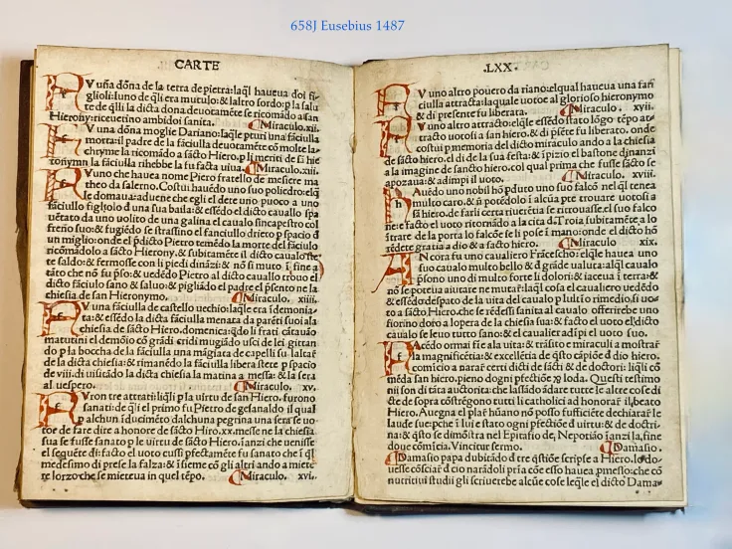

This collection of pseudonymous works are now considered to have been composed anonymously in the thirteenth or fourteenth century by Dominicans in Rome. These Epistles here attributed to three famous Bishops who were contemporaries of St Jerome Eusebius of Cremona 347-420, Augustine of Hippo 354- 430 and Cyril of Jerusalem 313-386.,

Goff H257; H 8645*; IGI 3743; Hunt 2881; Bod-inc E-060; Sheppard 4095; Pr 5014; BSB-Ink E-126; GW 9466

https://data.cerl.org/istc/ih00257000 United States of America Baltimore Two copies MD, The Walters Art Museum Library
San Marino CA, Huntington Library
8

Annotated; Letters of Marsilio Ficino 1497

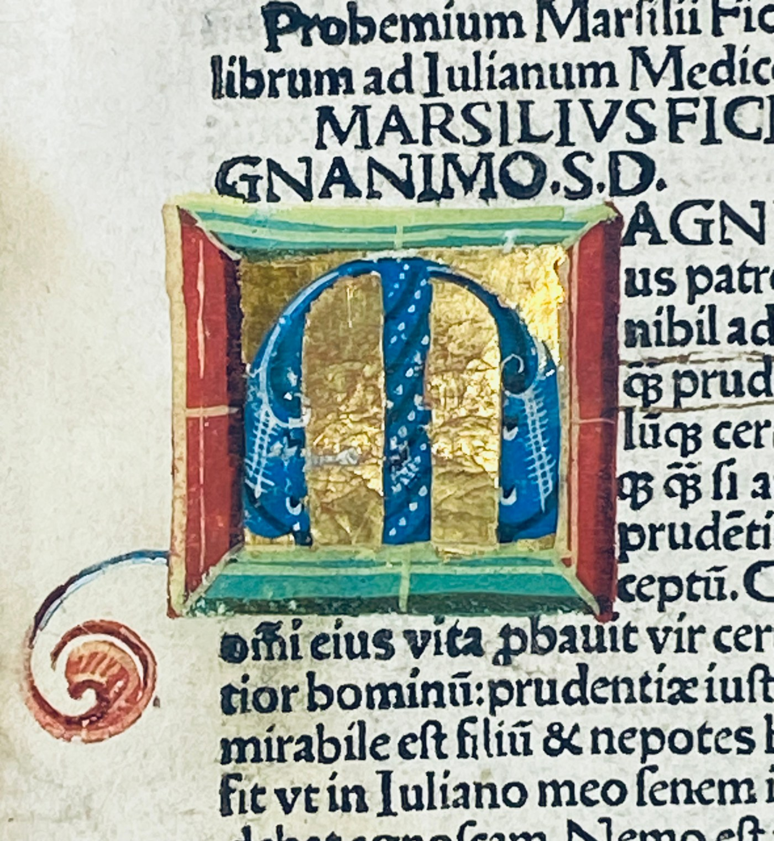

The Letters of Marsilio Ficino represent an essential core of his thought and influence as a chief architect of the Platonic and Hermetic revival, the philosophical and revelatory center of the new learning that was revamping religious vision and humanistic enquiry Italian Renaissance.
Marsilio Ficino (1433–1499), the great Florentine translator of Plato and a central figure of Renaissance humanism, left behind not only his philosophical works but also a vast correspondence. His Epistolae (Letters), first published in 1495, circulated widely and gave voice to the intellectual, spiritual, and cultural concerns of the fifteenth century.
525J Marsilio Ficino 1433-1499
Epistolae Marsilii Ficini Florentini.
[Nuremberg] : Per Antonium Koberger impræsse, 1497. Price $25,000
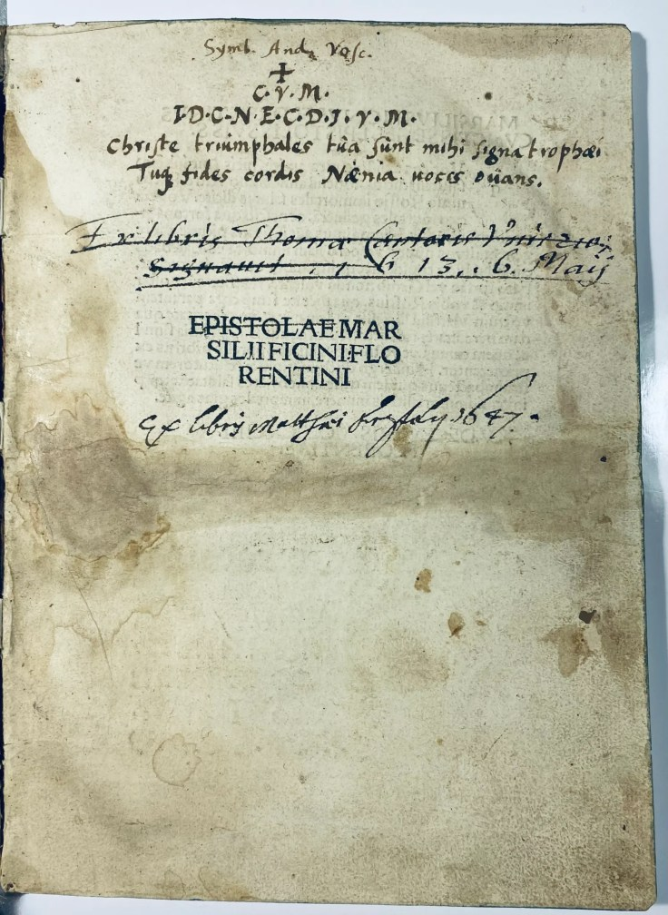
Chancery quarto 15 x 10cm. . Signatures: π¹⁰,A-Z⁸ a-g⁸ h⁴(lacking blank leaf h⁴⁾; Errors in folation: D² signed C²; G² unsigned, G⁴and G⁵ signed G³ and G⁴. Final leaf blank and wanting. Colophon reads: Marsilii Ficini Florentini eloquentissimi viri epistolae familiares per Antonium Koberger impraesse anno incarnate deitatis Mccccxcviixxiiii Februarii finiunt foeliciter./ Place of publication suggested by ISTC.
This copy is bound in seventh century, full vellum. With filled initial spaces, printed guide letters, foliation, without catchwords, The first initial letter is Illuminiated with colours on gilt background with tendrils and an arabesque on margin, red and blue initial letters. There is quite a bit of contemporary marginalia and underlining. Probably by Symb(olum) And(reae) Vasc(i / us / quez). “The motto of Andreas Vascus” (or Vascos, Vasquez, Vascensis
There is also an ownership note from the XVI century handwritten on title and crossed through. Ex libris Thoma [Cantuar?] Universit[atis] [Sigmunt?] 13. 6. Maij and finally a seventeenth century : Ex libris Matth[iae] ?? Lipsky 1647. That is a lot of names but Through all my searching I find nothing?
Restoration on foot of spine, some damp staining. This copy is better than most of the copies that I have seen in person or online.
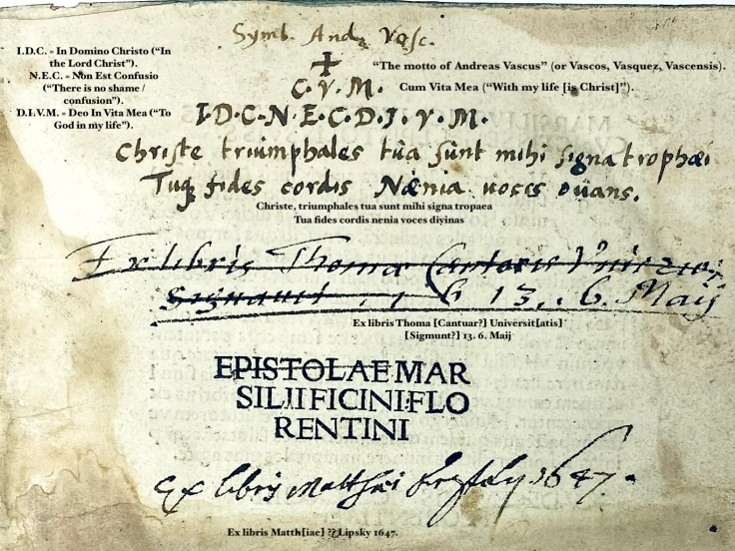
Here is my take on the title page.

I.D.C. = In Domino Christo (“In the Lord Christ”). N.E.C. = Non Est Confusio (“There is no shame / confusion”). D.I.V.M. = Deo In Vita Mea (“To God in my life”).
Christe, triumphales tua sunt mihi signa tropaea = “O Christ, your triumphal standards are my trophies.”
Tua fides cordis nenia voces divinas = “Your faith is the song of my heart, raising divine voices.”

Paul Oskar Kristeller makes clear below that the Letters of Marsilio Ficino represent an essential core of his thought and influence as a chief architect of the Platonic and Hermetic revival, the philosophical and revelatory center of the new learning that was revamping religious vision and humanistic enquiry Italian Renaissance.
Excerpt from Paul Oskar Kristeller Preface to volume 1 of the Letters of Ficino:
“The Letters occupy in fact a very important place in Ficino’s work. As historical documents, they give us a vivid picture of his personal relations with his friends and pupils, and of his own literary and scholarly activities. As pieces of literature, edited and collected by himself, the letters take their place among other correspondences of the time and are a monument of humanistic scholarship and literature. Finally, the letters are conscious vehicles of moral and philosophical teaching and often reach the dimensions of a short treatise.
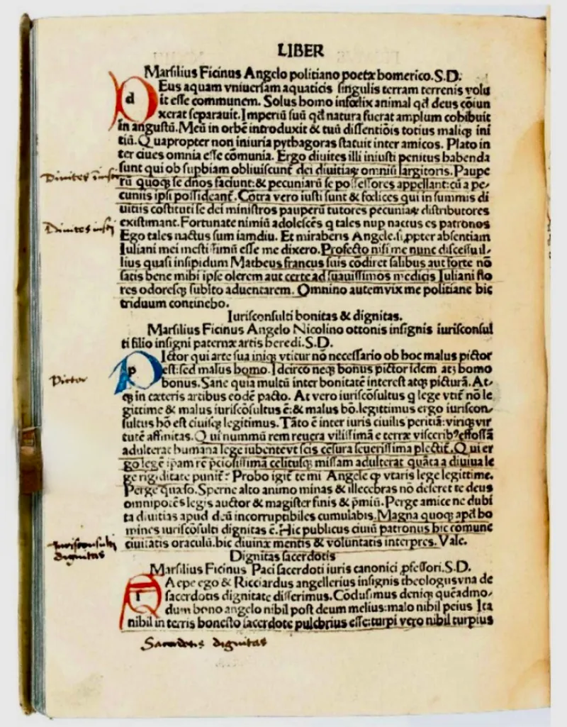
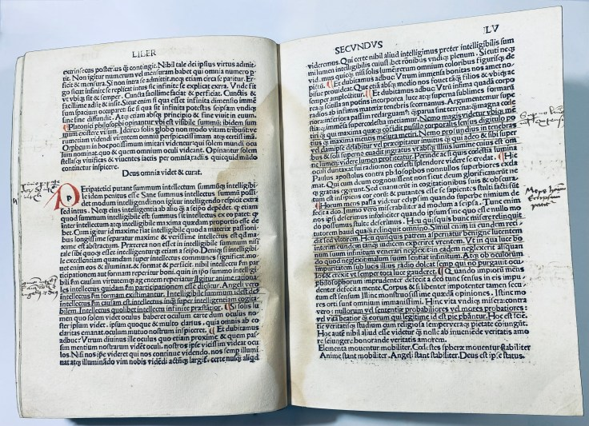
Ficino began to collect his letters in the 1470’s, gradually arranged them in twelve books, had them circulated in numerous manuscript copies, and finally had them printed in 1495. The first book contains letters written between 1457 and 1476, and its manuscript tradition is especially rich and complicated. These letters derive great interest from the time of their composition, for they were written at the same time as some of the commentaries on Plato and as the Platonic Theology, Ficino’s chief philosophical work. The correspondents include many persons of great significance: Cosimo and Lorenzo de’ Medici, and members of other prominent Florentine families, allied or hostile to the Medici at different times: Albizzi and Pazzi, Soderini and Rucellai, Salviati and Bandini, Del Nero, Benci and Canigiani, Niccolini, Martelli and Minerbetti. There are two cardinals, Francesco Piccolomini, the later Pius III, a famous patron and bibliophile, and Bessarion, the great defender of Platonism. There is Bernardo Bembo, Venetian patrician and ambassador, Giovanni Antonio Campano, bishop and humanist. Francesco Marescalchi in Ferrara, and Giovanni Aurelio Augurelli from Rimini. There are the friends of Ficino’s youth, Michele Mercati and Antonio Morali called Serafico, and his favourite friend, Giovanni Cavalcanti. There are philosophers and physicians, and there are numerous scholars, of different generations, who occupy a more or less prominent place in the annals of literature: Matteo Palmieri and Donato Acciaiuoli, Benedetto Accolti, Bartolomeo Scala and Niccolò Michelozzi, all connected with the chancery, Cristoforo Landino, Bartolomeo della Fonte and Angelo Poliziano, Francesco da Castiglione, perhaps Ficino’s teacher of Greek, and Antonio degli Agli, bishop of Fiesole and Volterra, Jacopo Bracciolini the son of Poggio, and Carlo Marsuppini, the son of the humanist chancellor of the same name, Benedetto Colucci and Lorenzo Lippi, Domenico Galletti and Francesco Tedaldi, Antonio Calderini and Andrea Cambini, Cherubino Quarquagli and Baccio Ugolini, known for their vernacular verse, and a number of Latin poets: Peregrino Agli, Alessandro Braccesi, Amerigo Corsini, Naldo Naldi and Antonio Pelotti.

This copy is extensively annotated throughout in a single contemporary hand, with marginal notes appearing on nearly every page. Rather than engaging in scholastic disputation or theological controversy, the annotator reads Ficino in a distinctly humanist manner, extracting authorities, summarizing arguments, and marking memorable sententiae. Repeatedly, the margins isolate concise moral precepts, rhetorical observations, and practical rules for conduct—on friendship, self-government, eloquence, praise and blame, prudence, and the cultivation of virtue. The annotations function as a working index to the text, transforming the printed volume into a personalized repository of useful wisdom.
What emerges is not merely evidence that the book was read, but evidence of how it was read. The consistency of the hand and method suggests a reader who worked systematically through the volume, harvesting passages for study, teaching, or future reference in the manner recommended by Renaissance humanists. Ficino's writings are treated less as abstract exercises in Platonic metaphysics than as guides to ethical self-fashioning and eloquent living. As such, the annotations offer unusually coherent testimony to the reception of Ficino in practice, preserving a rare record of a humanist reader actively organizing, digesting, and appropriating the text for his own intellectual formation.

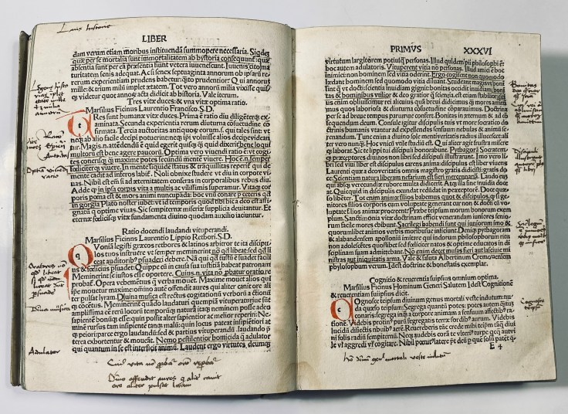
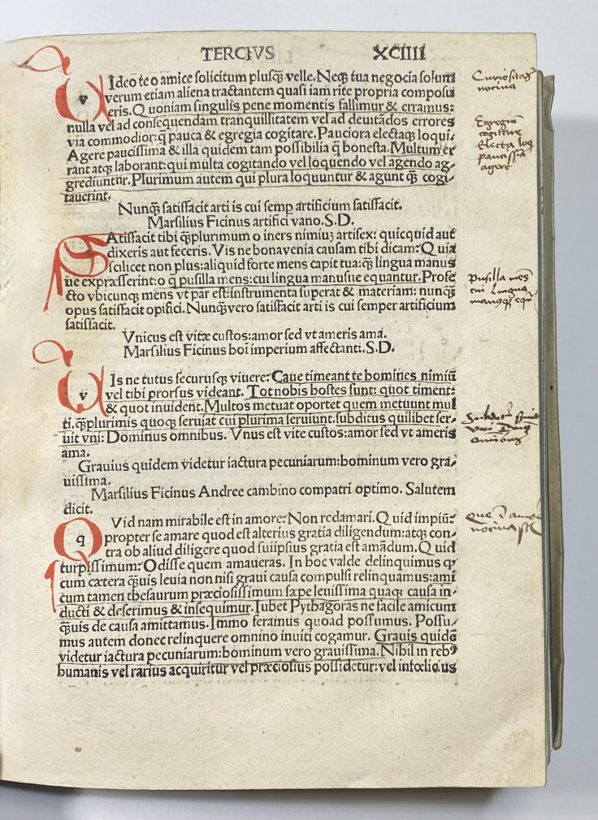
ISTC,; if00155000; GW; 9874; Goff; F-155; IGI,; 3864; BM 15th cent.,; II, 443; BSB-Ink,; F-120 Walsh
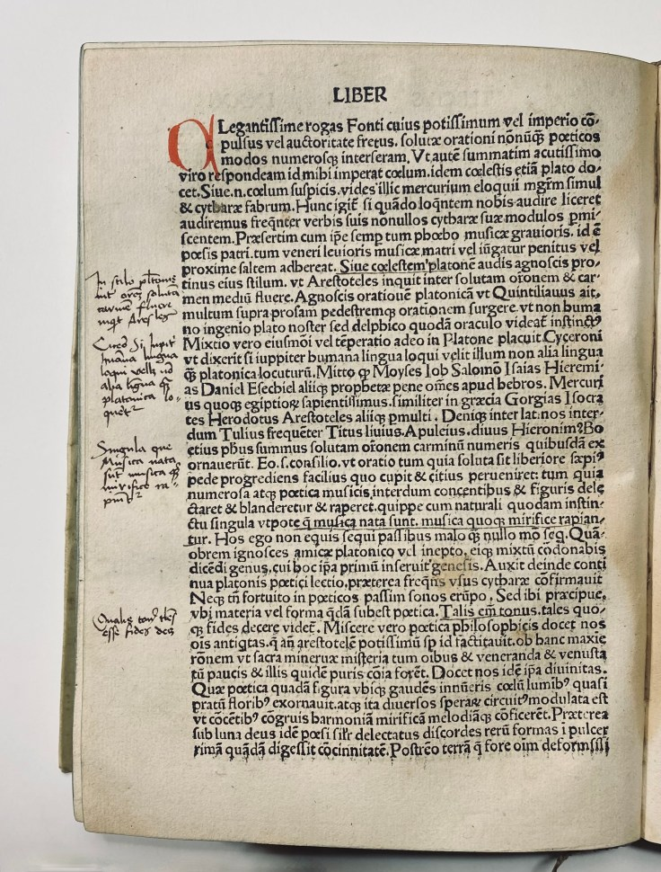
- Locations : if you are not on this list you might want to be! Just contact me.
- Boston Public Library
- Harvard Library, Countway (2)
- Bryn Mawr
- Claremont Colleges
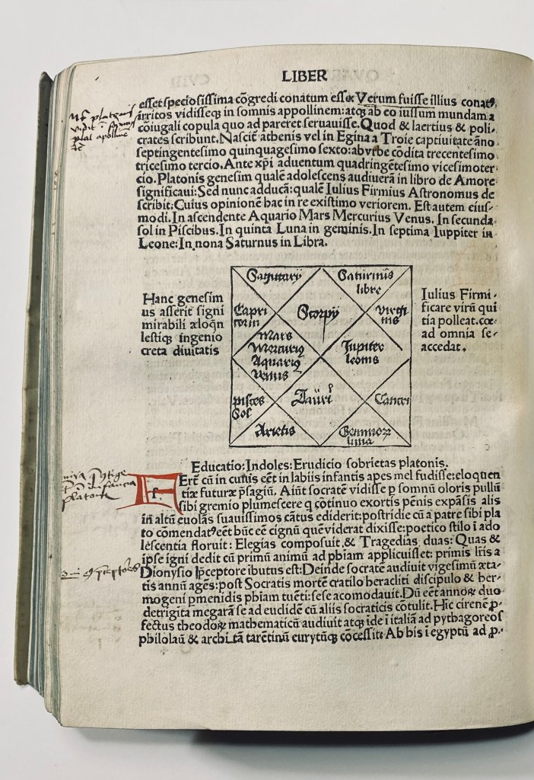
- College of Physicians of Philadelphia
- Cornell Univ.
- Free Library of Philadelphia
- Library of Congress,
- Columbia University,
- The Morgan Library
- Pennsylvania State Univ.
- Sacramento Public
- Smithsonian Institution,
- Stanford Univ.
- Newberry Library
- Univ. of California,
- Univ. of Chicago
- Univ. of Florida
- Univ. of Kansas,
- Univ. of Michigan,
- Univ. of North Carolina Library
- Yale University.
- University of Toronto

¹Marsilio Ficino as a Man of Letters and the Glosses Attributed to Him in the Caetani Codex of Dante, Paul Oskar Kristeller. Renaissance Quarterly Vol. 36, No. 1 (Spring, 1983), pp. 1-47

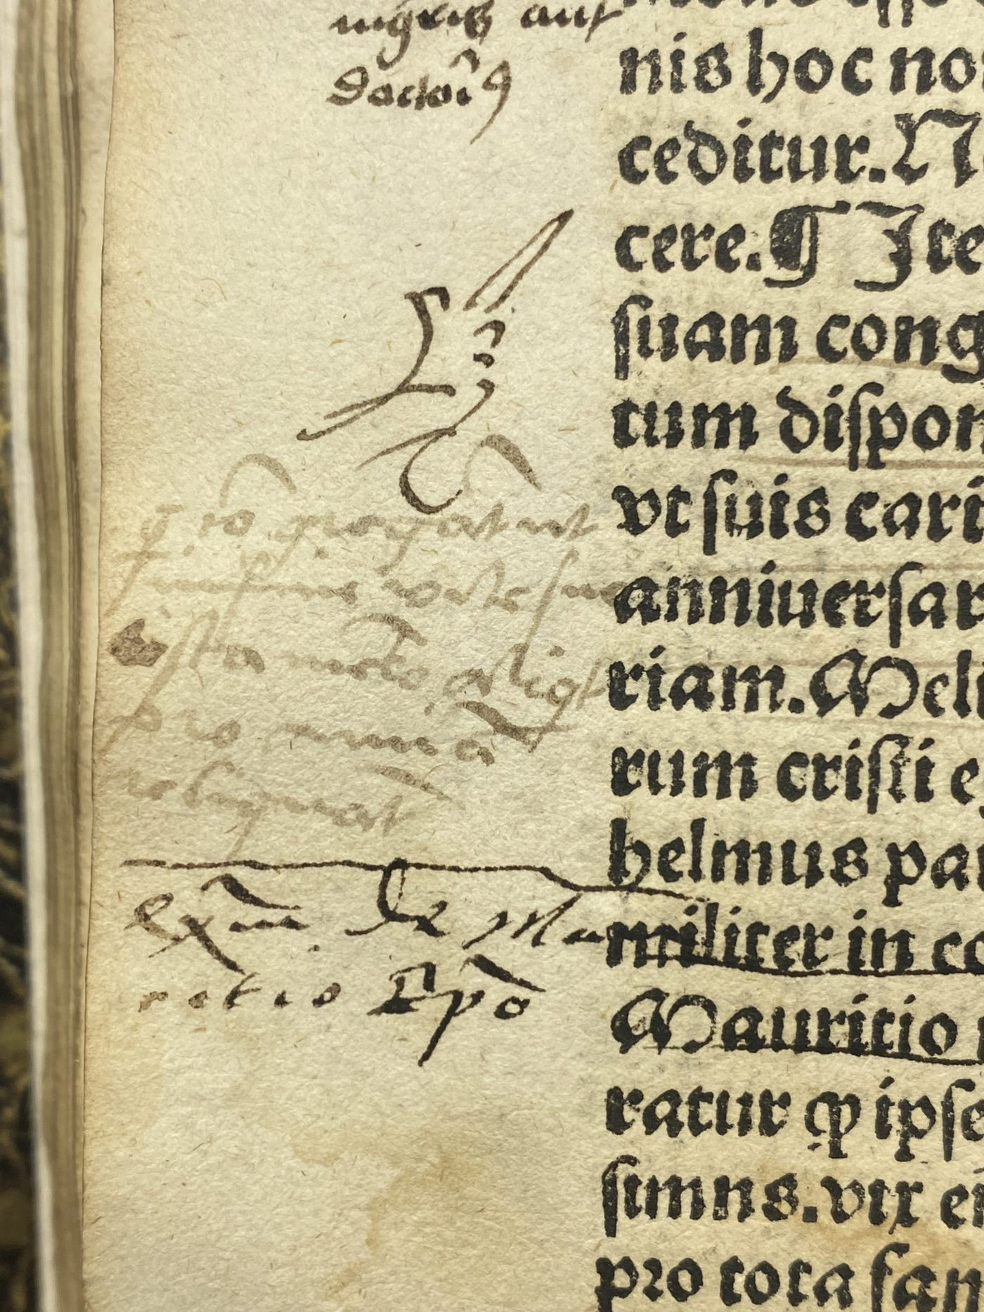
9

448J. Jacobus de Gruytrode
Lavacrum conciencie [sic] omnibus sacerdotibus perutile

Lyptzck [Leipzig] : Gregor Böttiger, 1495. Price $9,900

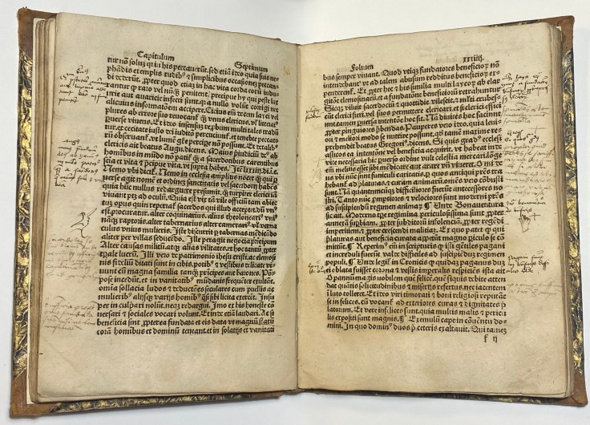
Quarto 12 x 9 cm. Signatures: a⁸ b-p⁶ q⁸.[Errors in foliation: lxxxviiii-xcviii foliated xc-xcviiii, with xc as cxi, xciiii as cxv] Blank initial spaces. Bound in half leather of the 19th century, with quite a bit contemporary marginalia.
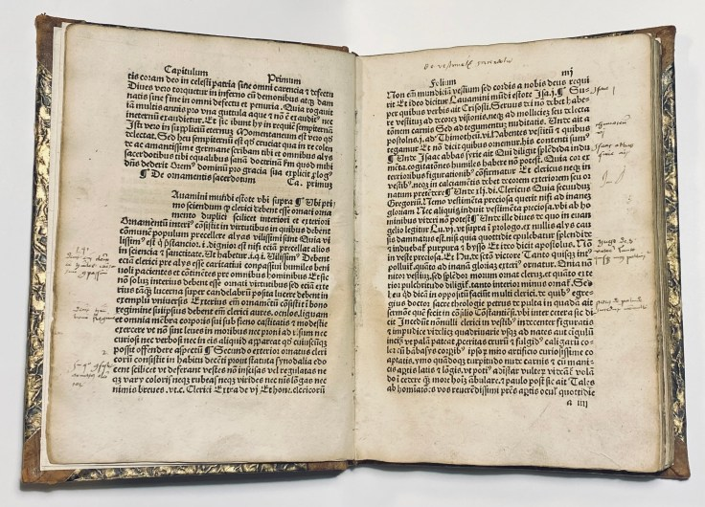
This “Soap of the Conscience” is filled with morally instructive stories intended to keep priests faithful to their vows and safe from worldly temptations, lest they suffer the “harshest punishments” of hell. In this work he tries in numerous moral and instructive stories to prove the nullity of worldly joys.
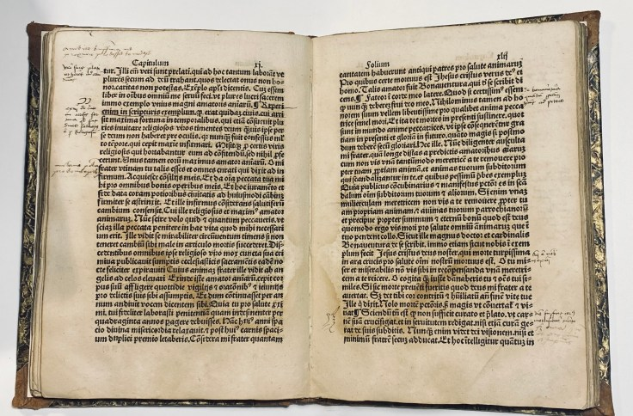
Born in Gruitrode ca. 1400-10, Jacobus van Eertwach was a Carthusian monk who served as an abbot of the prior of the Liege from 1440 until his death in 1475, during which time he produced numerous works of spiritual guidance for both clergy and laypersons. This treatise against immorality, especially the priests, which was first published in Nuremberg around 1488 and was attributed to Charterhouse, who died in 1482, with short stories and some German proverbs (e.g. on page XIIIv On women and on “wein mag nyemant frolich gesein “
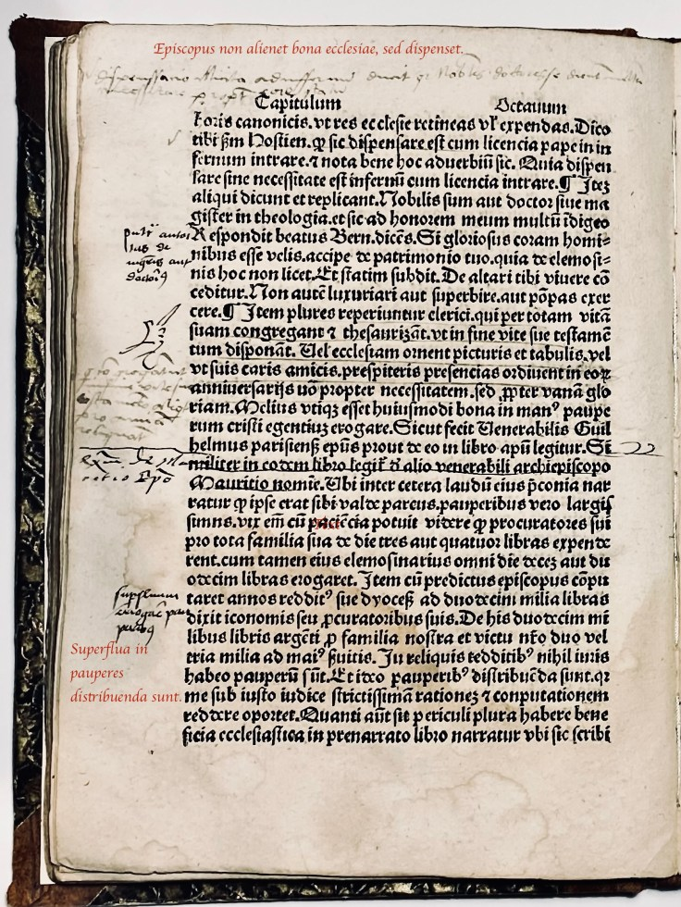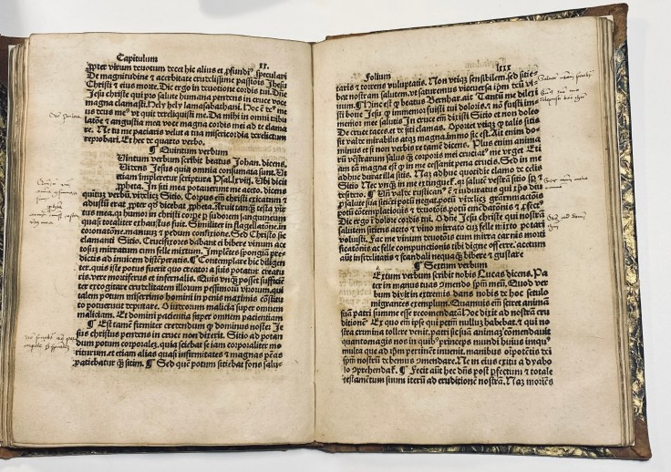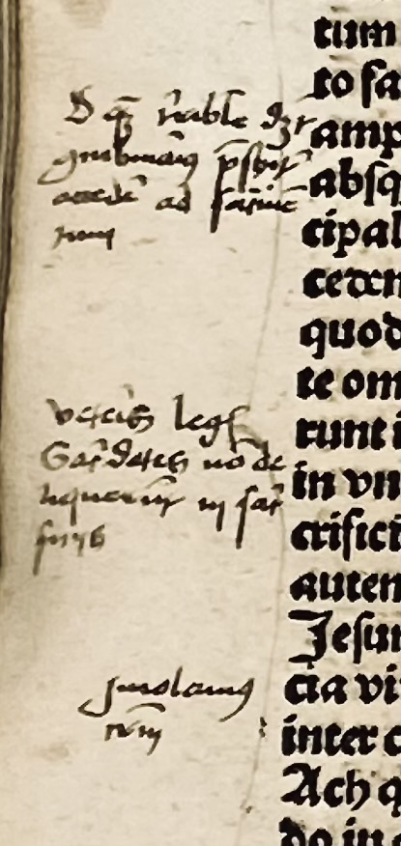
Although today the work is generally attributed to the Carthusian monk of German origin, Jacob von Gruytrode. According to Theodor Petreius, Bibliotheca Cartusiana (Cologne, 1609), the actual author is Johannes Meskirchius (Messkirch, d. 1511), a monk at the charterhouse of Güterstein near Stuttgart (for Messkirch see R. Deigendesch, ‘Bücher und ihre Schenker – Die Bücherlisten der Kartause Güterstein in Württemberg’, in S. Lorenz, ed., Bücher, Bibliotheken und Schriftkultur der Kartäuser. Festgabe zum 65. Geburtstag von Edward Potkowski, Stuttgart 2002, pp. 93-115. BMC assigns authorship to Jacobus de Gruytrode

ISTC il00099000 Goff L99; IBP 3382; Madsen 2157; Voull(B) 1383; Günt(L) 1205; Hubay(Würzburg) 1187; Pad-Ink 375; Wilhelmi 387; BSB-Ink L-71.050; GW 1388;
Not in Hain, BMC, STC et c.
Two US Copies :
Library of Congress and U Cal Law. library. https://data.cerl.org/istc/il00099000

10

882J Jacobus de Gruytrode (c. 1400/1410–1482)
Lauacrum conscientie
Augsburg, Anton Sorg, 1492. Price $6,000
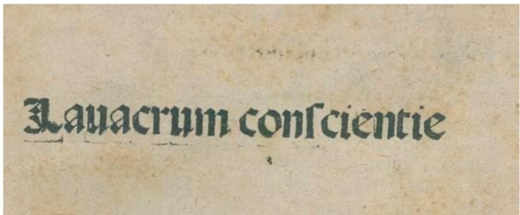
Quarto 13.5 x 18 cm. , Signatures a–m⁸[n²].98 leaves. Bound in blind-stamped Morocco binding in the contemporary style. 4 raised bands with beveled cover edges and gold-stamped title.
Today, the work is generally attributed to the Carthusian monk of German origin, Jacob von Gruytrode. He was prior of the Carthusian monastery near Liège and died in 1482 (cf. ADB X, 71). In this work, he attempts to prove the futility of worldly pleasures through numerous moral and instructive stories. The first two leaves have been trimmed in the lower corner, the title refolded. lightly browned, some with partially faded handwritten marginalia, unevenly trimmed, spine joints brittle, capitals slightly worn.
The Lavacrum conscientiae exemplifies the late-medieval conviction that the priest’s conscience, kept pure by sacramental confession and discipline, was the cleansing bath of the whole Church. In a macro sense, it is a text about washing the ecclesial body. For the Reformers, however, such manuals were the very problem: they embodied the clerical system that chained consciences instead of cleansing them. Thus the Lavacrum stands at a hinge-point—an emblem of purification to one side, an emblem of corruption to the other.
Goff L98; H 9958*; Pell Ms 6442 (6418); Neveu 383; Polain(B) 2175; Kotvan 677; Sajó-Soltész 1811; Gspan-Badalić 409; CCIR J-2; SI 2386; Sallander 2262; Coll(S) 1274; Madsen 2154; Šimáková-Vrchotka 1193; Ernst(Hildesheim) I,I 278; Voull(B) 158; Hubay(Augsburg) 1139; Hubay(Eichstätt) 536; Pr 1721; BMC II 356; BSB-Ink L-71; GW 13878
https://data.cerl.org/istc/il00098000
United States of America: Chapel Hill NC, University of North Carolina, Wilson Library
Chicago IL, The Newberry Library
Dallas TX, Southern Methodist University, Bridwell Library
Evanston IL, Northwestern University, McCormick Library
Minneapolis MN, University of Minnesota, University Libraries
Northridge CA, California State University, CSUN Library
Philadelphia PA, Free Library of Philadelphia, Copinger-Widener Collection
Pullman WA, Washington State University, Terrell Library
San Marino CA, Huntington Library

11

Two Incunabula bound together. One Very Rare, printed at Vienne by Eberhard Frommolt.

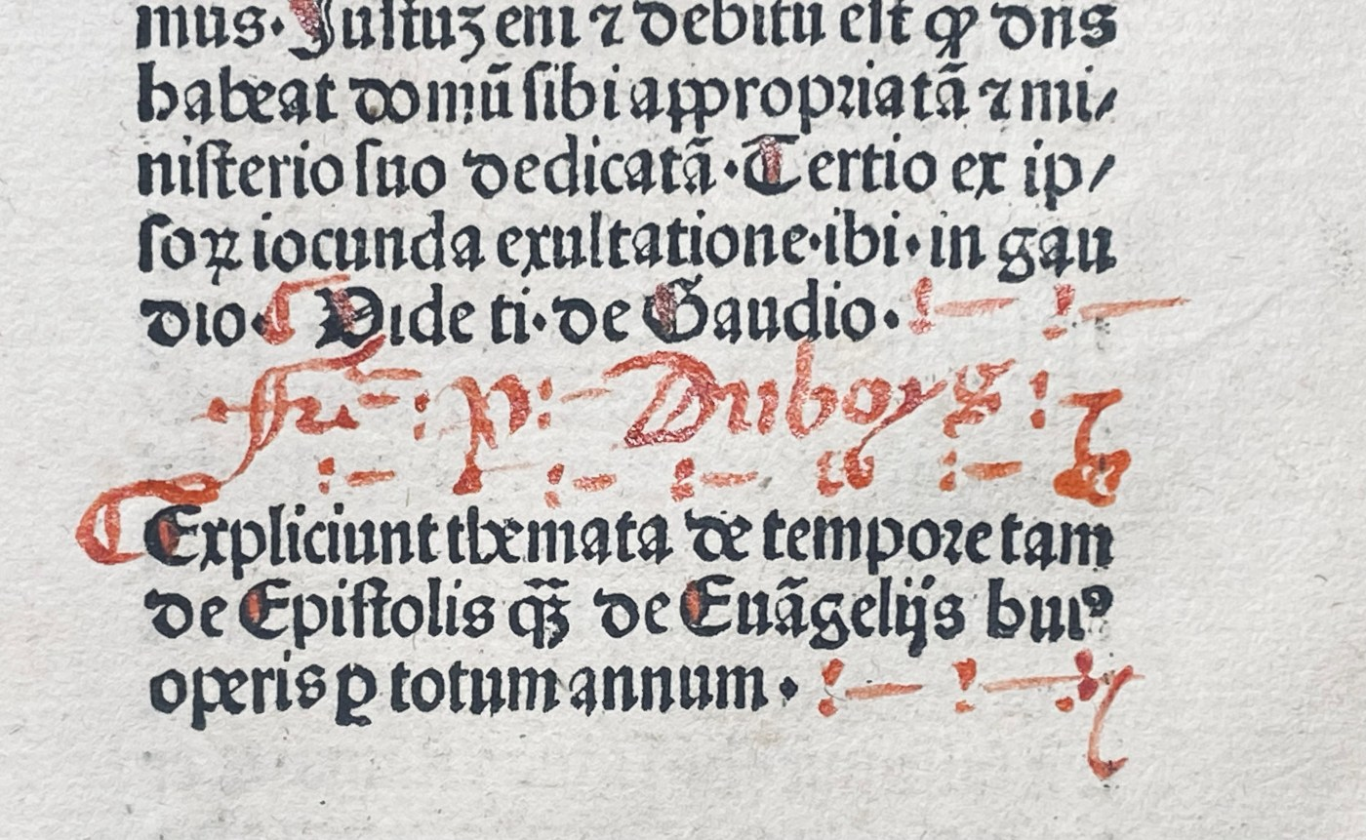
Both rubricated at the same time and both signed by the Rubricator!

444Ji Guillermus Parisiensis; (1297?-1312?)

f.1 VITAM BONAM ET EXITUM Beatum | Ego Frater Guilhermus sacre Theologie Profes | sor minimus parisius educat[um]. Sacroru[m] euangelio|rum ac epistolariu[m] de te[m]pore dieb[us] dominicus et sa[n] | ctis. Etiam super cômune Apostolo[rum] Martirum. confossorum. | virginum. Et pro defunctis Exposiciones in vnu[m] colligere v | olume mius expertis clericis.
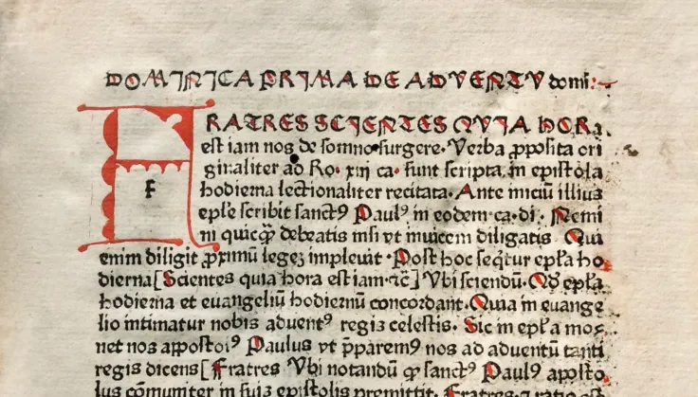

More than one hundred editions of the Postilla super epistolas et evangelia by Guillermus Parisiensis were printed during the fifteenth century. Frederick Goff devoted a pioneering study to its publication history in the Gutenberg-Jahrbuch(1959), documenting its remarkable diffusion throughout Europe and establishing the work as one of the great religious bestsellers of the late Middle Ages. During my own career I have handled thirteen fifteenth-century editions of the Postilla, a testament to its extraordinary popularity among clergy seeking guidance in the interpretation of the Epistle and Gospel readings throughout the church year. Yet the present edition stands apart from those more familiar printings. Assigned by the Gesamtkatalog der Wiegendrucke to the little-understood press of Eberhard Frommolt at Vienne and absent from Goff's census, it survives in only four recorded institutional copies and represents one of the rarest manifestations of a text otherwise known through more than one hundred editions.

The present edition is particularly significant as a witness to one of the least-documented printing enterprises of the incunable period. Only thirteen editions are assigned to Frommolt, and surviving copies of his work are remarkably scarce. Of the present edition, only four institutional copies are recorded worldwide, with the sole North American example at Brown University. Far from being merely another edition of a familiar pastoral text, this volume preserves evidence for a printing house whose output remains only partially understood.

Even more remarkable is the fact that this edition is bound with a 1481 printing by Johann Amerbach at Basel and bears the same distinctive rubrication throughout both works, including identical initials, paragraph marks, and rubricator's signatures. Acquired from an auction catalogue that described both texts as products of Amerbach's press, the volume rewards closer examination. The typography reveals the rare Frommolt edition, while the rubrication suggests that the two books passed through the same finishing workshop shortly after printing. The volume therefore preserves rare evidence not only of the popularity of Guillermus Parisiensis's text, but also of the commercial and artisanal networks that connected Vienne and Basel during the first generation of European printing.

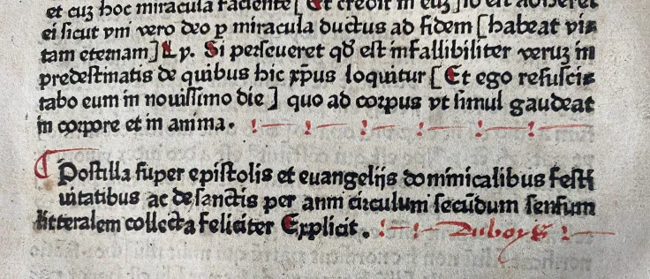

f 180v: [Et ego reſuſci—||tabo eum in nouiſſimo die] quo ad coꝛpus vt ſimul gaudeat|| in coꝛpore et in anima.
Poſtilla ſuper epiſtolis et euangelijs dominicalibus feſt||uitatibus ac de ſanctis per anni ciꝛculum ſecūdum ſenſum||litteralem collecta feliciter Explicit.
[Vienne: Eberhard Frommolt. not before 1480] ( Date and assignment to printer by GW)
Chanclery Folio. 26.8 x 18 cm. signatures: [a–x⁸ y-z⁶]. 179 of 180 leaves 40 lines Lacking the initial blank. Three-to six-line capital spaces, with guide letters. Six-line opening text initial supplied in red, capital strokes. In this edition the comentaries are pinted within the text controled by brackets. Many initials supplied in red.
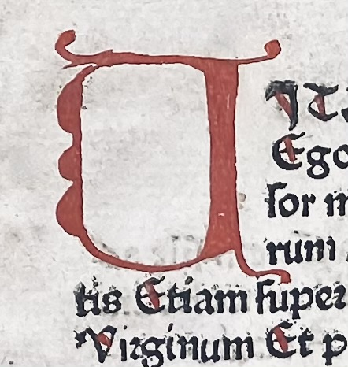
More than one hundred editions of the Postilla super epistolas et evangelia by Guillermus Parisiensis were printed during the fifteenth century. Surely this esteemed compilation must be regarded as one of the earliest ‘best sellers’, for how else can one explain why the text was not only frequently reprinted but was reissued time and time again by the same printer. The introduction to the Postilla, his only published work, tells us that he was a Dominican and a professor of sacred theology at Paris. This compilation of the Postilla was written down in 1437 expressly for members of the clergy and for those desirous of understanding the excerpts from the Epistles and the Evangelists, more commonly called lessons, which are read at appropriate services throughout the church year. It obviously filled a most pressing need (Goff, “The Postilla of Guillermus Parisiensis,” Gutenberg-Jahrbuch 1959, p. 73).
Thirteen titles are assigned to Frommolt. Of the present edition, only four copies are known with Only one in the US at Brown University which came from the Southwark Diocesan Archives, London.
GW 11926.; ISTC ig00654800. ;Pellechet 5641. ; Copinger 2861.
- World wide Holdings:
- France: Beaune BM, Besançon BM, Colmar BM
- United States Brown Univ. ONLY
- Number of holding institutions 4
- Of printings by Frommolt there only 11 copies of any of his titles, representing 6 Titles and only 8 Institutions.
https://data.cerl.org/istc/_search?query=+ig00654800u0026amp;from=0

BOUND WITH
Johannes de Turrecremata, (1388-1468) NICOLAUS DE BYARD(fl. c.1300).
Quaestiones Evangeliorum de tempore et de sanctis. & [Dictionarius pauperum:] Flos theologiae sive Summa de abstinentia.
2 parts in 1 volume.
Incipit materia aurea enucleata ex originalib[us] virtutu[m] et vitioru[m], Flos theologi[a]e nu[n]cupata, [secundu]m ordine[m] alphabeti pro sermonib[us] applicabilis tam de tempore q[uam] de sanctis totius anni.
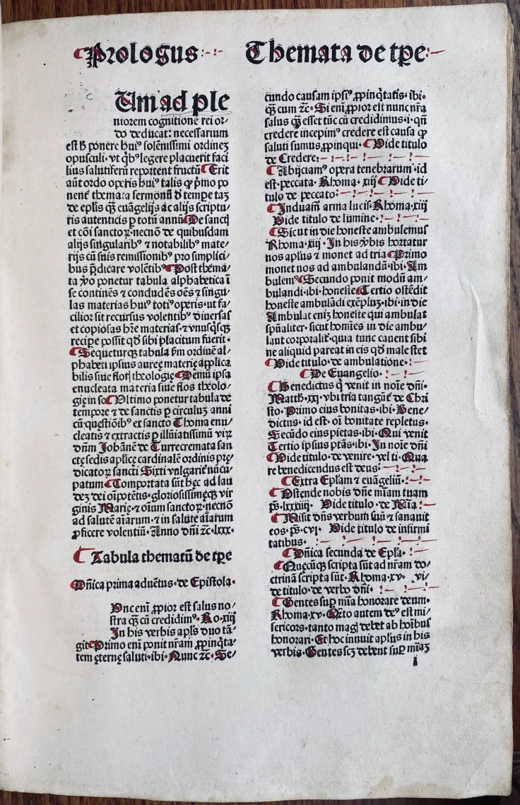
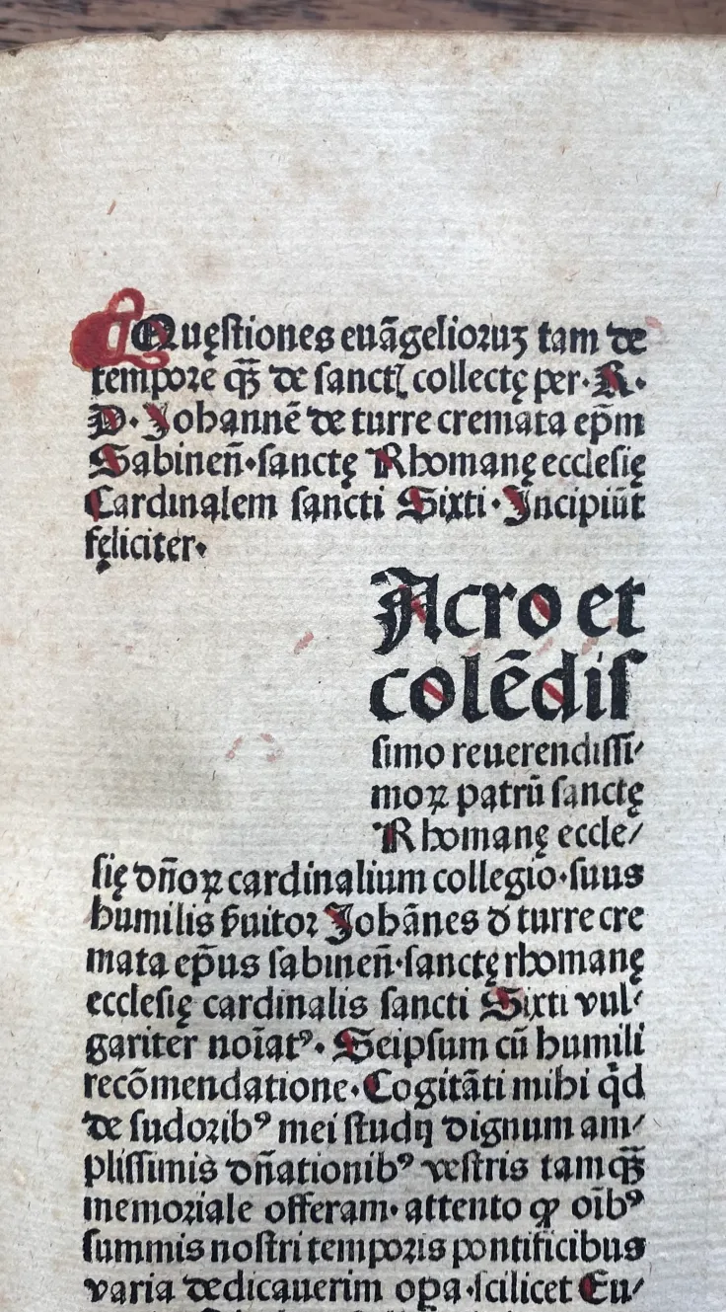
[Basel: Johann Amerbach, [ A copy at Frankfurt am Main has rubricator’s date 28 Sept. 1481]
Price $29,000
Chanclery Folio. 26.8 x 18 cm. [350].f ; 1¹⁰ 2⁸ 3¹⁰ 4⁸ 5⁸ A^{10/8}-L¹⁰ M^{12 (Flos)} π⁸, a^{10/8}-v⁸ x⁶
ISTC it00553000; Goff T553 ; BMC III 747; GW M48236 ; HC 15714* ; Pell Ms 11270; Polain(B) 3869 ; IDL 4519 ; IBE 5680 ; IGI 9889 ; Sheppard 2414 ; Pr 7566 ; BSB T-568
Bound in later full calf over wooden boards.
https://data.cerl.org/istc/it00553000
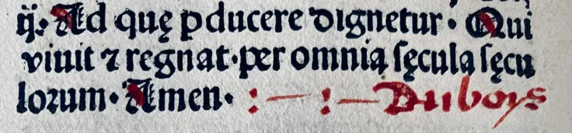
- US Holdings
- Collection of the late Phyllis and John Gordan, New York NY (BMawrCL?)
- Columbia University,
- Cornell Univ.
- Free Library of Philadelphia,
- Library of Congress,
- Huntington Library
- Southern Methodist
- Stanford Univ. Library
- Univ. of Illinois Urbana-Champaign
- Washington Univ.
- Yale
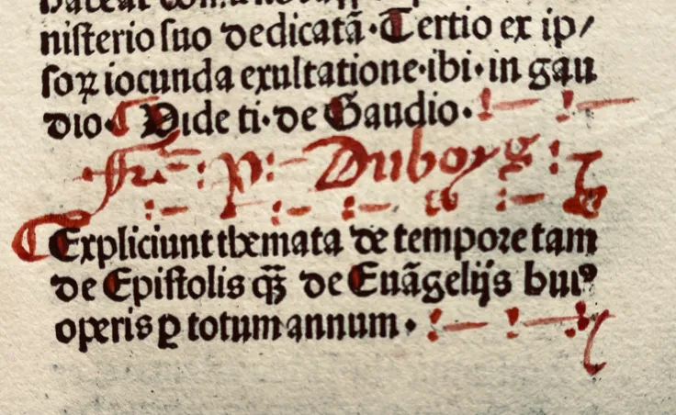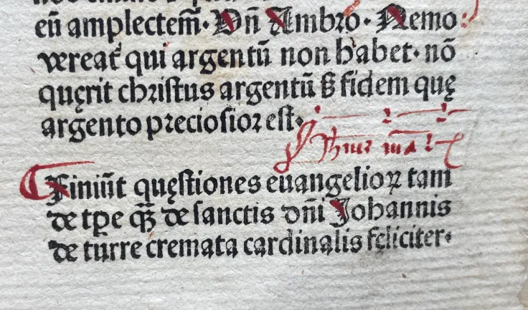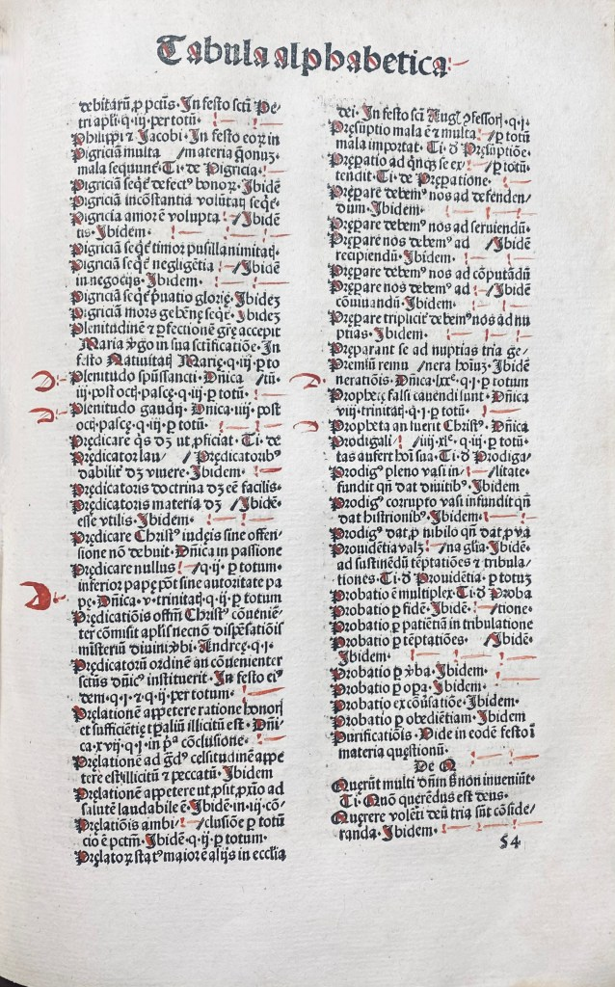
12
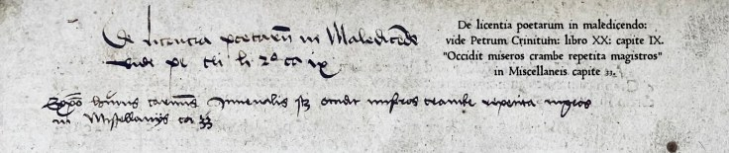
The Finest Example of Material Evidence I Have. Encountered: Argumenta Satyrarum Iuuenalis per Antonium Mancinellum. Nuremberg, Koberger, 6 décembre 1497.

This copy presents an unusually complete record of a book’s life from the earliest years of the sixteenth century to the present. Preserved in its original Rhenish binding, the volume retains evidence not only of ownership but of sustained scholarly engagement. The earliest annotator, a German humanist active in the years around 1511, filled the margins with references to classical, patristic, and contemporary authorities, transforming the printed book into a working instrument of study. Particularly significant are notes written deep into the gutters of gatherings, demonstrating that portions of the text were annotated before binding or while still in temporary wrappers. The annotations are therefore not merely contemporary with the volume; they belong to the earliest stage of its existence as a physical object.

670J JUVENAL (Decimus Junius Juvenalis) with the commentary of Domitius Calderinus, Georgius Valla and Antonius Mancinellus
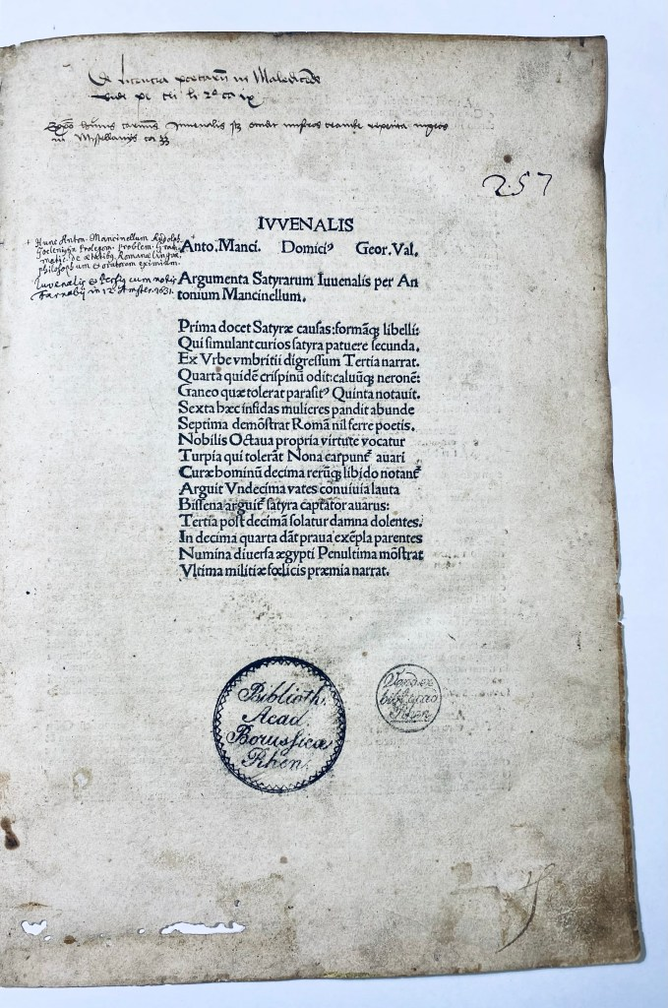
IVVENALIS Anton.Manci. Domici(us) Geor. Val. Argumenta Satyrarum Iuuenalis per Antonium Mancinellum.

“Repeated cabbage kills unfortunate schoolmasters, see chapter 33 of Angelo Poliziano’s Miscellanea. (1489?)
Príma docet Satyræ caufas: formaq libelli:
Qui fimulant curios fatyra patuere Secunda.
Ex Vrb: umbrítíí digreffum Tertia narrat.
Quarta quidem crifpinu odit:caluuq neroné:
Ganeo quæ tolerat parafitus Quinta notauit,
Sexta hæc infidas mulieres pandit abunde
Septíma demonftrat Romam nil ferre poctís
Nobilis Octaua propria uirtute uocatur.
Turpia qui tollerant Nona carpuntur auari
Cura hominum Decima rerüq; libido notátur
Arguit Vndecima uates conuiuia lauta
Biffena arguitur fatyra captator auarus.
Tertia poft decimam folatur damna dolentes
In decima quarta dant parua exempla parétes;
Numina diuerfa ægypti penultima monstrat
Vitíma militiæ fœlicis præmia narrat.

[Colophon:] Nurnberge impressum est hoc Iuuenalis opus cum tribus commentis per Antonium Koberger, MCCCXCVII die vero vi Dece[m]bris. 1497
Price $31,000

Folio 30.8 x 21.5 cm. Signatures : A⁸ a–z⁸ &⁶. This copy is bound in its original * blind stamped half pigskin over wooden boards, lacking clasps. This copy has been strongly annotated by a German humanists circa 1511. Important edition with 3 commentaries from the end of the 15th century by great figures of Italian humanism and following the Venetian edition of Tacuio, 1494/1495- ISTC ; ij00663000. Mancinelli; Domizio Calderini and finally, the one by Giorgio Valla, which has a philological importance: it reproduces ancient scholia from a now lost manuscript.
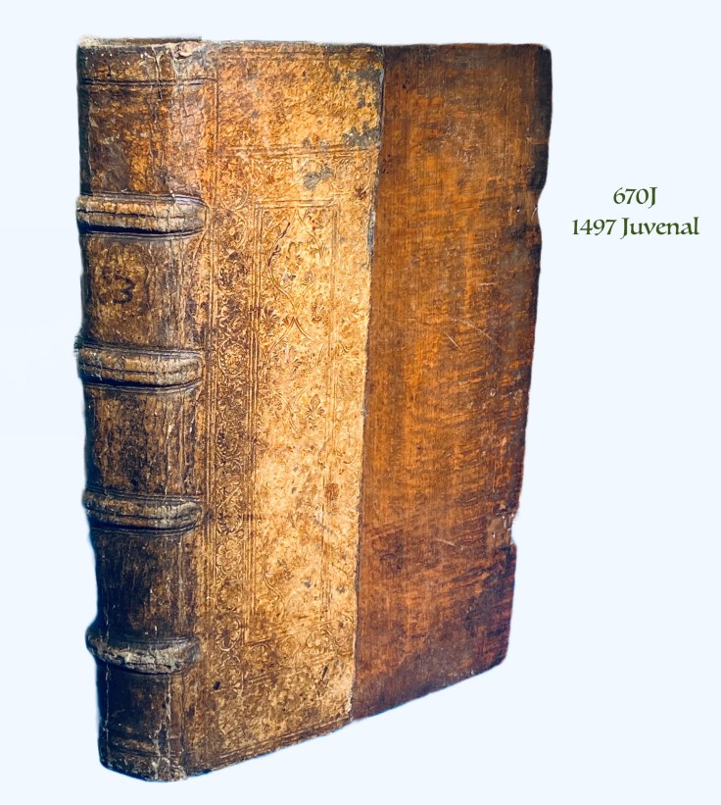
Provenance:
1. German reader, early 1510s. 2. Transfer stamp ” Vend. ex bibl. acad. Rhen.” (“Sold by the Prussian Academy Library,” former library of the University of Bonn, the stamp “Bibliotheca Accademiae Borussicae Rhenanae”, was apparently used in the period 1818-1828. 3. 17th century owner (note on title page with reference to the in-12 Juvenal-Perse published in Amsterdam with Farnabius’ notes in 1631). 4. Marquis Giuseppe Terzi of Bergamo (1790-1819). It does not appear in the catalogs of the sales held in Paris between March 11 and 23, 1861. 5) Joseph Nève, lawyer and bibliophile from Brussels (1857-1940) 6). The book is later in the collection of Jean-Baptiste Colbert de Beaulieu (1905-1995) (ex-libris). 7). It is then in the collection of Jean Stefgen, Joinville le Pont (1927-2017, bookplate).
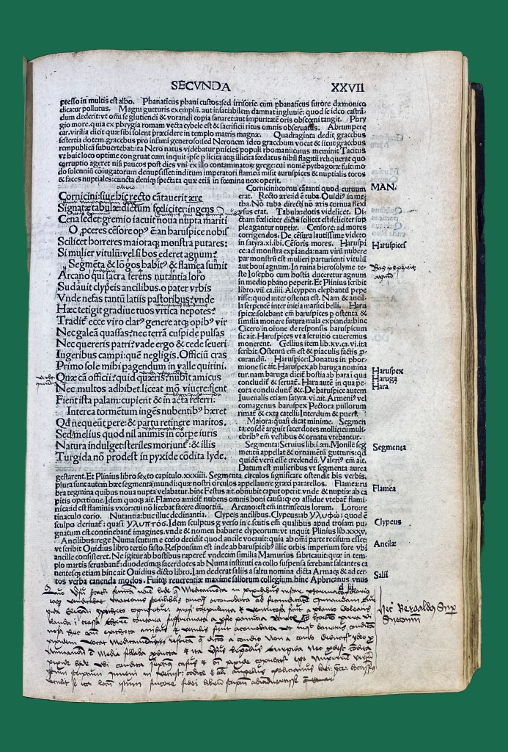

This copy is profusely annotated (up to satire 6) by a German reader in the first decade of the sixteenth century, as indicated by the diacritical sign above the u’s, its spelling Yason (for Jason), apoptegmata (without an ‘h’). This incunabulum is found in its interesting first binding, Rhenish,{Koberger} half pigskin stamped in blind over wooden boards.
****Our German reader most likely annotated the work while it was still in quires or paperback: indeed, some notes are in the inner margin. The work was probably annotated before being bound, which caused some minimal outside marginal cuts.****
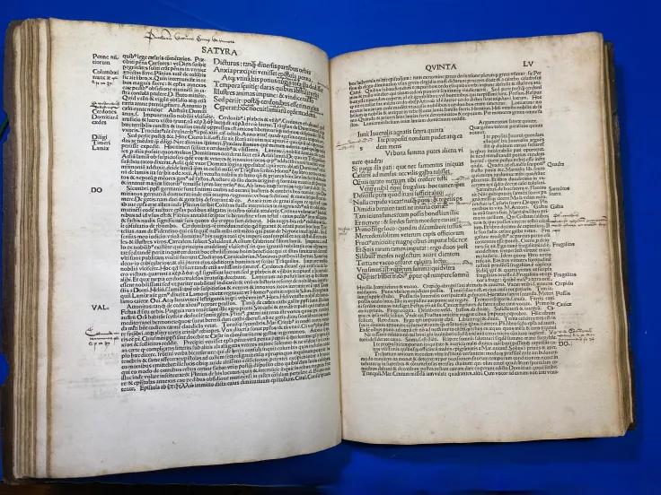

The sources used by the annotator betray a strong anchorage in Rhenish humanism, around 1511. This reader obviously evolved in a circle close to the young Beatus Rhenanus and mmost likely Jakob Wimpfeling at the crossroads of classical and Christian culture. His reading is indeed a mixture of Italian philological and historical commentaries and works of northern humanism (Reisch, Erasmus). Several notes reveal the use of a series of editions published in Strasbourg in 1511: the Hymni heroici tres of Pico de la Mirandole with the annotation of Beatus Rhenanus, the collection of ps. Bérose published by Grüninger (with a false text of Xénophon). Our anonymous reader reads Erasmus’ Adages in an edition by Schürer (c. 1511) and the Praise of Folly, the first editions of which also date from 1511 (Paris, Gilles de Gourmont and then M. Schürer). XXI v. The annotator also has recourse to contemporary Italian encyclopedias (Enneades by Sabellico, Commentarii by Volaterranus) to which he adds the reading of Reisch’s Margarita philosophica, the jewel of northern humanism (the editio princeps dates from 1504). The annotator refers to a passage of this work (Book VII, chapter VII) where Atlas is presented as the inventor of astronomy (note on f. CXIIIr: “Atlantem caeliferum fuisse negat Lucrecius. Lege, invenies in Margarita ex Plinio, li 7 ca 2” etc). These readings and references to editions of 1511 make us think that the annotator plausibly followed a university course held in Strasbourg around 1511, always in the close circles frequented by Beatus Rhenanus.
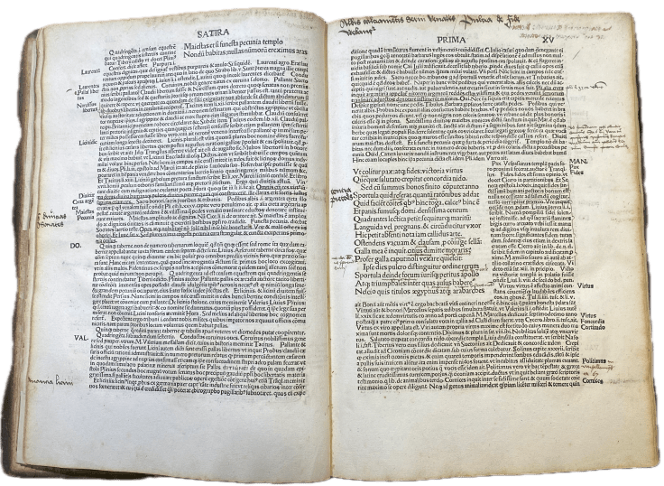
The humanist commentary here focuses on word radicals, lexicon and context (the annotator mobilizes printed commentaries), with little interest in figures. He shows a predilection for natural history (Pliny and Solinus very much in demand) and Roman history in general (the annotator resorts as well to Suetonius as to modern commentaries such as Philippe Béroalde and Sabellico, whose Enneads he quotes several times, f. XXIV v for example).
This erudite reader sometimes commits approximations in his references: he confuses for example a title of the pseudo-Xenophon with a collection of the pseudo-Beroses. A long quotation of a passage that he attributes to Philip Beroalde (the Elder) on f. XXVIIr comes in fact from the Annotationes centum and not from his commentary on Suetonius (see Anthony Grafton, “On the Scholarship of Politian”, Journal of the Warburg, 1977, p. 166). He recopies from memory (incorrectly) on f. VI a licentious epigram by Martial (book VI, 67) & notes in the margin, still on this verse but this time about eunuchs: “Martialis / Cur tantium eunuchos uxor tua Caelia quaeris / Pannice vult futui (Caelia) non parere.”
The annotator also has recourse to the vast Latin poetic heritage: Ovid and Seneca on f. II (Vide Ovidium Transformationum… Vide Senecam in Agammemnone); Horace, Satire VI, I (on f. XVr). Also to some poets of late Latinity like Sidoine Apollinaire through an incunabula edition (1498) with commentary. He also gives some suggestions for corrections to the text: f. LIX r to the lemma “caldum”, he refers to the Attic Nights of Aulu Gelle: “emendatius caldus haud (…) quam calidum apud Gellium caldam saepeponitur li 19 ca 4”.
Some more developed notes are to be noted:
- A reference to the practice of hunts (venationes) in the circus under Domitian, with an anecdote of a certain Maevia descended the pointrine naked in the arena (f. V r). It reproduces the words of an ancient scholiast of Juvenal: ” Alia indignatio in mulierum impudentiam quae temporibus Domitiani descendebant (?) in venationes et pugnas theatrales ” (words of the scholiast of Juvenal).

- On the title page, two references to Italian miscellanea of the end of the 15th century: one to the freedom of poets to slander, which refers to Pietro Crinito’s De honestis disciplinis (lib. 20 ca. IX), and the other to a complicated passage of Juvenal explained in chapter 33 of the Miscellanea of Ange Politien (Expositio hujus carminis Juvenalis scilicet occidit miseros Crambe repetita magistros in Miscellaneis ca. 33 1489? <goffP-890?) it revolutionized textual criticism and humanism through short, brilliant essays analyzing and correcting ancient texts. Each chapter is a mini-essay on some lexical or textual problem which Poliziano, drawing on the riches of the Medici Library and Lorenzo’s Antiquities. This chapter of the Miscellanea explains the very graphic proverb Occidit miseros Crambe repetita magistros which appears in Juvenal’s Satire VII (v. 154), which can be translated literally by ” “It is from this cabbage unceasingly re-served that unhappy masters die” to denounce the repetition to which masters are forced.” Each chapter is a mini-essay on some lexical or textual problem which Poliziano, drawing on the riches of the Medici Library and Lorenzo’s to denounce the repetition to which masters are forced.
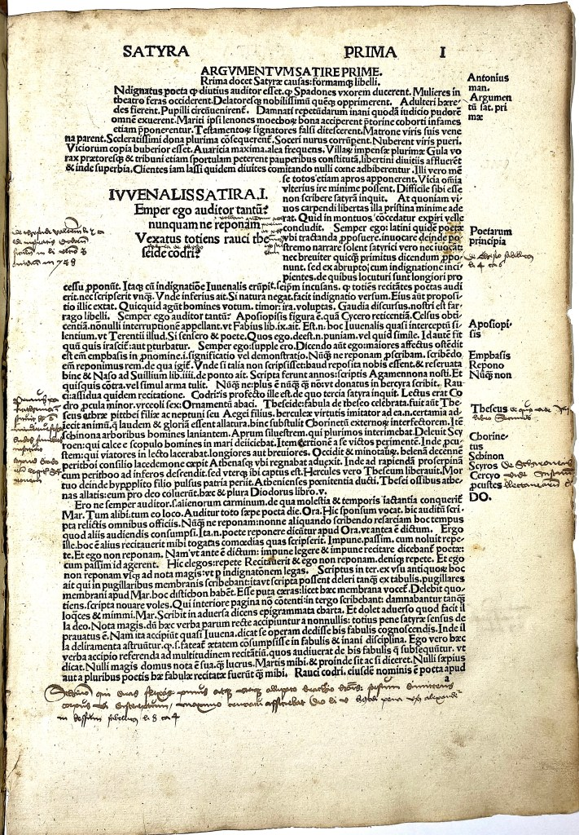
- To the last page the reader has affixed a note with references to ancient authors and poetic formulas (perhaps beginnings of unfinished verses) related to Pindar and the Pindaric writing: “E Salaminiaco gesta (?)… cothurno… / Pindarici… enthea plectra (inspired poetic writing) / Juvant…” Below we read: Plutarchus. Then below the list of the Latin agronomists: Varro, Columella, Palladius. Let us note that the beginning of verse “E Salaminiaco” is found in Petrarch in the poem “Ad Benedictum XII Pont. Rom.”

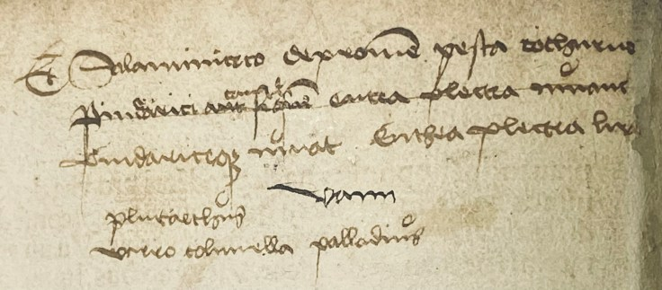

A typical sample.

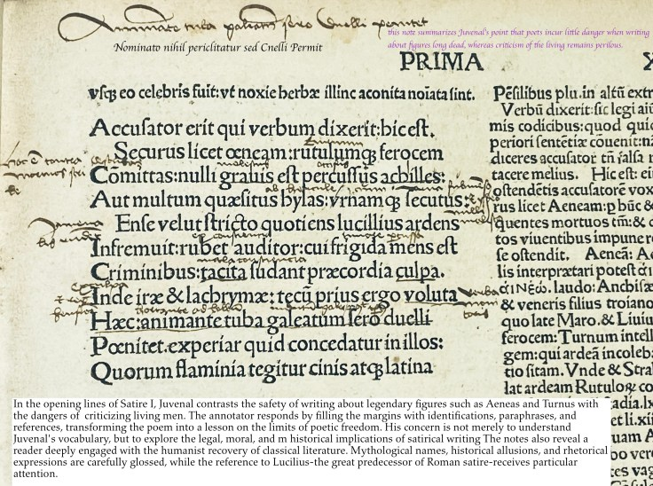

A 17th century owners note. 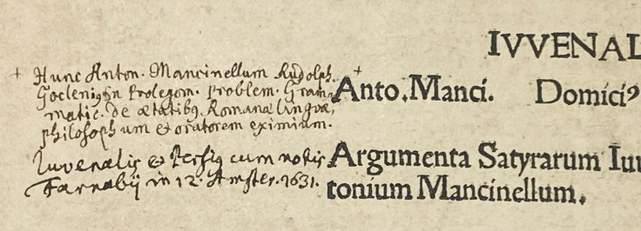
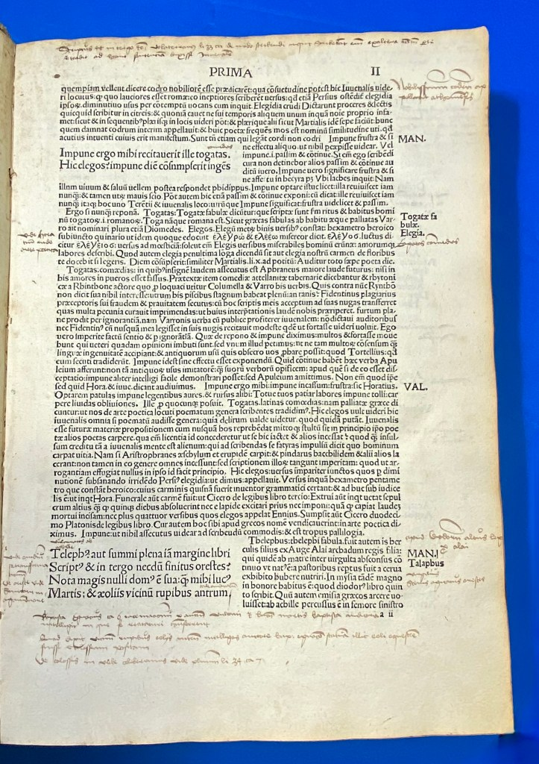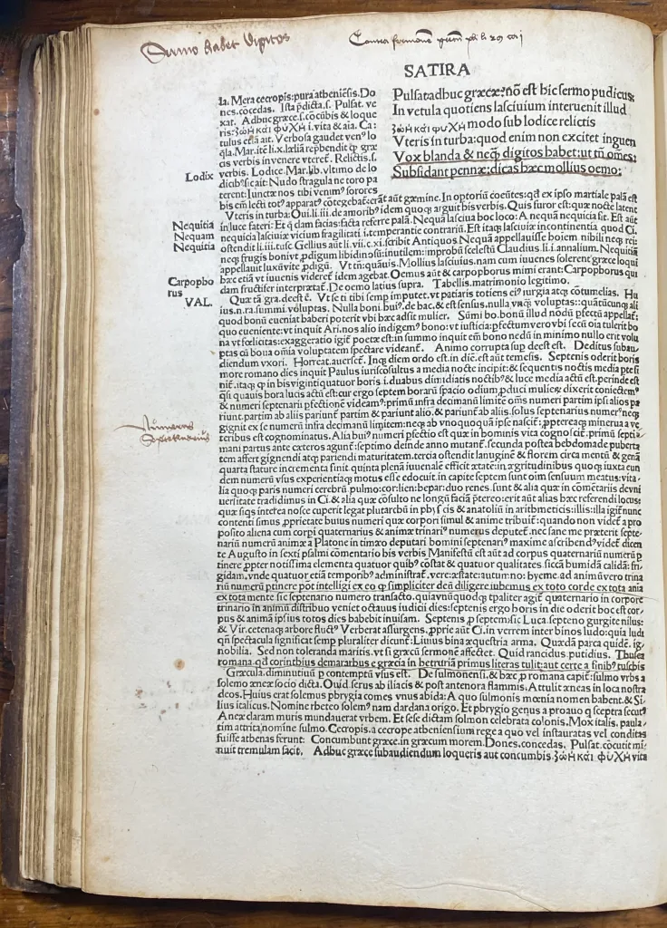
Short Link: https://wp.me/p3kzOR-67c
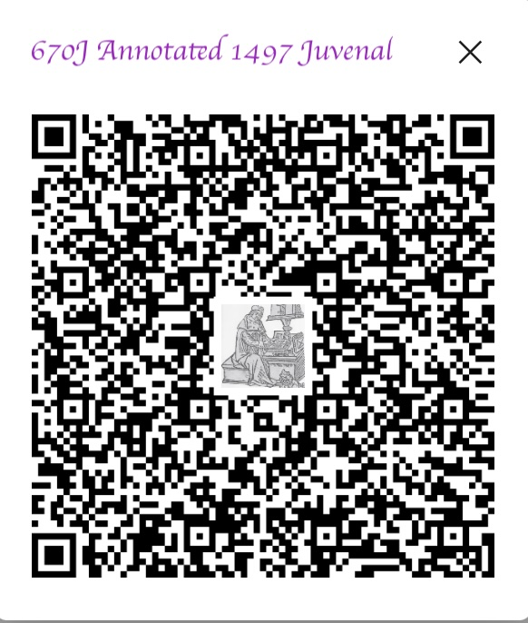

13

“An Annotated Livy, Venice 1491: A Humanist’s Working Copy”

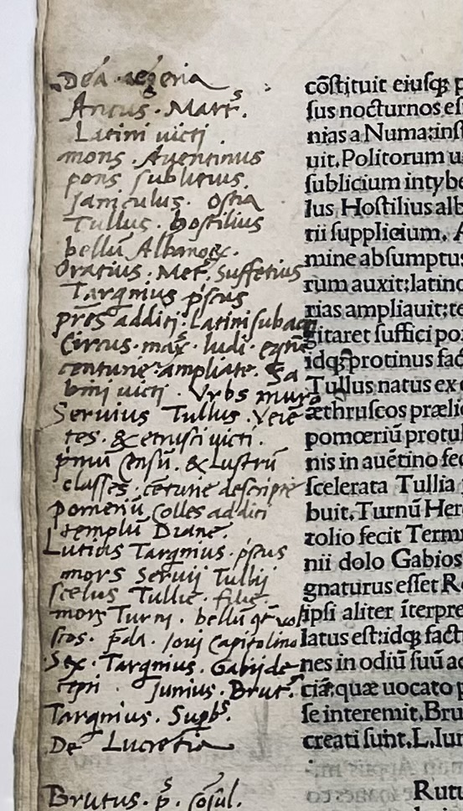
671J Titus Livius (59BC-AD17) , Marcus Antonius Sabellicus.(1436-1506); Johannes Andreae, and others

[Titi Livii Historiae romanae decades I, III-IV, cum Johannis Andreae Epistola et L. Flori Epitome decadum XIV. Praemittuntur M.A. Sabellici epistola et annotationes.].

Venice : (no printer) [Johannes Rubeus Vercellensis], 5 Nov. 1491 Imprint: [Matteo Capcasa (di Codeca)], [Although the types are indistinguishable, the layout suggests Rubeus rather than Capcasa as the printer (Sheppard)]
Price: $12,000
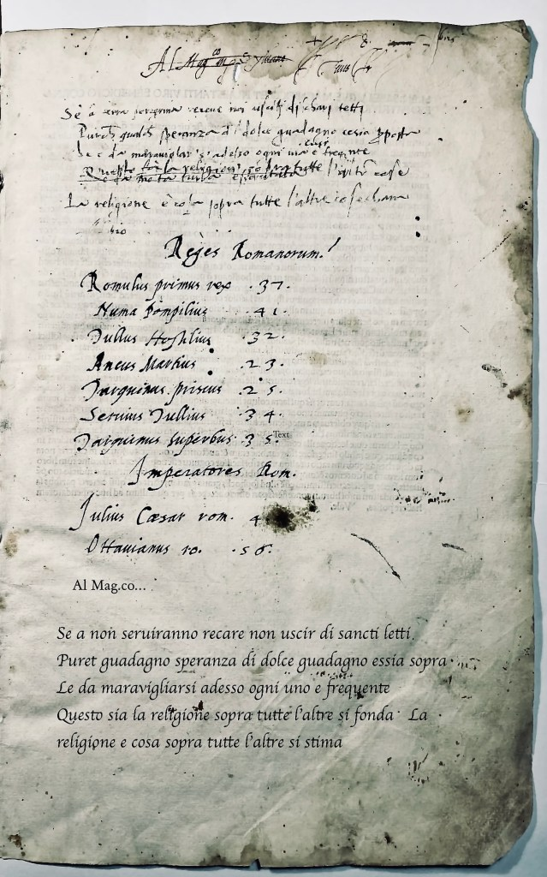
There seems to controversies over who printed this volume. Goff, CIBN, IGI, and Polain assigns it to [Matteo Capcasa (di Codeca)]: Sheppard notes that, although the types are indistinguishable, the layout suggests Rubeus rather than Capcasa as the printer. BMC and Hain suggest another 1493 edition.

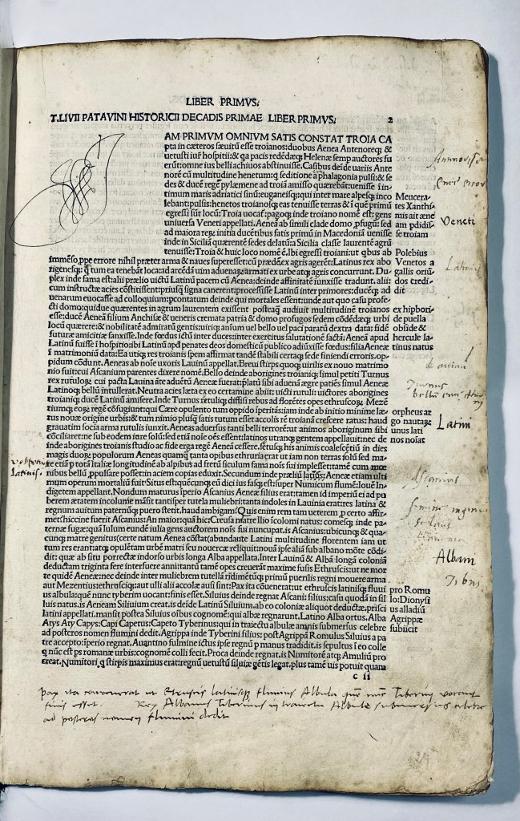
Super-chancery folio: 33.5 x 22 cm. Signatures π6, a¹⁰ b⁶ c¹⁰ d-n⁸aa-ii⁸ kk-ll⁶, A-G⁸H¹⁰ (π⁶, a¹,n⁸ blank and present) Bound in sixteenth century vellum. Ownership note: “Al Mag.co…” strongly suggests a formula of address, possibly a dedication to a Magnifico patron or owner. Could be linked to a Florentine or Venetian context. This copy is profusely annotated, from beginning to end by a clear contemporary hand. The present example is remarkable for its continuous contemporary marginalia: a running index of names, places, and events throughout the prima decade to the quarta decade, liber decimus. The annotator systematically extracts auctores on

every page, producing a personal epitome of Roman history. More than this, he interweaves cross-references to other authorities — Augustine, Varro, Aulus Gellius, Virgil, and Cicero among them — and transcribes entire ritual formulae (the devotio Decii of Book VIII) and antiquarian notes (on banquets, kinship terminology, etc., from Gellius). The effect is to transform a standard Venetian Livy into a working commentarius, a kind of personalised critical edition. From the very first leaf, an early Italian hand has turned the book into a working commentarius. Every page bristles with marginalia: lists of names, places, and episodes, effectively a running index of Roman history from the fall of Troy through the early Republic. But the annotator goes further. He checks Livy against Augustine, Varro, Aulus Gellius, Virgil, and Cicero, transcribes entire ritual formulae like the devotio Decii (Livy VIII), and even copies antiquarian notes on banquets and kinship. At the front, a vernacular maxim — “La religione è cosa sopra tutte l’altre si stima” — shows the book being read not just historically, but morally. Our annotator the reader turns Livy into a kind of personal index & commonplace book. At the beginning, the notes are dense, listing auctores in long chains (Virgil, Augustine, Cicero, etc.), then throughout Books I–X each page gets its marginal catchwords: names, places, episodes, authorities. The effect is cumulative: a running epitome and concordance of Livy.
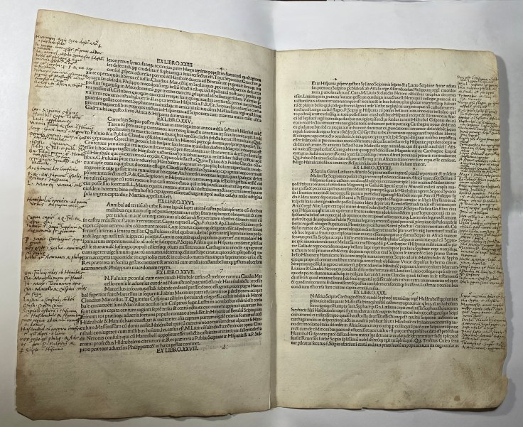
Fifteenth century Humanists saw Livy’s work as a model of classical eloquence, and his emphasis on traditional Roman virtues and stoicism proved immensely influential on Renaissance humanism. Additionally, Livy’s emphasis on the power of human agency in historical events was praised as a rejection of fatalism and a sign of the Renaissance focus on individualism and human potential. The text of Livius’ History survives in ten books referred to as Decade, but only three of the original fourteen were known in the late Middle Ages, with the first, third, and fourth books eventually circulating together.
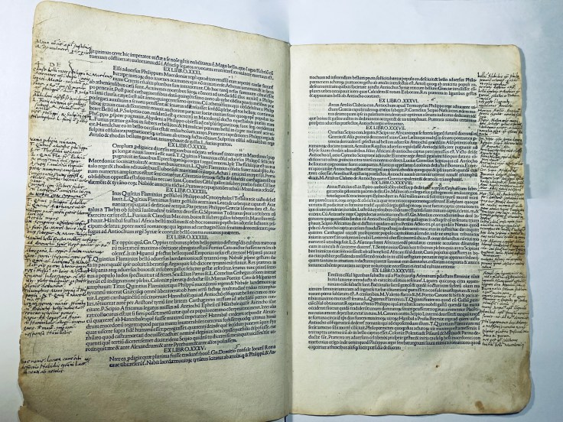
His work was highly influential in the Renaissance and was widely read during the 15th century, particularly in Italy. Several Italian humanists, such as Leonardo Bruni and Poggio Bracciolini, made extensive use of Livy’s works in their own writings, and it is thought that Livy’s work played a significant role in shaping the humanist movement. “The Renaissance was a time of intense revival; the population discovered that Livy’s work was being lost and large amounts of money changed hands in the rush to collect Livian manuscripts.
The poet Beccadelli sold a country home for funding to purchase one manuscript copied by Poggio. Petrarch and Pope Nicholas V launched a search for the now missing books. Laurentius Valla published an amended text initiating the field of Livy scholarship. Dante speaks highly of him in his poetry, and Francis I of France commissioned extensive artwork treating Livian themes; Niccolò Machiavelli’s work on republics, the Discourses on Livy, is presented as a commentary on the History of Rome.”
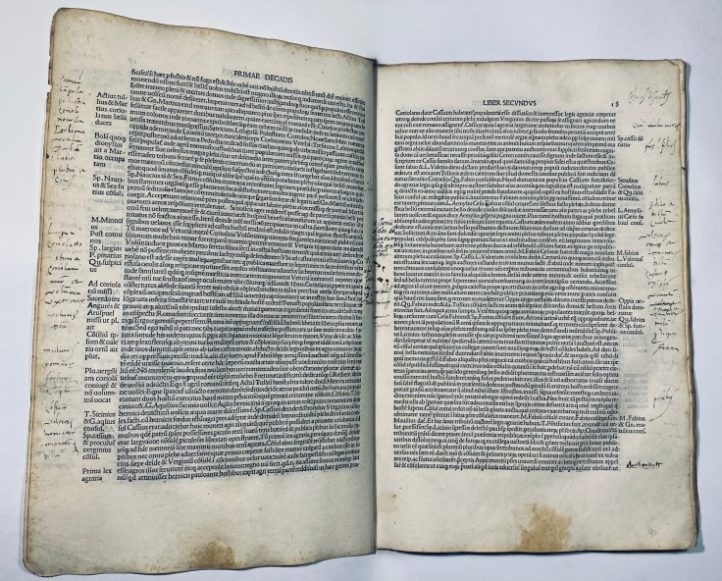
On the last leaf our annotator leaves us three interesting messages.
Hic mihi Cæsar numerat tesseram Iunio
Calavius Sic geminino dicto consilio petit
insidioser, si audis bello Catroni
Ita tibi geminos miles et socios erit
“Here Caesar gives me the watchword: Junius Calavius.
Thus, by such a twin-named plot, he seeks treachery.
If you listen, in the Catronian war,
so you will have twin soldiers and allies with you.”
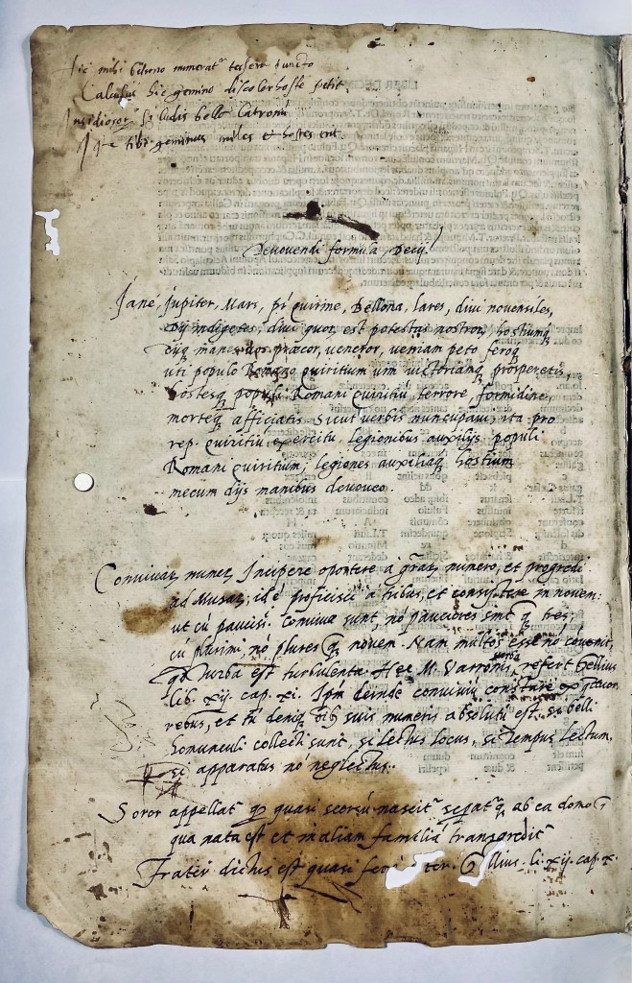
Iane, Iupiter, Mars, P. Quirine, Bellona, Lares, diui nouensiles,
di indigetes, diui quorum est potestas nostra, hostiumque, di manes, vos precor, ueneror, veniam peto feroq[ue], uti populo Romano Quiritium uim uictoriam prosperetis,
hostesq[ue] populi Romani Quiritium terrore formidine morteq[ue] afficiatis. Sicut uerbis nuncupauimus, ita prore publica Quiritium legionibus auxiliis populi Romani Quiritium legiones auxiliaq[ue] hostium mecum dis manibus deuoueo.
Conuiuium munus, incipe oportere a graui numero, et progredi
ad minutas; id est proficisci a tribus, et conuenire in nouem: ut cui paucis. Conuiuae sunt, no pauciores sint tres, cum strennui no plures. Conuiua tamen multos esse no conuenit,
quia turba est turbulenta. Haec M. Varronis refert Gellius lib. xij. cap. xi. Ipsum deinde conuiuium constituit ex grauioribus rebus, et sic denique ubi suis muneris absoluti est, sa. Belli. Conuiualiis collecti sunt, si lection locus, si tempus lectum, et apparatus no negligi.
—
Soror appellatur, eo quod secorum nascitur, separata ab ea domo,
qua nata est et in aliam familiam transgreditur. Frater dictus est, quasi feriator.
(Gellius. lib. xij. cap. x.).

This is the devotio, the ritual self-sacrifice of a Roman commander (here, famously Decius Mus). In Livy, this occurs in Book VIII (8.9–10), where Decius Mus vows himself and the enemy army to the gods of the underworld in exchange for Roman victory.
The annotator has copied the verbatim ritual formula that Livy transmits — almost like a liturgical text. It’s written out carefully, with a heading, as though for reference or even recitation. This is a direct lift from Livy, not just a marginal note. The annotator is treating it like a ritual formula worth preserving on its own. This depicts the Humanistic interest in Roman religion, ritual, and antiquarian detail — not just narrative history. The presence of such a formula in the margins suggests the annotator thought this passage had special importance (maybe as a model of piety, patriotism, or Roman ritual exactitude).
It also aligns with Renaissance antiquarian interests: Roman law, priestly formulas, ritual language — things rediscovered and studied alongside Livy.
Yet another book I could spend not just hours but months reading through.

Goff L245; Walsh 2421; Bod-inc L-123; H 10137*; ; GW M18491; Polain(B) 4529; IGI 5778; IBE 3530; Sheppard 4119; BSB-Ink L-193. https://data.cerl.org/istc/il00245000

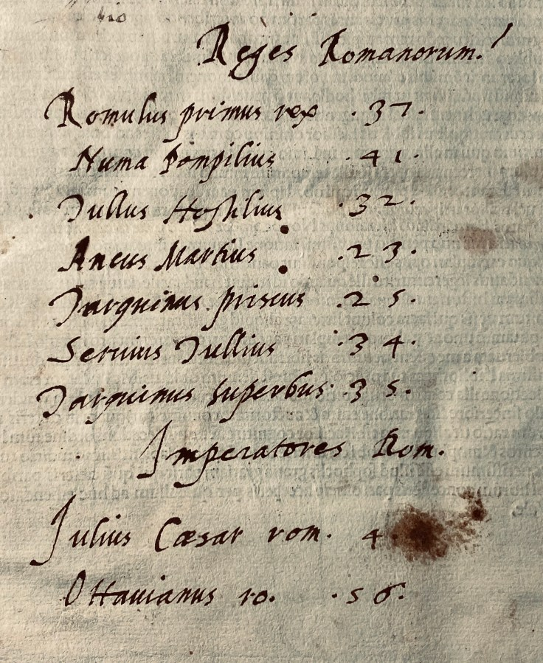

14

976J Johannes Melber active 15th century., Jodocus Eichmann, 1420?-1491

976J Johannes Melber active 15th century., Jodocus Eichmann, 1420?-1491

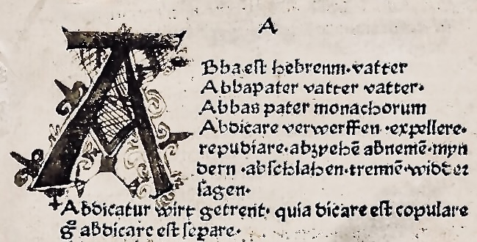

“Si te materne remoratur .. Vocabularius praedicantium, sive Variloquus. Ed: Jodocus Eichmann

[Speyer: Peter Drach der Ältere, c. 1476] Dated by BSB-Ink following F. Geldner, in Archiv für Geschichte des Buchwesens (1964), col. 177 Price $9,500
Quarto .Signatures: A–G⁸ H¹² I–O⁸ P¹² Q–X⁸ Y⁶ Z⁸ Aa–Dd⁸ Ee⁶ Ff⁸. Lacking A¹ supplied in an expert facsimile (236 of 237 leaves)

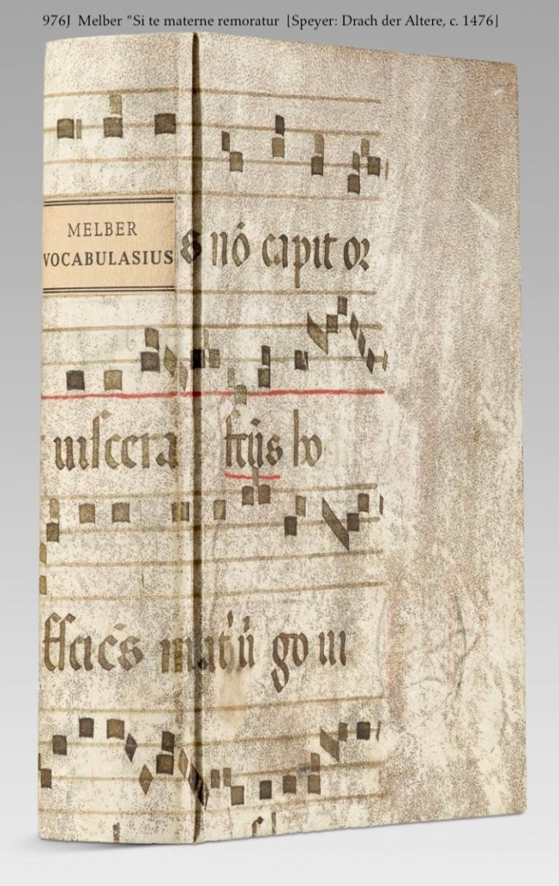
The text is German and Latin. Leaf A1 is missing (recto w., verso with octastichon). Signatures Yiii and Yiiii miss labled instead of Ziii and Ziiii. – Folios A², A³ and Ff⁸ with minor backed areas in the outer margin, however without loss of text. A²i has 1 eight-line initial decorated with lilies and interlacing in black there is narrow and only slightly visible water staining in the top and bottom margins, folios A⁷ and A⁸ with reinforcement in the fold. Formerly coloured edges partly worn, slight finger and dirt stains in places at the margins, otherwise well-preserved, wide-margined copy of this strong print on voluminous handmade paper. Contemporary (or early) parchment wrapper, formed from a recycled medieval liturgical manuscript on vellum, preserving fragments of square notation on a four-line staff.

The first edition of Melber’s Vocabularius praedicantium (Goff; GW M22716), an early Latin–German preaching aid compiled from the sermons of Jodocus Eichmann and intended for clergy working across linguistic boundaries. Produced at Speyer by Peter Drach the Elder and dated to c. 1476 (BSB-Ink following Geldner), this edition represents the earliest fixed form of a widely disseminated pastoral tool, designed to assist preachers in negotiating between learned Latin and vernacular expression in sermon composition.

Unlike later and more standardized lexica, the Vocabularius preserves the practical, adaptive character of late medieval preaching, offering insight into the linguistic realities of pastoral care on the eve of the Reformation. As a utilitarian text, it was subject to heavy use, and early survivals are accordingly rare. Johannes Melber, a scholar whose life has remained obscure, compiled this work from the sermons of the popular Heidelberg preacher Jodocus Eichmann (died 1491). Melber’s aim was to create a rhetorical aid for preachers who ‘understood neither Latin nor German’ (Jöcher-Adelung-Rotermund IV, 1336), which distinguishes his vocabulary from similar works of his time. –

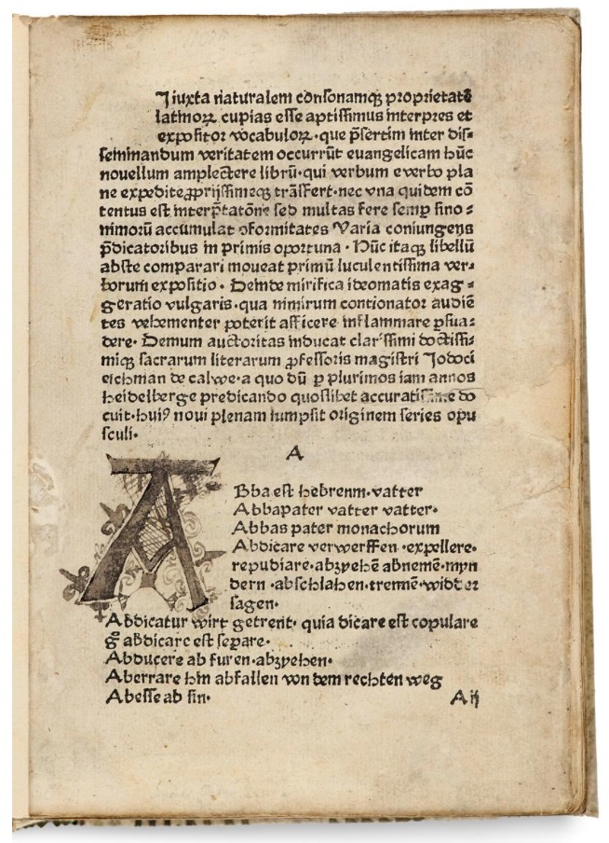
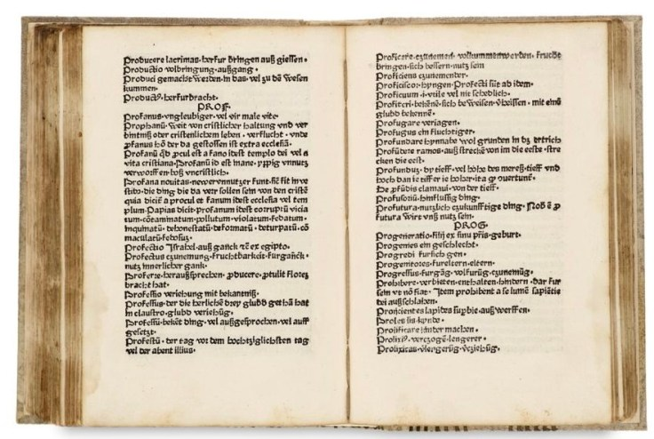
Notably, this first edition appears to be unrecorded in U.S. institutional collections.

The 30 known early editions of Melber’s ‘Vocabularius’ listed in the Gesamtkatalog der Wiegendrucke (GW) are all very rare and mostly undated. This is the oldest of the editions of the work dated by GW, which I have been unable to trace at auctions at all. –

“According to the natural character and properties of the Latin language, I have desired to be a most fitting interpreter and expositor of words—especially those which, among the unlearned, may assist in grasping the truth of the Gospel. This little book is not to be embraced as a novelty, since it does not explain word for word, nor does it offer a continuous translation; rather, in interpretation it accumulates many expressions and various combinations, especially suited for preachers. Therefore, this book should be valued for two principal reasons: first, for its very clear exposition of words; second, for its admirable rendering into the common (vernacular) speech, which can greatly move and inflame the hearts of hearers. Finally, the authority of the most learned masters supports it—above all that of Master Jodocus Eichmann of Heidelberg, who for many years has most diligently preached and from whose teaching this work has drawn its full origin and substance.”
GW M22716; H 11029; Pell 7758; Pr 2348; IBP 3695 [um 1481/82?]; BN-Inc M-288 [um 1481/82]; BSB-Ink M-304 [Datierung]; ISTC im00456100.
ISTC im00456100.

Geldner, Drach Geldner, Ferdinand: Das Rechnungsbuch des Speyrer Druckherrn, Verlegers und Großbuchhändlers Peter Drach mit Einleitung, Erläuterungen und Identifizierungslisten In: Archiv für Geschichte des Buchwesens 5, 1964, Sp. 17
This is the test of the often-missing leaf. [advertising leaf]

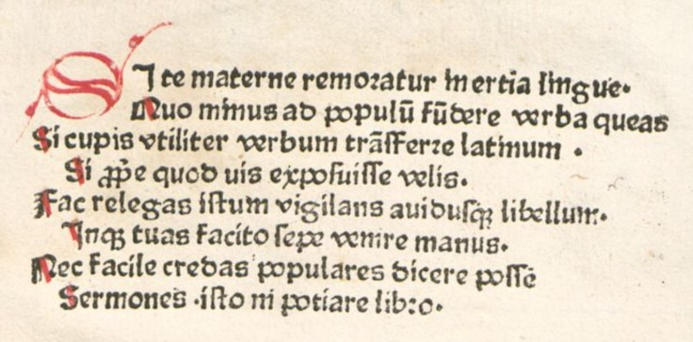

STe materne remoratur inertia linguae,
Quo minus ad populum fundere verba queas,
Si cupis utiliter verbum transferre Latinum,
Si apte quod vis exposuisse velis.
Fac relegas istum vigilans auribusque libellum,
Inque tuas facito saepe venire manus;
Nec facile credas populares dicere posse
Sermones isto nobiliare libro.

The sluggishness of your native tongue holds you back,
so that you are less able to pour forth words to the people.
If you wish to translate a Latin word usefully,
if you want to explain properly what you intend—
then read this little book again attentively, with alert ears,
and make sure it often comes into your hands.
Do not readily believe that common people are able
to speak eloquently without being refined by such a book.

15

794J Prosper of Aquitanus ±c. 499-505 (more likely Julian Pomerius)

Prosper de vita contemplatina atque actuali : sive de norma ecclesiasticorum
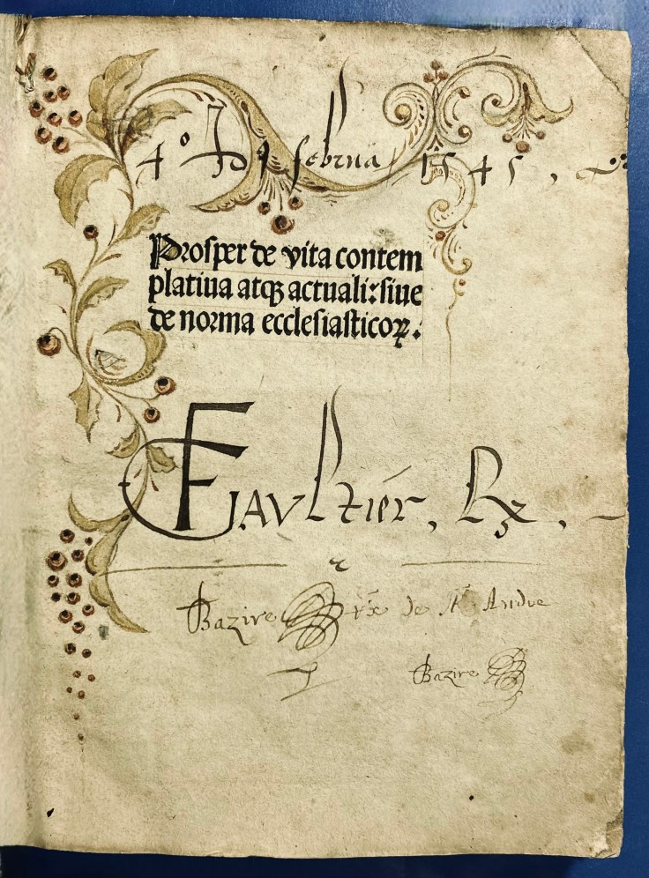
[Speyer : Peter Drach], 1487 Price $7,500


Quarto 18 x 13.5 cm Signatures: a-c8 d-f6 g8 (g8 blank and present) Bound in early green sturdy vellum slight cracking at joint; paste-downs with bookplates, light wear, glue residue at front with free endpaper glued to front paste-down at inner margin; mild cracking at front hinge; several leaves with small corner losses or tears, or small corner repairs; pages toned with occasional light grime, foxing, and light damp staining; upper margin closely trimmed; a good copy.
Pseudo- Prosper. The author is probably Julianus Pomerius, cf Lexikon für Theologie und Kirche, VIII (Freiburg i.B., 1936) pp.362, 504-505 (Aquilon) “Pomerius. [He] claims for Pomerius the further distinction of having bequeathed to us the oldest pastoral instruction that survives in the West. Mostly certainly, [Julianus Pomerius] is to be credited with a place of honor in the survival and justification of Augustine’s name and teaching; and the thoughtful reader of his one remaining treatise will not deny him his place in the early history of pastoral theology. But who other than patrologists and a few theologians even know the name Pomerius” (Suelzer, Mary Josephine (1947). Julianus Pomerius, A Contemplative Life) De vita contemplative (or De contemptu mundi) in three books treats of the value of the contemplative life, the second of the active life of the Christian, and the third of vices and virtues.
. The entire works are full of the spirit of Augustine. The similarity of the latter treatise to the eschatological meditations of St. Julian, bishop of Toledo, early led to Julian’s identification with Pomerius, who flourished fully two centuries before him. Julian, a convert from Judaism, was archbishop from Jan. 29, 680, to Mar. 8, 690, and was zealous in defending and extending the faith and reformation of the clergy, at the same time maintaining a firm attitude toward Benedict II. when the pope criticized his creed. His apology addressed to Benedict, together with some of his other works, has been lost; but his Prognosticorum futuri seculi libre tres (Leipsic, 1535); De demonstratione sextette’s (Heidelberg, 1532);. He probably took part in the final redaction of the old Spanish liturgy and of the Visigothic canon law. (Christian Classics Ethereal Library at Calvin College Last modified on 06/03/04.

Goff P-1023; Walsh 857; GW M35776; BMC II 496; USTC 748339; ISTC ip01023000.

https://data.cerl.org/istc/ip01023000

16

935J Petrus Reginaldetus fl/15thc. and Ficino 1433-1499

Speculu[m] finalis retributio[n]is magistri Petri Reginaldeti ordi[ni] mi[n]oru[m].
bound with
Marsilii ficini florentini: doctoris in omni disciplinarum genere profundissimi: de christiana religione : aureum opusculum: post omnes impressiones ubiq[ue] locoru[m] excussas: a bene docto theologo adamussim recognitum: cunctisq[ue] mendis expurgatum.

Impressum Uenetijs : [Per] Iacobinu[m] de Pentijs de Leucho impe[n]sis vero Lazari de Soardis,1489
and
[Venice] : summa diligentia per Caesarem arrivabenum venetum, 1518 Price $9,400
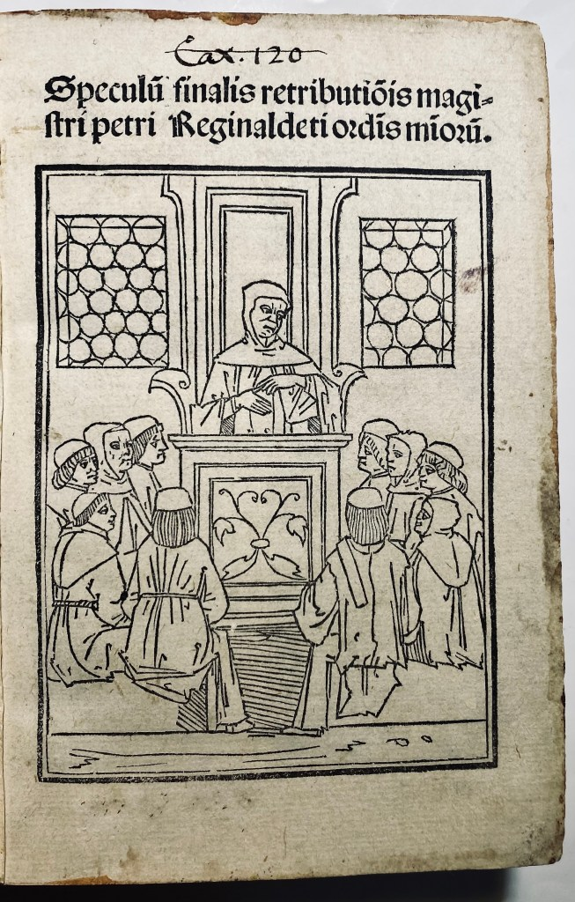
Octavo 15 x 12cm. Signatures: ad1: π⁸ a⁴ b-p⁸ | ad2 :A-M⁸ (M⁸ blank) Bound in a contemporary Venetian blind-stamped calf over paste-paper boards, circa 1518. With a woodcut title page showing a Franciscan preacher addressing an attentive audience from a pulpit within a simple architectural interior. The scene underscores the book’s function as a sermon-based manual of moral and eschatological instruction, typical of late-medieval devotional printing. Covers decorated with a deeply impressed rectangular panel design, framed by multiple fillets and filled with dense late-Gothic vine and floral tools, a style still current in Venetian workshops in the early sixteenth century. Spine with raised bands and later gilt lettering. The binding is structurally sound, with expected surface wear and darkening from early use. Housed in a modern custom clamshell box, with a glazed window allowing the decorated upper cover to remain visible while fully protected. For Provenance see below.*

The volume brings together two works that stand at a pivotal moment in the transition from late-medieval pastoral theology to early Renaissance Christian humanism. Petrus Reginaldetus’s Speculum finalis retributionis is a classic product of mendicant moral culture: a sermon-oriented compendium focused on the Four Last Things—death, judgment, heaven, and hell. Structured for preaching and exhortation, the text deploys scriptural authorities, atristic citations, and vivid exempla to shape conscience through fear, hope, and moral urgency. Its wide circulation in the late fifteenth century reflects its effectiveness as a practical tool for confessors and preachers tasked with guiding Christian conduct in an age deeply concerned with salvation and final accountability.
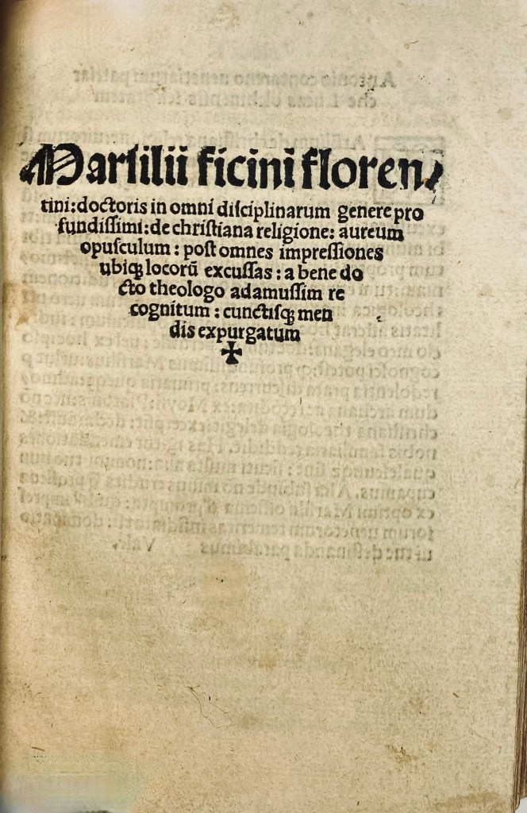
Bound with it is Marsilio Ficino’s De christiana religione, a work that addresses a different but complementary problem: not how Christians should live in view of judgment, but why Christianity itself is intellectually true and defensible. Written by the leading Florentine Platonist, the treatise offers a learned apology for Christianity, harmonizing Christian doctrine with Platonic philosophy and responding to pagan, skeptical, and heterodox challenges. Ficino’s approach is rational, humanist, and synthetic, presenting Christianity as the fulfillment rather than the negation of classical wisdom.
Taken together, the two texts form a coherent and revealing pairing. Reginaldetus represents the late-medieval pastoral tradition, oriented toward discipline, repentance, and preparation for the afterlife; Ficino represents the Renaissance humanist defense of faith, concerned with reason, harmony, and intellectual persuasion. Their union in a single contemporary volume reflects the lived reality of the late fifteenth and early sixteenth centuries, when older mendicant modes of moral instruction coexisted with—and were increasingly reframed by—humanist theology. The book thus stands as a material witness to a moment when Christian belief was simultaneously preached from the pulpit and argued in the language of classical philosophy.
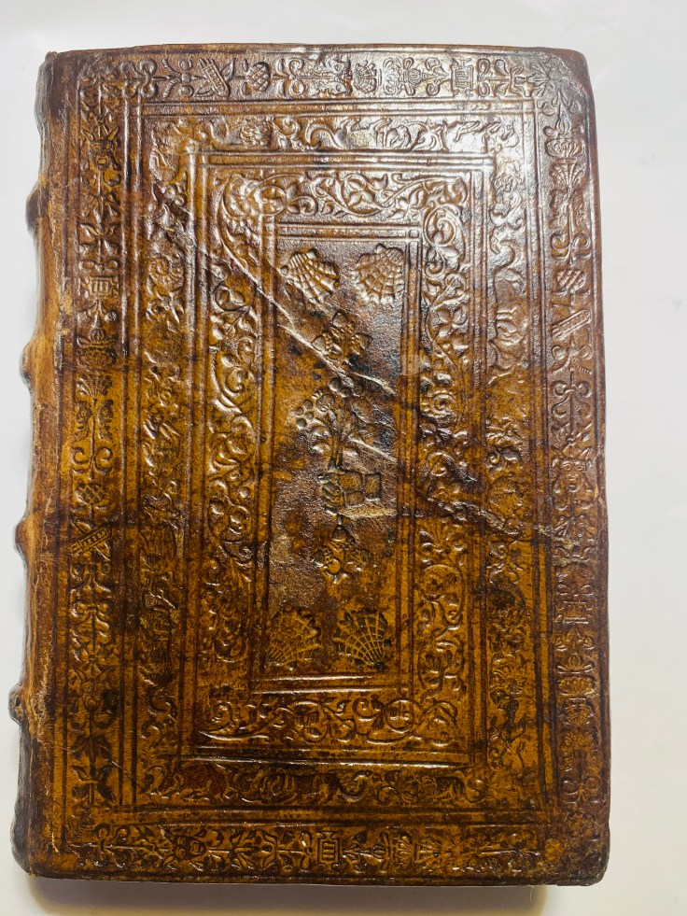
Ad1). Goff R890; ISTC,; ir00089000; BMC 15th cent.,; V, p. 565;HC 13766. 13771. Sander 6393. Ce³ R-89. IBE 4887. IBP 4691. IGI 8312. CRF VI 1722. BSB-Ink R-56. Pr 5580. Collijn: Uppsala 1292. Madsen 3467. Oates 2197. Scardilli-Venezia 247.
U.S. copies: | Austin TX, (Incun 1498 R263s), The Newberry Library, Princeton Univ, Huntington Library.
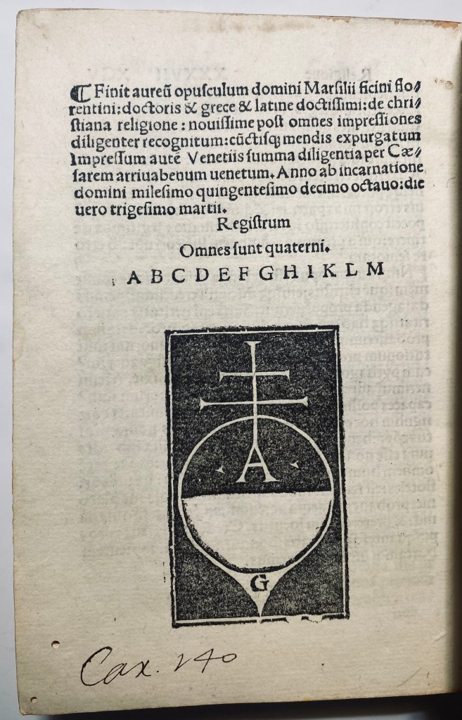
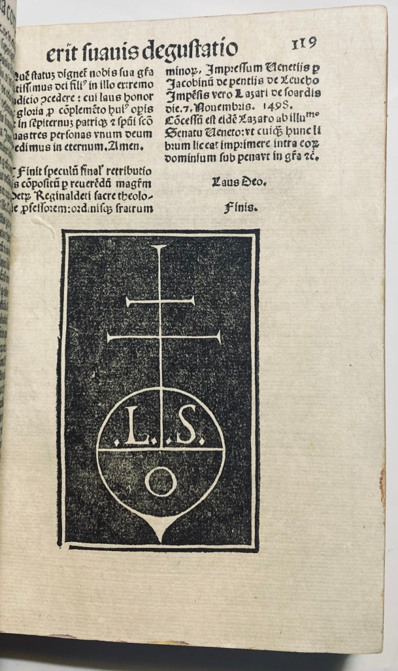
Ad2). LC: BT1100; Dewey: 230.01. U.S. copies:| STANFORD,EMORY,INDIANA U, MIDDLEBURY COL.
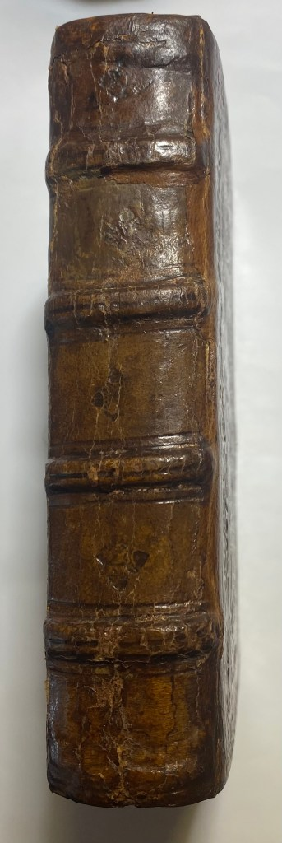
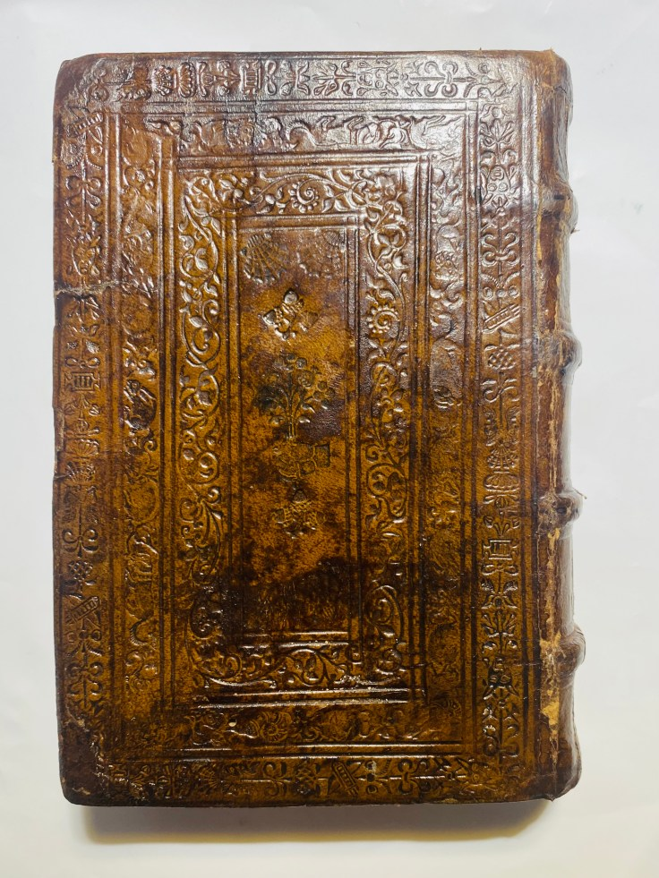

Provenance: This book has had a handful of proud owners.
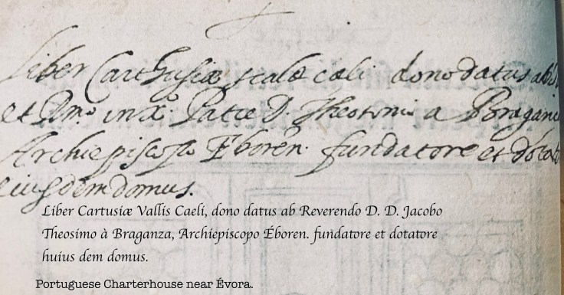
From the library of the Carthusian Charterhouse of Scala Coeli (Vallis Caeli), near Évora, [Established between 1587 and 1598, it was home to Carthusian monks until the 19th-century expulsions, later becoming an agricultural school before restoration.]donated in the early 16th century by its founder Teotónio de Braganza, Archbishop of Évora, as recorded in a contemporary Latin inscription. After the suppression and dispersal of monastic libraries, the volume entered the celebrated collection of José de Salamanca y Mayol, Marquis of Salamanca, and was sold with that library in Guipúzcoa in the spring of 1885. It was then acquired by Cardinal Manuel María de la Barrera y Parra, associated with the Biblioteca Nacional, Madrid, who subsequently presented the book to José María de Valdenebro y Cisneros, librarian and Spanish bibliophile. Preserved with Valdenebro’s engraved ex-libris (motto Quo trahor), and later presentation inscription dated 1 January 1901, marking its transmission as a humanistic and bibliographical gift at the opening of the 20th century.
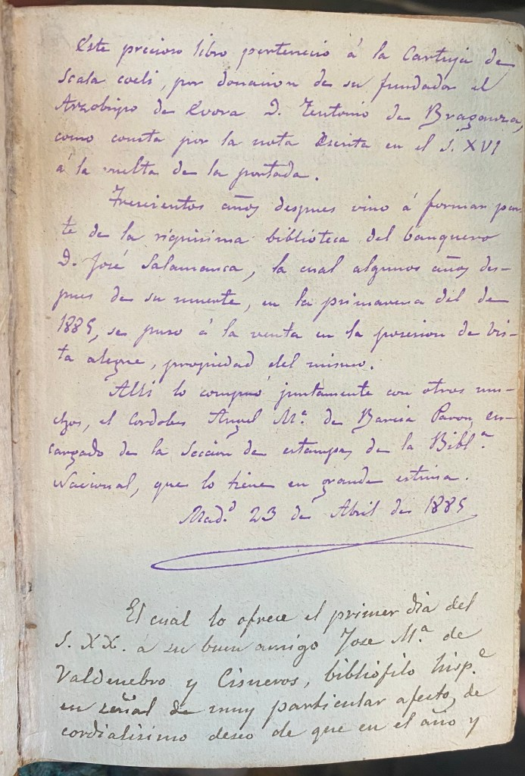
This precious book belonged to the Charterhouse of Scala Coeli, by donation of its founder, the Archbishop of Évora, Don Teotónio of Braganza, as is shown by the note written in the 16th century on the verso of the title page.
Three hundred years later it came to form part of the extremely rich library of the banker Don José Salamanca, which, some years after his death, in the spring of the year 1885, was put up for sale in the province of Guipúzcoa, remaining his property.
There I purchased it together with many others — Cardinal Manuel María de la Barrera y Parra, then in charge of the Prints Section of the National Library — who held it in very high esteem.
Madrid, 23 April 1885.
(Later note) Which he offers on the first day of the 20th century to his good friend José María de Valdenebro y Cisneros, librarian
…

18

5 part Sammelband _{537J}i-v This volume is Sammelbandof five printed books. Four from the early sixteenth century and one printed in the late fifteenth.

Basel, Mainz, Oppenheim, Speyer, Straßburg, 1499-1515. Price $ 9,500
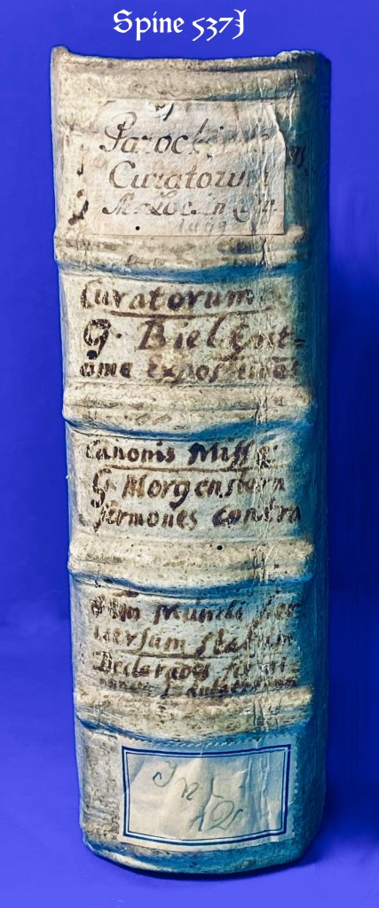

Five Chancery Quarto volumes, 20 x 15.5 cm These copies are bound together in early {1550} blind stamped pigskin over wooden boards with the remains of clasps. Covers panel-stamped and framed within multiple fillets and ornamental rolls. Front board: Central panel depicting a biblical miracle scene (Christ healing the sick or Resurrection motif), with legend below in Gothic capitals:
FRISCH ERNEV MEIN GOTT. ICH BIN DEIN DOCTOR.
This German motto panel is recorded in the Einbanddatenbank as p002307, attributed to Augsburg workshops c. 1545–1555. Cf. Haebler, Rollen- und Plattenstempel des XVI. Jahrhunderts, Augsburg section, pl. XXX (for similar motto-panels). Back board: Central Crucifixion panel, Christ on the Cross flanked by figures of the Virgin and St. John, within a scrolled border. Rolls: Vertical ornamental roll including a cartouche impressed with the date “1550”, accompanied by foliate and grotesque motifs. Surrounding border rolls of Renaissance ornament, including double-headed eagle medallions. The binding style, panel iconography, and dated roll together point securely to Augsburg around 1550, possibly the circle of Caspar Angstat or a closely allied shop [S.S.]. Titles of works contained in this volume on spine in an early hand. The first work in this sammelband has a repaired margin ripped out section of the title page, removing some of the decorative border, and a few words from the back of the page.
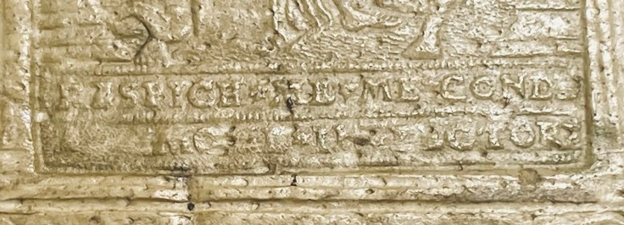

With the monastic ownership stamp ofThe Fransiscian Klosters of Engelberg In October 2021, Reiss & Sohn ran its autumn sales (auctions 205–207) with a tranche of incunabula and early prints from the Engelberg Franciscan monastery (some carrying older Capuchin Engelberg provenance marks). The Franciscan Kloster Engelberg (Großheubach)Founded as a Capuchin house and pilgrimage site in 1630; secularized in 1803. Franciscans took over the site in 1828, continuing the pilgrimage ministry. In 2024, amid shrinking numbers, the Franciscans left; pastoral care is being continued by the Oblates of St. Joseph (OSJ).

i) Lochmaier,Parochiale curatorum 1514.[No US copies located ]
iii) Biel,Epitoma expositionis sacri canonismissae.. 1499 [5 Us copies]
iii) Directorium Misse de nouo 1509 [One US copy CONCORDIA SEMINARY LIBR] iv) Interpretationes et declarationes terminorum .indulgentiarum. 1515 [No US copies located ]
v) Morgenstern ,Sermones-mu[n]dip[er]uersum 1513.[One North American copy , Toronto.]

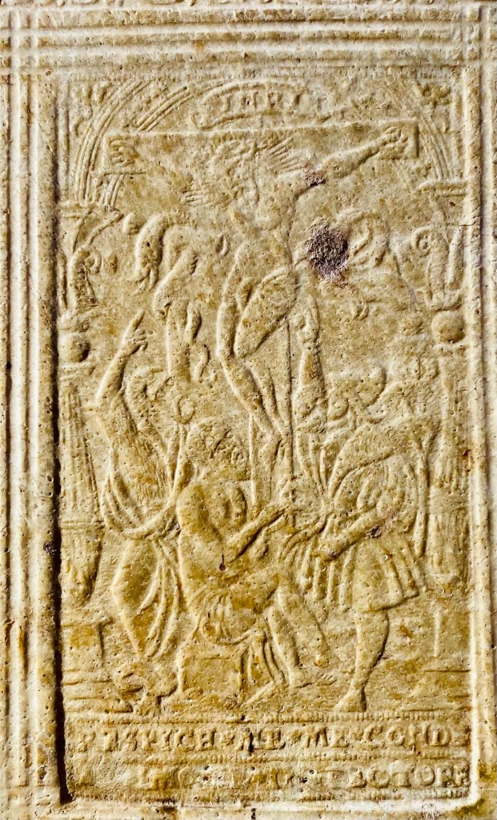

_{537J}i.MichaelLochmair; Wilhelm Nesen.

Parochiale curatorum a Michaele Lochmayers Iurisconsulto ac Theologie concinnatumexquisitissimaque diligentia doctioris hominis emaculatum
Basel, M. Furter, 1514.( [Basle] : Gaspar HaflachiusMichaele [sic] Furter Basilee vrbis inquilino [dedit] imprimendū) Gaspar Hastachius … Que[m] ego Michaele Furter Basilee vrbis Inquilino dedi imprimendu[m] … Anno. M.ccccc.xiiij. Mensis Julij] 1514
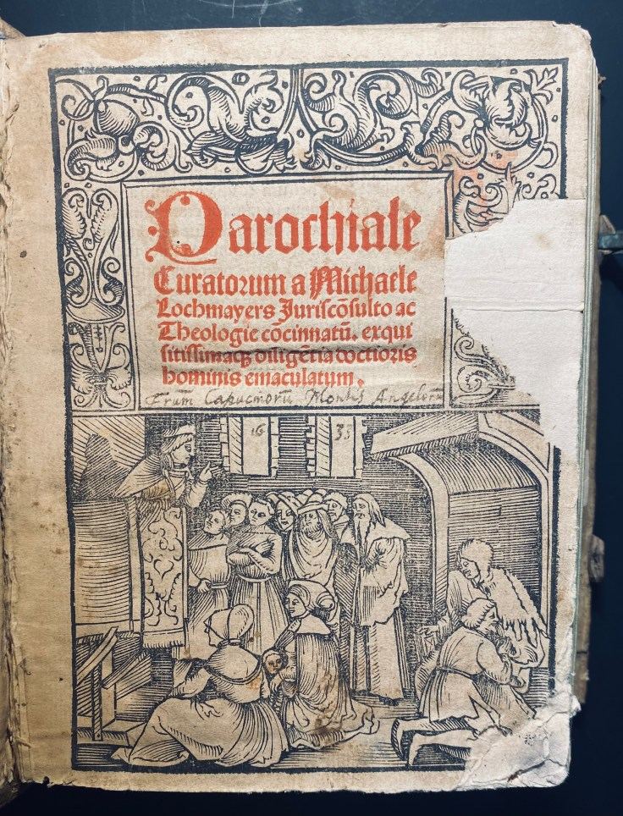
Chancery quarto: 20 x 14cm. Signatures:π⁴ a⁶ b-l^{8/4}m-t^{4/8}v ⁴ x⁶. This is an early edition of a work on the rights and duties of pastors by Lochmaier, preacher and professor of canon law and theology in Viennaand a canon of the cathedral of Passau.Before Lochmaier’s “Parrochiale curatorum”, parish handbooks were usually written by the individual parish priests for their own use, as no reliable, official or general handbook existed. The “Parrochiale curatorum” describes all that a parish priest needs to know, and as such it is the first work to remedy the greatlack of such a work, which had otherwise occasioned merely individual efforts. Thefirst printing of the work appeared without place and without date, but not earlier than 1493. A reproduction of this edition appeared in Leipzig in 1497 (by Kachelofen), and in 1498 this, the third edition of the work, appeared in Hagenau. In 1499 Lotter produced yet an edition of the work, in Leipzig, and in 1500 Furter produced one in Basle. All these editions are scarce..VD16, L 2231; Adams L 1392; Hieronymus 132. ; GW M18659; Panzer VI, 191, 123

_{537J}ii.
Gabriel . Biel, edited by Wendelin Steinbach, Heinrich Bebel, Friedrich Meynberger

Epitoma expositionis canonis missae. Magistri Gabrielis Biel
Hrsg. von W. Steinbach. Mit Beigabe von H. Bebel. Speyer, Konrad Hist, (um 1500). Thüwing[e]n : [Johann Otmar für Friedrich Meynberger], 1499
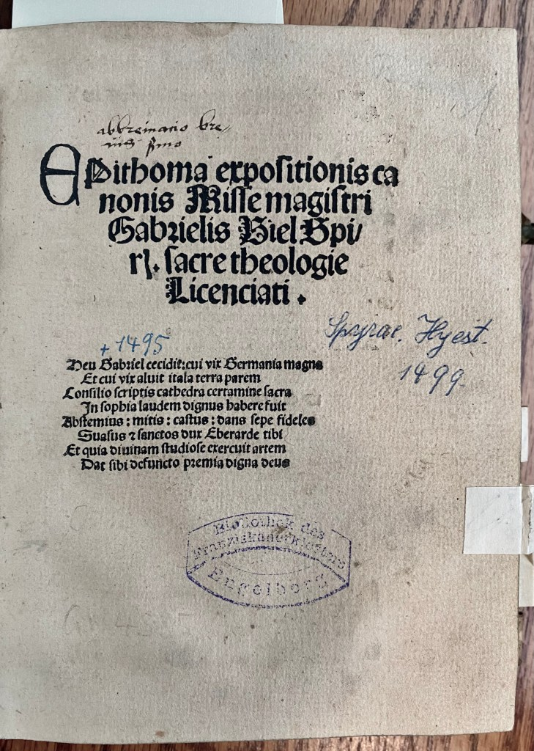
Quarto 22x __cm Signatures: A-B⁴ C⁸ D⁴ E⁸ F⁴ G⁸ H⁴ I⁸ K⁴ L⁸. – Bl. L⁸. Mit 1 Textholzschnitt. 64 nn. Bll. (l.w.).
With a letter to Friedrich Meynberger, Tübingen February 20, 1499, ed. by Wendelin Steinbach. With a poem to the clergy and to Wendelin Steinbach by Heinrich Bebel and with an epitaph to Gabriel Biel.- Second of Biel’s writings posthumously edited by Wendelin Steinbach. “B. wrote the ‘Epitome …’ with regard to the ‘simplicices sacerdotes’, which are ‘scolasticarum sublimatum minus exercitati’. Incidentally, it is not a mere excerpt from the larger work (the ‘Expositio’), but one independent processing “(Steiff, Tübingen 6 for edition 1499).
There are two things that everyone “knows” about Gabriel Biel (d. 1495).1 The first of these things is that Biel was heavily influenced by William of Ockham. Although other scholars appear in the most important of Biel’s scholastic works, his Collectorium circa quattuor libros Sententiarum (written from 1484 on) — we meet time and again Thomas Aquinas, John Duns Scotus, Robert Holcot, Adam Wodeham, Gregory of Rimini, and Pierre d’Ailly — Biel tells us explicitly that his purpose is to capture the meaning of Ockham’s Sentences commentary in abbreviated form.2 The second of the things that everyone knows about Biel is that he was read by the young Martin Luther and that Biel acted as something of a conduit through which some later-medieval scholastic thought was channeled to the Reformation and perhaps beyond.- Somewhat stained or finger-stained.
United States of America: Arne Pettersen, Tuckahoe NY Concordia Seminary, Pritzlaff Memorial Library Duke Univ. Library,Library of Congress, Rare Book DivisionLutheran Theological Seminary, Krauth Memorial Library San Marino CA, Huntington Library, The Newberry Library
Oberman, H.A. 1963 The Harvest of Medieval Theology: Gabriel Biel and Late Medieval Nominalism. Cambridge, Massachusetts: Harvard University Press (rpt. Durham, North Carolina: The Labyrinth Press, 1983 ).
ISTC https://data.cerl.org/istc/ib00654000.
III
_{537J}iii. Anonymous

Directorium Misse denovo perspectum & emendatum. Maguntie [… s[e]c[un]d[u]m frequentiorem cursum diocesis Magunitn. …]. Directorium Misse de novo perspectum & emendatum
(Mainz),Friddericu(m).Heumann,1509.
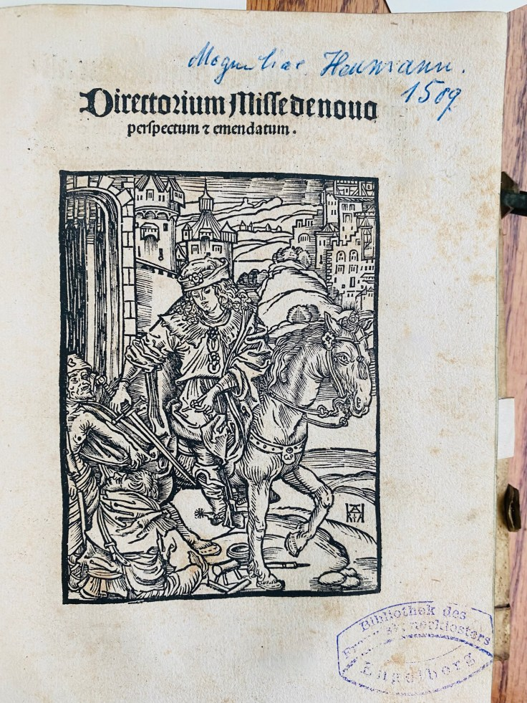
4to . This is a a directorium: instructions for priests how to say the Mass, particularly regarding variants, options, liturgical parts that change. It helps guide use of Mass throughout the liturgical year in that diocese. The beautiful title woodcut shows St. Martin on horseback sharing his cloak with two beggars, similar to the canon picture of the Missale Moguntinum by Joh. Schoeffer, 1507. The woodcut is monogrammed “HRA” (Nagler 1429: “Unknown woodcutter, who at the beginning was active in Mainz in the 16th century. “). .VD 16, D 2017.
.IV
47537JivAnonymous

Interpretatio(n) es et declarationes Terminoru(m) indulgentiaru(m) scilicet. Quid sit quadragena, septena, carena, et in quibus differant. De institutione festi Corporis Christi. siue Eucharistie Sacramet̄o. Cūtransumptis Bullarum desuper confectarum .
(Oppenheim, J. Köbel, um 1515). 4to. 6 nn. Bll. –¶ “Köbel graduated in arts and lawfrom Heidelberg University in 1491. He appears to have then studied mathematics at Cracow andis said to have been a fellow student of Copernicus there.He learnt the publishing trade as editor and proofreaderfor Heinrich Knoblochtzerin Heidelberg. In 1494 he married a woman from Oppenheim and settled there as secretary to the city council.”R. M. Gascoigne, A chronology of the history of science 1450-1900, Garland Pub., 1987, p.413.VD 16, I 242

.537Jv Georg. Morgenstern.
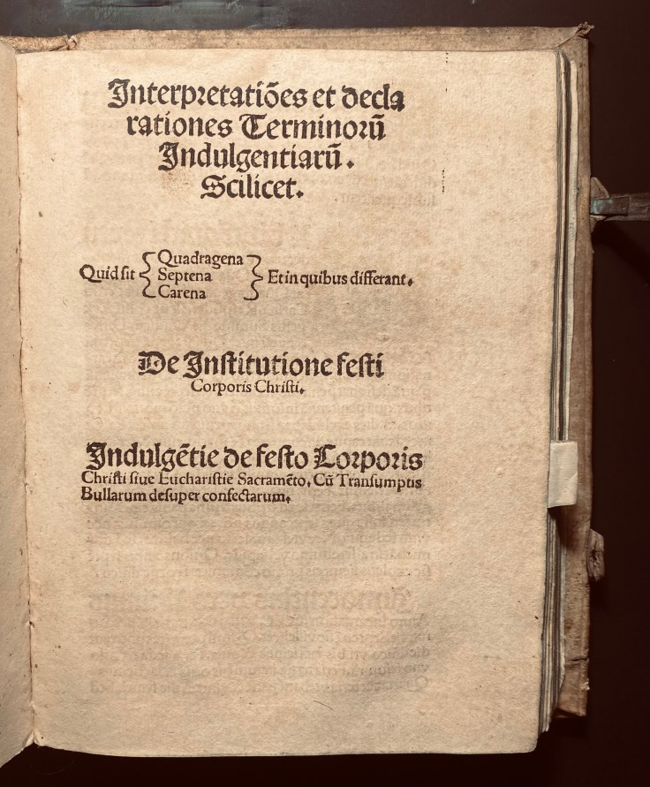

537Jv Georg. Morgenstern.
Sermones co[n]tra omne[m] mu[n]di p[er]uersum statu[m] que[m] de[us] gloriosus et equitas naturalis da[m]nat. Egregij et famosissimi domini Gregorij Morge[n]stern, Decretorum doctoris celeberrimi, Qui iura canonica in gymnasio. Liptzensi q[ua]m fideliter docuit. Ex secunda recognitione.Straßburg, W. Schaffner, 1513
.Quarto Signatures: a-q6, r4 The Final leaf is a very detailed Crucifixion woodcut. With some, isolated water marks. On the Last 2 ll. with traces of ink, woodcut not affected, penultimate sheet with a smaller tear in the edge and stamp on recto. Second printing by Schaffner who is famous for the first printing of the “Hortulus animae” in 1498.This is Georg Morgenstern’s only known published work “Sermones contra omnem mundi perversum statum” (Sermons Against the Whole Perverse State of the World). Little is known about Morgenstern, except that he was a doctor of canon law and taught at the Univeristy of Leipzig. VD 16 M 6350; Muller 54, 13.; BM STC Germany,; p. 628
V
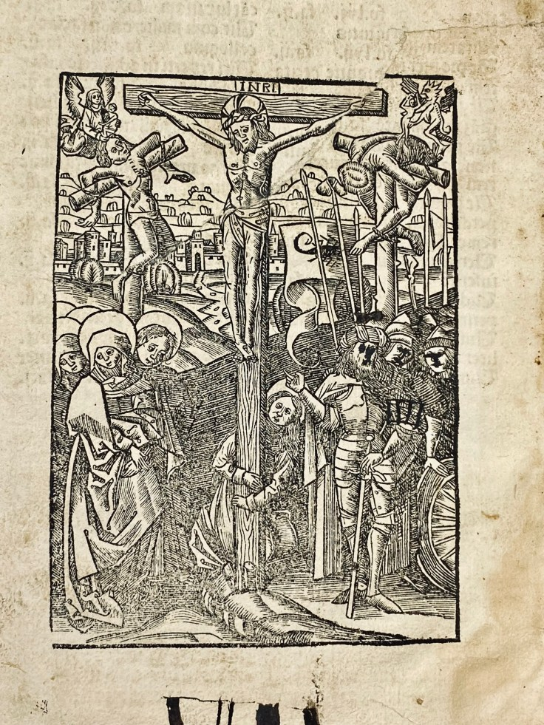
537JV Georg. Morgenstern.

Sermones co[n]tra omne[m] mu[n]di p[er]uersum statu[m] que[m] de[us] gloriosus et equitas naturalis da[m]nat. Egregij et famosissimi domini Gregorij Morge[n]stern, Decretorum doctoris celeberrimi, Qui iura canonica in gymnasio. Liptzensi q[ua]m fideliter docuit. Ex secunda recognitione.
Straßburg, W. Schaffner, 1513.
Quarto Signatures: a-q⁶, r⁴ 93 Final leaf with a very detailed Crucifixion woodcut. Partly browned, isolated water marks. Last 2 ll. with traces of ink, woodcut not affected, penultimate sheet with a smaller tear in the edge and stamp on recto. Second printing by Schaffner who is famous for the first printing of the “Hortulus animae” in 1498. Georg Morgenstern’s only known published work “Sermones contra omnem mundi perversum statum” (Sermons Against the Whole Perverse State of the World). Little is known about Morgenstern, except that he was a doctor of canon law and taught at the Univeristy of Leipzig.
VD 16 M 6350; Muller 54, 13.; BM STC Germany,; p. 628
– Partly browned, isolated water marks. Last 2 ll. with traces of ink, woodcut not affected, penultimate sheet with a smaller tear in the edge and stamp on recto.
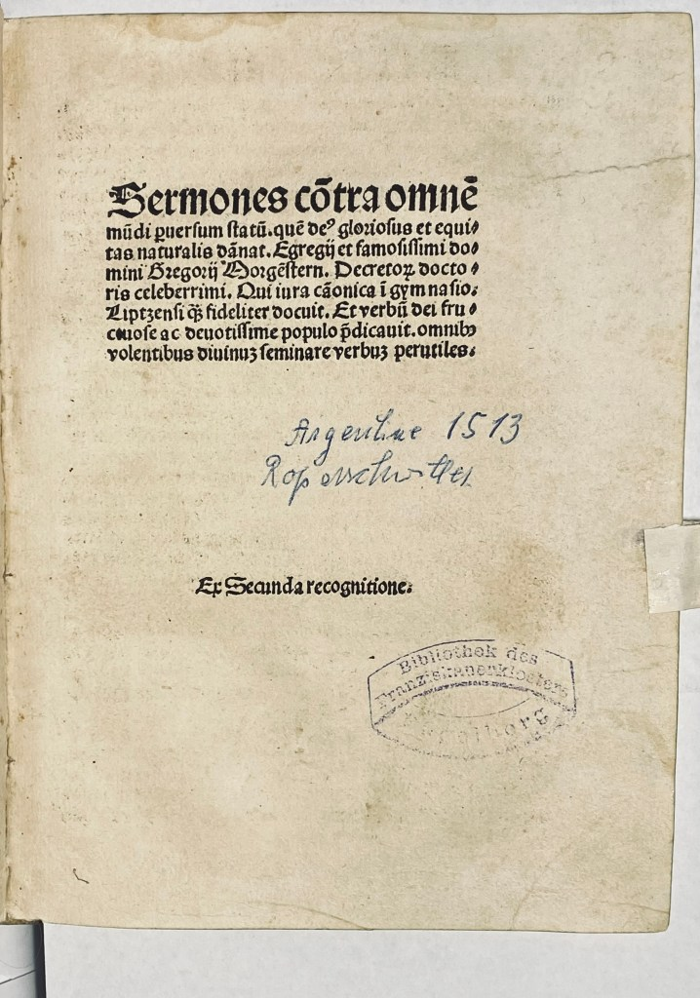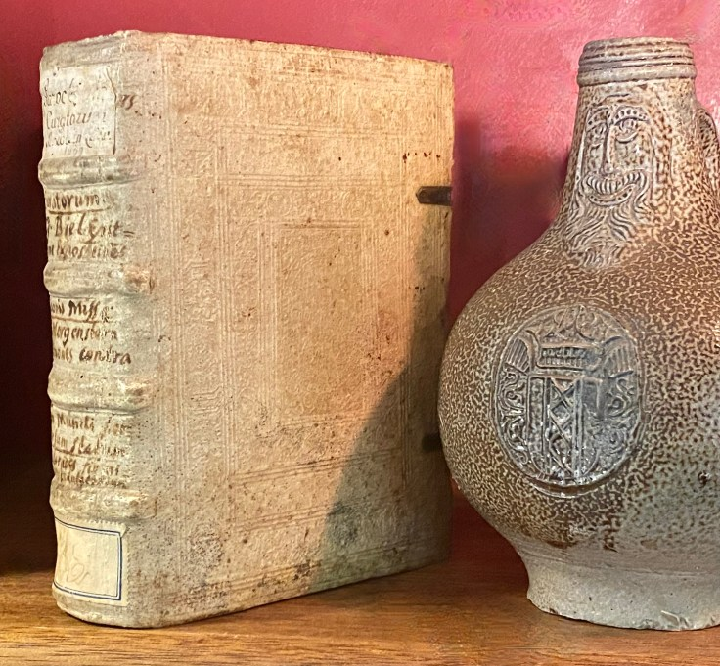

For university and special collections purchases, I am accustomed to working within committee timelines and budget cycles. Titles may be placed on hold during review, and flexible invoicing arrangements can be discussed where appropriate. I welcome inquiries at jamesgray2@me.com.

